**Programming with**

**B4J & B4X**

Brief Theory

**Leon Prokopis**

****Version 1.3, April 2021

[](https://creativecommons.org/licenses/by/4.0/)

|  |  |
| --- | --- |
| CC BY 4.0 | by Leon Prokopis, 2021, Nafplio, Greece This work is licensed under a [Creative Commons Attribution 4.0 International License](http://creativecommons.org/licenses/by/4.0/). |

# Table of Contents

Table of Contents iii

Lesson 1 – Why B4X? 1

Installing B4X 1

Lesson 2 – The meaning of the problem 3

The concept of the problem 3

Understanding the problem 3

Searching for a solution or set of solutions. 3

Choosing the right solution 4

Implementing the solution 4

Checking whether this solution had the desired results. 4

Lesson 3 - My first Program 5

Hello World 5

Recommended instructions for the instructor 5

Exercises 6

Lesson 4 - Variables and Range 7

How to find how many variables you need 8

Naming Variables 9

Declaring Variables 9

My First Variable 9

Comments 10

The log area and the log function. 10

Mathematical Operators 11

Strings 12

Exercises 13

Lesson 5 – Designer 17

First steps with design 18

Visual designer 19

The Views Tree 20

Properties 20

Abstract Designer 20

Example 1 20

Decide on the size of the app screen. 21

Set an appropriate variant. 21

Design a wireframe. 21

Create the views. 22

Excercises 24

Lesson 6 – From Designer to Code 25

Class_Globals 25

A deeper look at the use of variables. 26

Passing Values to Code 26

Events 27

Writing code in Event 28

Properties 29

Exercises 30

Lesson 7 – Conditional Statements 31

Logical Variables 31

Comparative Operators 31

Logical Operators 32

Logical operators in programming 33

Examples of evaluation of logical sentences. 33

If command 34

If – Else 35

If – else - else if 36

Algorithms with if 38

Exercises 38

Lesson 8 – Subroutines 41

Create a subprogram in B4J 41

Example 1 41

The memory of the subprogram in B4X 43

Return a value from a subprogram. 44

Example 2 44

Exercises 45

Lesson 9 – Classes 47

Classes 47

Example of class in B4J 48

Implementation methodology 48

Insert a book. 50

Show Book Items. 50

Change book items. 50

The Initialize subprogram. 50

Use Class 50

Use of methods 51

Getters and Setters 51

Exercises 53

Lesson 10 – B4XPages 55

The structure of an application's folders 55

Starting an application with B4XPage. 56

What is Root 56

Create a new B4XPage 57

Call a new B4Xpage. 59

Close a B4XPage. 60

Transfer information between pages 61

The Life of B4XPages 62

Exercises 63

Lesson 11 – First Project 65

Mobile Phones shop application. 65

Timetable 67

Wireframe Sketching 68

Classes 69

B4XPages 70

Lesson 12 – Loops 71

The Do While command 71

Examples of the command Do While. 73

Loops with unknow repeats. 75

The Do Until command. 76

For Loop 79

Examples for 80

Exercises 81

Lesson 13 – XUI Views 83

Libraries in B4X 83

The XUI Views library 84

Using XUI Views 85

Scrolling Label 85

B4XFloatTextField 85

RoundSlider 86

AnotherProgressBar 86

B4XImageView 87

B4XDialogs 88

MsgBoxAsync 89

MsgBox2Async 89

Wait For 90

CustomDialog 90

Templates 91

B4XDateTemplate 92

B4XColorTemplate 92

B4XLongTextTemplate 93

Exercises 93

Lesson 14 – Arrays 95

Declaring Tables 95

Functions in tables 96

Insert items into a table. 96

Display items in a table. 97

Show items in reverse order 97

Find Total and Average Table Items 97

Find Maximum and Minimum 97

Search Algorithms 98

Serial Search 98

Binary Search 98

Sort 99

Exercises 102

Lesson 15 – Lists 103

Create a list 103

Insert an item in a specific location 104

Remove an item from a specific location 104

Change position value 104

More commands in lists 105

Exercises 106

Lesson 16 – Maps 109

Create a map 110

Insert items into Map 110

Use a map value 111

Indexes in Maps 111

The command “for each” 112

Check key existence 112

Delete Key and Empty Map 112

Exercises 113

Lesson 17 – Files 115

Storage Folders 115

File.DirAssets 115

xui.DefaultFolder 115

File.DirData 116

File.DirApp 116

File.DirTemp 116

Create folders 116

Check file existence 116

Create and write to a file 117

Writing and reading data 117

String-type variables 117

Lists 117

Maps 118

Exercises 118

Lesson 18 – Complex Data Types, Files & Views 119

The type statements 119

Show Items 120

Table of a type 120

List of Type 121

Maps of Type 121

Save to KVS files 122

Declare a KVS file 122

Initialize the KVS file 122

Insert items into a KVS file 123

Retrieving items from a KVS file 123

Check the existence of a record 124

Delete KVS file content 124

More Views 125

CustomListView 125

B4XComboBox 127

Exercises 129

Lesson 19 – Final Project 131

Create a School Library Application 131

Files 132

Data 133

Types 133

Screen Design and Functions. 134

Cheat Sheet 135

Timetable 137

Wireframe Sketching 138

B4XPages 139

Lesson 20 – From B4J to B4A 141

Congratulations! 141

Application description in B4J 141

Designer 141

Transfer the app to B4A and Android 144

Transfer of design 144

Install an app on your mobile phone. 145

# Lesson 1 – Why B4X?

**1h**

Many new developers wonder in which programming language to invest their time and effort. Each programming language has advantages but also disadvantages that should be considered. Often the selection of a language also determines the subsequent evolution of the developer. Even more, when it comes to using language for educational purposes, there are individual elements that need to be considered.

So, the programming language must be:

* Modern and structured
* Be easy to learn for kids and new programmers.
* Provide an integrated development environment without confusing.
* To be able for the student to develop applications on different platforms like Windows, Android, IOS, Linux, Raspberry Pi, Arduino etc.
* Provide all modern data structures as lists, maps etc.
* To keep students interested by providing the possibility of developing different types of applications for example games etc.

The **B4X** programming language provides all the above features and is also a language for developing high-level applications which can be a springboard for future professional development. In addition, it has a very enthusiastic audience that gladly help in any kind of question.

For more information and material you can visit the website at [https://www.](https://www.b4x.com/learn.html) [b4x.](https://www.b4x.com/learn.html) [com/learn.](https://www.b4x.com/learn.html) [html](https://www.b4x.com/learn.html)

## Installing B4X

The most updated information about installing will always be here: <https://www.b4x.com/b4j.html>

# Lesson 2 – The meaning of the problem

* What is a problem?
* What is data?
* What is information?
* What steps need to be taken to resolve a problem.
* What is algorithm.

What students should know

**1h**

## The concept of the problem

Every day in our lives we have problems. Simple problems of everyday life and often even bigger. As a problem we usually define a situation that we are experiencing and which makes it difficult for us to deal with it or solve (Cambridge, 2021).

When we are thinking about a problem these are steps become unconscious in our minds:

* Understanding the problem
* Searching for a solution or set of solutions.
* Choosing the right solution
* Implementing the solution
* Checking whether this solution had the desired results.

### Understanding the problem

Understanding the problem is the first step in designing and solving a problem. It is a particularly critical stage because this will also affect the development of the solution. Includes the following steps:

1. Description of the problem

The description of the problem is usually done by ourselves or someone who has it. In this step it is important to clarify all its 'dark' points and to have no doubt as to its wording.

1. Find the data.

Finding the data means what these elements are based on in order to solve a problem, for example in an equation ax + b = 0 data are the factors a and b.

1. Find the requested.

The information that we need to find to deal with the problem. Continuing the previous example information is the x of the equation ax+b=0.

### Searching for a solution or set of solutions.

Once we have recognised the data and what is requested, a solution must be found to solve the problem. Often that's not easy. Thus, it is necessary to look for a method or **a logical set of steps leading to the solution**. These steps must lead to a solution **whenever** the same problem arises and, moreover, be done in **a relatively short period** of time.

**In mathematics and computer science, an algorithm is a finite sequence of well-defined, computer-implementable instructions, typically to solve a class of problems or to perform a computation.**

### Choosing the right solution

Often a problem can have more than one solution or some of them may be more efficient than others. Choosing the solution correctly leads to a shorter and more reliable outcome.

### Implementing the solution

After the resolution method is selected, a series of actions must be taken to implement it. In other words, apply **the Algorithm.**

### Checking whether this solution had the desired results.

Finally, after applying the solution it is necessary to test with various data, to examine whether it leads to correct results each time it is performed without problematic situations.

Picture 1 The steps

# Lesson 3 - My first Program

**2h**

* How to start B4J
* How to create and save a new project
* How to run a project
* What is error screen.
* How to see Turtle commands
* How to write a new project using Turtle

What students should know

## Hello World

Make a program that draws a straight line with the help of the turtle on the computer screen.

## Recommended instructions for the instructor

The aim of the above exercise is to familiarize students in the creation of a project with B4J and to become the first acquaintance with the programming environment. The following instructions in no way limit the instructor to adapting his course to the relevant educational conditions.

**Teachers tip**

This is students first lesson. Therefore, keep it simple!



| **Function** | | **Description** |
| --- | --- | --- |
| **1** | How to create a first project with B4J | *Menu File -> New -> B4Xturtle*  *Project Folder*  *Project Name*  Explain to students the importance of the right names in each project they create and the value of correct storage in folders in a structured way |
| **2** | Run Project | *Menu Project -> Compile & Run*  Explain what means compile and how to recognize syntax errors in log. You don’t need to provide to much information about compilation. Just the basic stuff in order to run a project. |
| **3** | #Region Project Attributes | Change Values in *MainFormWidth* and *MainFormHeight* to make different size application |
| **4** | Sub Turtle_Start | *What means Sub?*  A small amount of code which is doing a certain activity. |
| **5** | Turtle methods | What is Turtle?  What .MoveForward do?  How can we find more commands?  (Tell students to write “Turtle.” To see the list of methods. |
| **6** | Errors | How to identify an error in log screen |

## Exercises

1. Using turtle and methods ***MoveForward****,* ***TurnLeft****,* ***TurnRight***draw a square with any size you want.
2. Using Previous commands and ***PenUp****,* ***PenDown***and***Move***draw 3 squares like the image bellow.
3. Using previous commands design a sketch of your choice. Give a name to your sketch and explain how you did it.

# Lesson 4 - Variables and Range

* Explain how a computer stores data in ram.
* Explain what a variable is.
* How to name a variable
* Assign a value to a variable.
* Use Mathematical Operators
* Use log command to display a variable value
* What is a string.

What students should know

**3h**

Imagine that you live on a street with a few million houses all in a row; each house has as you all know its address which starts at number 1 and ends at the last house; in order to be able to locate a friend who lives on that street you need to know the number of the house; so we have on the one hand a house number and on the other the friend who lives in that house. 

Figure 1 Computer Memory (https://www.freepik.com)

The computer's central memory works in much the same way. There are many houses each with its address and a "resident" within each house. This address is called memory address and the "resident" content. On the computer often the "resident" who from now on we will call variable needs more houses to fit.

For a programmer to use memory, he must know the data he needs and the type of data. These can be integers or real numbers, words or letters, some reasonable values (truth, false). He also needs a “home” in the computer memory to store them represented by address.

In B4X the data can be stored in different types as:

|  |  |
| --- | --- |
| **B4X** | **Type** |
| Boolean | boolean |
| Byte | integer 8 bits |
| Short | integer 16 bits |
| Int | integer 32 bits |
| Long | long integer 64 bits |
| Float | floating point number 32 bits |
| Double | double precision number 64 bits |
| Char | character |
| String | array of characters |

Table 1- Simple types of variables

Every type needs different space in memory to store values.

Because it is difficult for the developer to remember all the addresses of his data, each address corresponds to a name. Fortunately, in fact this is done by the programming language itself and all it takes is to think of a good name for his data. For example, a data that is an integer for age could be called “age”. Now, there is a “home” called age in computer memory.

**Remember**

Variables are used to store information to be referenced and manipulated in a computer program. They also provide a way of labeling data with a descriptive name, so our programs can be understood more clearly by the reader and ourselves. It is helpful to think of variables as containers that hold information.

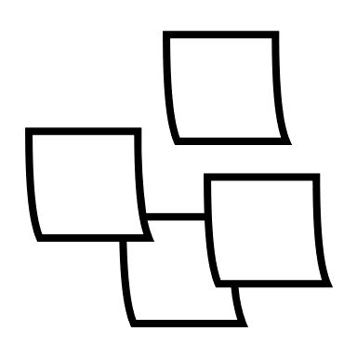

## How to find how many variables you need

In any programming problem that a developer encounters, they should be able to locate the data and the information’s of the problem.

In programming we name all those elements that we need to know to move forward in solving a problem. Usually in a programming problem we find them in the pronunciation of the exercise with the help of keywords such as:

* Reads
* Registers
* Ask
* Accept
* Type

*Example 1: Write a program that converts the euros we type into dollars.*

*Example 2: Make a program that accepts a positive integer and calculates its square, cube, and square root.*

Information’s

Information’s in programming are all the elements that we need to calculate after processing our data. We usually find them in pronunciation using keywords such as:

* Calculates
* Displays
* Writes
* Counts
* Convert

In the previous examples what are the requested?

## Naming Variables

The names of the variables in B4X must follow specific rules.

* They must start with a capital or small character.
* They can then have digits or the character underscore.
* B4X does not distinguish capital and small letters.

Also, it’s a good practice to name variables beginning with 3 small letters indicating the kind of a variable and continue with 1 uppercase letter and a meaningful word. For example:

* Dim **intAge** as Int
* Dim **fltAmount** as Float
* Dim **strName** as String

This practice helps a lot when you find variables in the code to recognize the type and the value it stores.

## Declaring Variables

### My First Variable

Make a program that assigns a value into integer and then draws with the help of the turtle a line of length as long as the value in the variable.

In B4X to use a variable we must first inform the language of its existence in order to commit space in the computer's memory to store its value.

For example, in the following code, the statement is as follows:

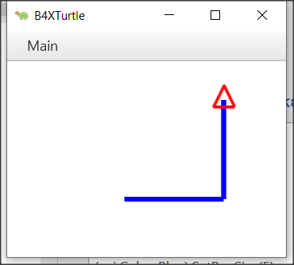‘Program: My First Variable

Sub Turtle_Start

Private intDistance As Int

Public intTurn As Int

intDistance = 100

intTurn = 90

Turtle.SetPenColor(xui.Color_Blue).SetPenSize(5)

Turtle.MoveForward(intDistance)

Turtle.TurnLeft(intTurn)

Turtle.MoveForward(intDistance)

End Sub

The declaration of variables begins with the keyword Private or Public.

Private means that the variable is known only in the specific space declared and no other program or subprogram does not know its existence and thus the value it contains.

Instead, a variable statement that starts with the keyword Public can be known to other programs or subprograms or classes etc.

After the keyword Private or Public follows the name of the variable we chose to give. This is where the rules discussed above apply. Finally, the type of the variable follows. For simple variables these are all those described in the *Table 1- Simple types of variables*.

**Teachers tip**

You don't have to explain all the variables already as well as their use. For your students to start programming, the basics of integer, float, string are enough. As you progress through the courses you can include other types according to your needs.



## Comments

In computer programming, a comment is a programmer-readable explanation or annotation in the source code of a computer program. They are added with the purpose of making the source code easier for humans to understand and are generally ignored by compilers and interpreters. The syntax of comments in various programming languages varies considerably. (Wikipedia, 2021)

In B4X comments are inserted by writing the character ' as their first letter. From this point on it is not recognized by the translator of the language. Generally, in B4X comments you should put anywhere it is important to remember what you are doing as well as before the subprograms to explain what their job is. Comments are easily distinguished in code from the green color given to them by the programming environment (IDE).

Example

‘Program: My First Variable

‘This program draws a right angle, with sides as much as the   
‘value of the intDistance variable

Sub Turtle_Start

Private intDistance As Int

Public intTurn As Int

intDistance = 100 ‘The sides of the right angle

intTurn = 90 ‘90o angle

Turtle.SetPenColor(xui.Color_Blue).SetPenSize(5)

Turtle.MoveForward(intDistance)

Turtle.TurnLeft(intTurn)

Turtle.MoveForward(intDistance)

End Sub

## The log area and the log function.

During programming various errors occur. Generally, errors in programming are divided into two categories syntax and logical. For now, we will deal with the syntax errors that are recognized by the programming language and indicate them on the logs screen. In order to access the logs screen we need to click on the relevant logs tab at the bottom right. The Logs screen itself is divided into two frames, the first of which displays errors and the bottom screen displays language messages or that information we want to display using the log() function. Using the Log() function helps the developer display messages while running a program as well as variable values to help control the program's proper operation.

Figure Logs Screen

To display any information on the screen it is sufficient to use the log() function as the example of the following image.

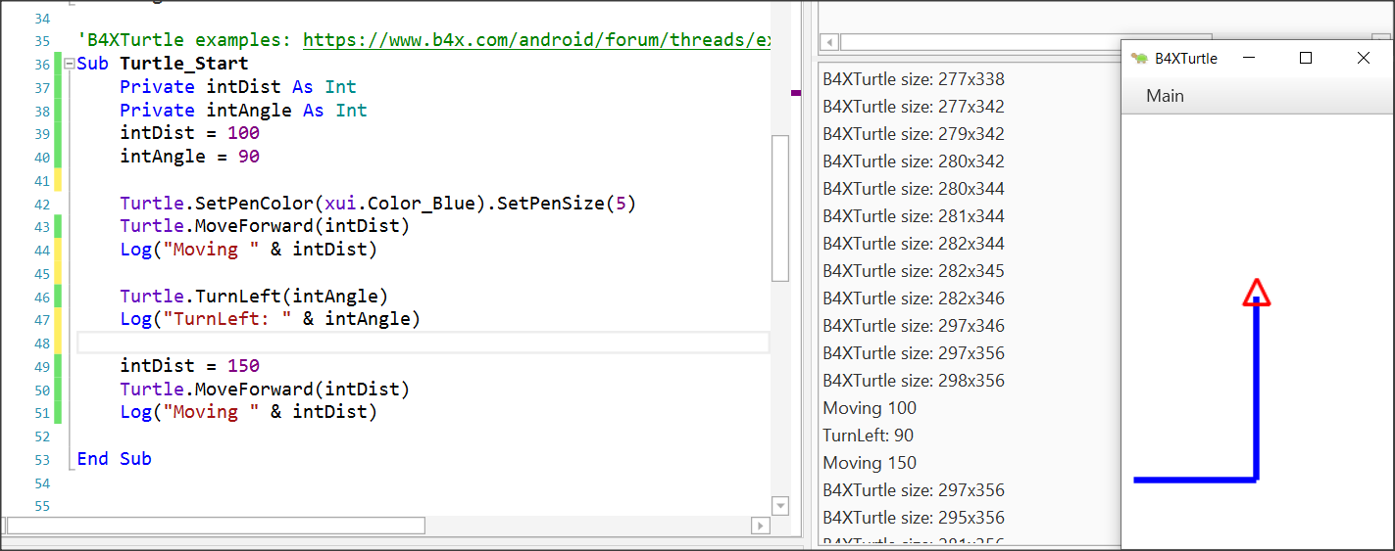

Figure 3 Using log function

## Mathematical Operators

B4X supports all known mathematical operations:

|  |  |  |
| --- | --- | --- |
| **Operator** | **Example** | **Operation** |
| + | x + y | Addition |
| - | x - y | Subtraction |
| * | x * y | Multiplication |
| / | x / y | Division |
| Mod | x Mod y | Modulo |
| Power | Power(x,y) xy | Power of |

Examples:

Private intA, intB, intC, intS As Int

Private fltD, fltM As Float

intA = 40

intB = 20

intC = 30

intS = intA + intB + intC

Log(intS) ‘Shows 90

fltD = intS / 3

Log(fltD) ‘Shows 30

intA = intAa + 1 ‘Increase intA by 1

Log(intA) ‘Shows 41

intS = Power(intA – 11, 2) ‘ 302

Log(intS) ‘Shows 900

fltM = intA mod 2 ‘41 modulo 2

Log(fltM) ‘Shows 1

## Strings

In computer programming, a string is traditionally a sequence of characters, either as a literal constant or as variable. The latter may allow its elements to be mutated and the length changed, or it may be fixed (after creation) (Wikipedia, Wikipedia - Strings, 2021).

A string is declared like the other variables using the String statement.

Private strName as String

Assigning value to a string can be done with the = symbol or by reading a value from the user (something we'll see later).

Private strName, strSurName as String

strName = “George”

strSurName = “Smith”

Also we can string together using the character &.

Private strName, strSurName as String

strName = “George”

strSurName = “Smith”

Private strPerson as String

strPerson = strName & “ “ & strSurName

log(strPerson) ‘ shows George Smith in log screen

Private strName2 as String

strName2 = “John”

strName2 = strName2 & “ Smith”

The are also a lot of functions regarding strings that makes our life easier when we are dealing with them:

|  |  |
| --- | --- |
| **CharAt**(Index) | Returns the character at the given index. |
| **CompareTo**(Other) | Lexicographically compares the string with the Other string. |
| **Contains**(SearchFor) | Tests whether the string contains the given SearchFor string. |
| **EndsWith**(Suffix) | Returns True if the string ends with the given Suffix substring. |
| **EqualsIgnoreCase**(Other) | Returns True if both strings are equal ignoring their case. |
| **Length** | Returns the length, number of characters, of the string. |
| **Replace**(Target, Replacement) | Returns a new string resulting from the replacement of all the occurrences of Target with Replacement. |
| **StartsWith**(Prefix) | Returns True if this string starts with the given Prefix. |
| **ToLowerCase** | Returns a new string which is the result of lower casing this string. |
| **ToUpperCase** | Returns a new string which is the result of upper casing this string. |
| **Trim** | Returns a copy of the original string without any leading or trailing white spaces. |

Table 2 String Functions (https://www.b4x.com/android/documentation.html)

**Teachers tip**

You can find more information about string manipulation in language booklets at (<https://www.b4x.com/android/documentation.html>)



## Exercises

1. In the following exercises, identify the variables you need to declare. For each of them, write the relevant statement and give it an appropriate name.
   * Calculate the volume of a cylinder with a radius of one metre and a height of two metres.
   * Make a program that accepts a positive integer and calculates its square, cube, and square root.
   * Make a program that reads a sum of money in € and calculates and displays the corresponding amount in $.
   * Write a program that reads the length of the sides of a rectangle from the keyboard and calculates and displays its area.
   * The total resistance R of two resistances R1 and R2 connected in series is R1 + R2 and parallel (R1*R2)/(R1+R2) respectively. Male a program that it reads two values of resistant R1 and R2 and calculates the total resistance in series and parallel.
2. In the following variable names, select which are correct and which are not:

intAge

|  |  |  |
| --- | --- | --- |
| **Name** | **True** | **False** |
| int Age | □ | □ |
| _fltAmount | □ | □ |
| strName | □ | □ |
| 1myAge | □ | □ |
| int_value | □ | □ |

1. It's the end of the semester and you got your grades from three classes: Geometry, Algebra, and Physics. Create a program that: gives in 3 variables the grades of these 3 classes (Grades range from 0 - 10) Calculate the average of your grades.
2. You have bought a Bitcoin and now it's on the rise!!! Create a program that:

* Assign the value of the bitcoin at the time of purchase.
* Assign the percentage of increase (or decrease)
* Logs the total value of your bitcoin.
* Logs the increase or decrease value.

1. You now own some property, and you want to calculate the total area of the property. Create a program that:
   * Assign the width and height in two variables.
   * Calculate and log the area.
2. You are interested in buying a new laptop. You check the price and you see that the price is 300$ without the 10% tax. Create a program that:
   * Assign the the price of the laptop in a variable.
   * Assign the tax percentage in a second variable.
   * Calculate and logs the total amount.
3. In a company the monthly salary of an employee is calculated by the minimum wage 400$ per month, plus 20$ multiplied by the number of years employed, plus 30$ for each child they have. Create a program that:
   * Assign the number of years employed in a variable
   * Assign the number of children the employee has in second variable.
   * Calculate and logs the total amount of salary the employee makes.
4. Create a program that log the last digit of a given integer.
5. Create two variables a and b, and initially set them each to a different number. Write a program that swaps both values.

Example: a = 10, b = 20

Output: a = 20, b = 10

1. Create two variables ‘a’ and ‘b’, and initially set them each to a different number. Write a program that double the Value of ‘a’ variable and increase the value of ‘b’ by 1.

Example: a = 10, b = 20

Output: a = 20, b = 21

# Lesson 5 – Designer

**2h**

* Talking about Designer
* Design the first Screen.
* Inserting and customizing Views: Labels, TextFields, Buttons, Panes
* Saving forms
* Design their own Main Screen using wireframes.

What students should know

Until now you have used the turtle to move it through the screen, and the log command to display information on the language log screen. What if you ask the program user to enter values? Or what happens when you want to display information to the user? The B4X has a special interface screen design environment. Through it you can design the appearance of the screens and generally communicate with the users of your application.

Every time you must design an app you should keep in mind that the look of your app is what will attract users to it. In other words, it is not enough to be simple functional but also easy to use as well as to offer information in an organized way without confusing.

Before designing any app remember some key design elements (usabilty.org, 2021):

**Keep the interface simple**. The best interfaces are almost invisible to the user. They avoid unnecessary elements and are clear in the language they use on labels and in messaging.

**Create consistency and use common UI elements**. By using common elements in your UI, users feel more comfortable and can get things done more quickly.

**Strategically use color and texture**. You can direct attention toward or redirect attention away from items using color, light, contrast, and texture to your advantage.

**Use typography to create hierarchy and clarity**. Carefully consider how you use typeface. Different sizes, fonts, and arrangement of the text to help increase scanability, legibility and readability.

**Make sure that the system communicates what’s happening**. Always inform your users of location, actions, changes in state, or errors.

**Think about the defaults.** By carefully thinking about and anticipating the goals people bring to your site, you can create defaults that reduce the burden on the user. This becomes particularly important when it comes to form design where you might have an opportunity to have some fields pre-chosen or filled out.

## First steps with design

First of all, you should begin the B4J and now from file menu choose **New** and **B4XPages.** Choose a directory and write a name for your project. You will see the code bellow. There are two tabs of code here, the first one called **Main** and the second **B4XMainPage**.

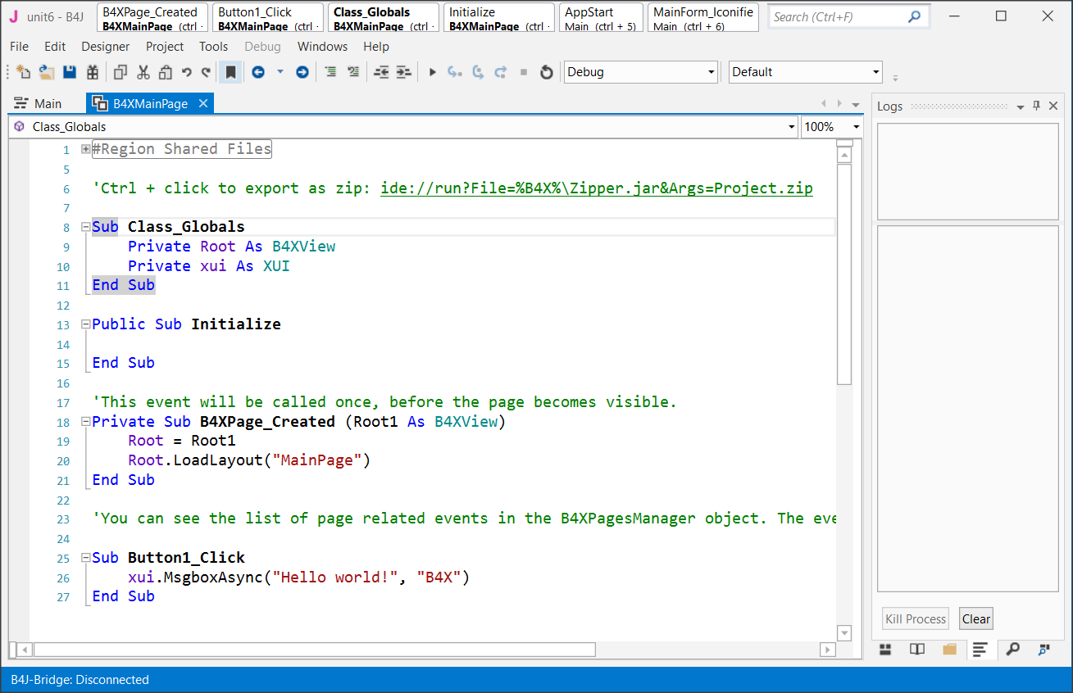

Do not worry about them now. We will discus later about them. Now all you need to know is that inside the B4XMainPage all the beautiful things happen for our code!

Now from the **Designer menu** select **Open Internal Designer.**

This is where the design process begins. Two windows will open, the first is the designer and the second is the preview of the screen you are designing.

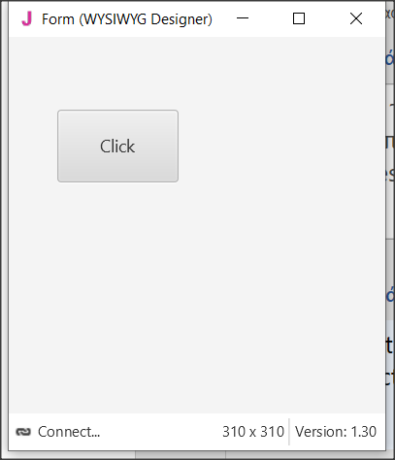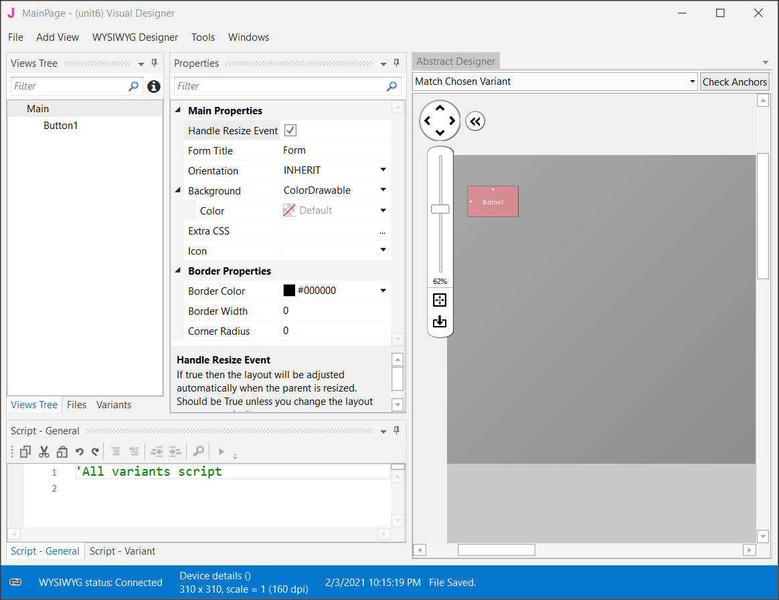

Figure Designer Screen

## Visual designer

The AddView menu includes all the objects needed to create our screen.

Select a label from the menu, and then move it to the preview screen where you decided before in the wireframe stage.

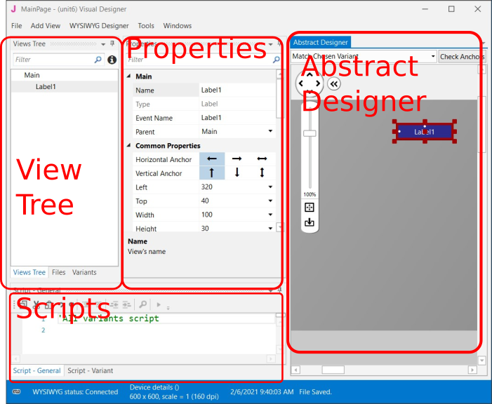

Figure Designer's parts

**Remember**

You can move all objects around the view by selecting them and holding the left mouse key.



### The Views Tree

Here you see all the objects in your design. Keep in mind that the objects above the list are placed behind the next ones.

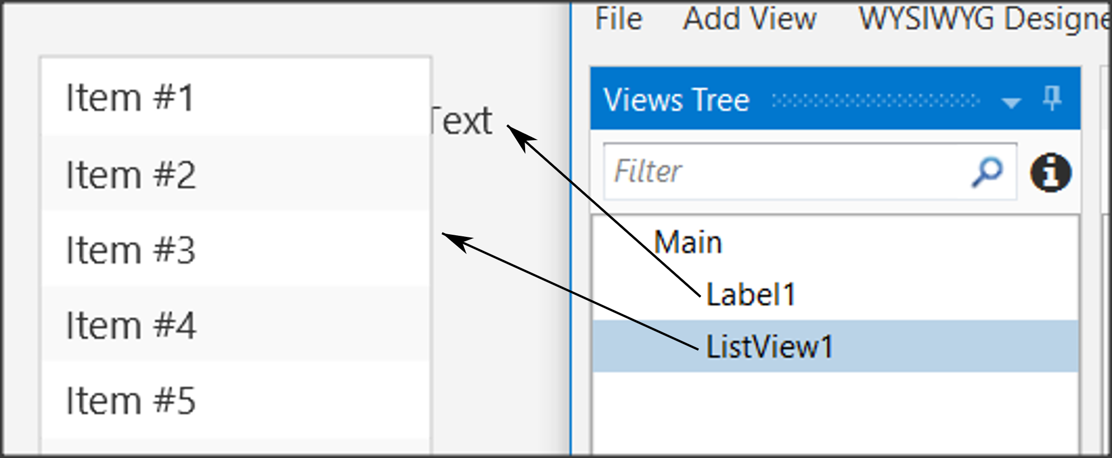

Figure Views Tree

### Properties

Each object has properties such as size, screen position, colors, font, etc. Each property can be changed either through the properties option or later through the program code.

One of the most important properties is the name of the object. This, like variables, should follow specific rules to indicate their type. For example in *Table 3* Naming objectssome cases of names.

|  |  |  |
| --- | --- | --- |
| **Type** | **Prefix** | **Example** |
| Label | lbl | lblName |
| Button | btn | btnSave |
| TextField | txt | txtAge |
| Spinner | spn | spnYears |
| Pane | pn | pnLine1 |
|  |  |  |

Table Naming objects

### Abstract Designer

The Abstract Designer allows to select position and resize Views. It is a very useful function for quickly placing objects in the correct position (however the most accurate placement is made by the Properties tab by setting the relevant values).

## Περιβάλλον εργασίας χρήστη/Εμπειρία χρήστη περίγραμμαExample 1

Imagine that you want to make a program that reads from the screen two Integers, calculates, and shows the sum.

### Decide on the size of the app screen.

This depends on the amount of information we must display as well as on the individual items such as menus, graphics etc.

To set the application’s size before beginning the Designer first go to **Main** Tab and change the first lines of code Width and Height:

#Region Project Attributes

#MainFormWidth: **600**

#MainFormHeight: **400**

#End Region

Save your project and open Designer.

### Set an appropriate variant.

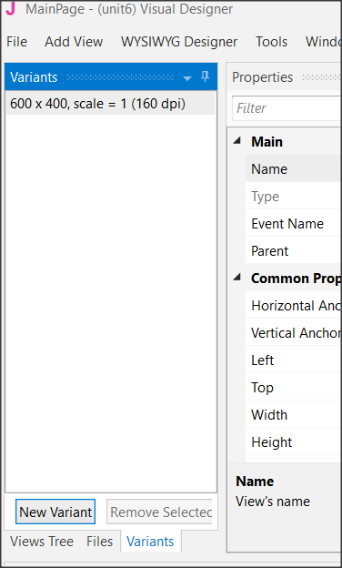

Figure Variants Screen

Usually, you should set the variant as the MainFormWidth and MainFormHeight. This will help you plan without the risk of going outside the screen limits.

Choose Variants and then New Variant and set the width and height.

You can have as many variants as you want for different screen size but for now, we stay to only one. Also, you can remove any variant by selecting it and choosing “Remove Variant”.

### Design a wireframe.

For small applications, this step is optional, but it is a good habit to have decided from the beginning where you want to display your details. You can use a simple sheet of paper or several programs to help create previews.

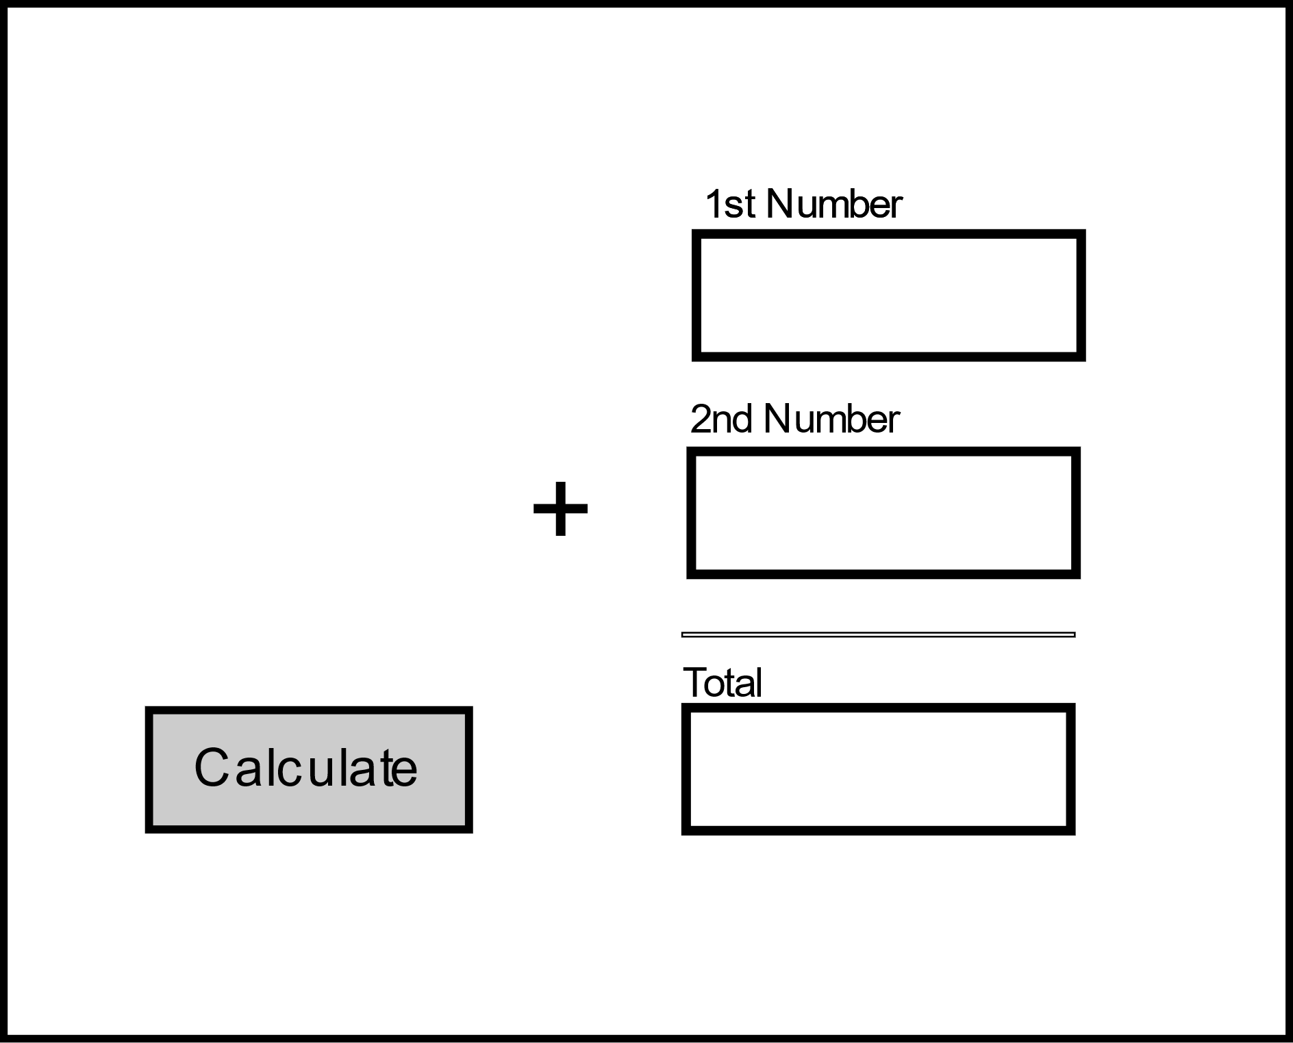

Label

Text Box

Button

Figure 8 Wireframe

### Create the views.

Now that you know what you need and where to place it, use the Designer tools to complete the process.

#### Inserting a label.

From View menu select label and you will see a label object in your View Tree and in the Abstract Designer. Move it in the place you decide in wireframing and choose an appropriate name from properties.

Now scroll down the Properties and set:

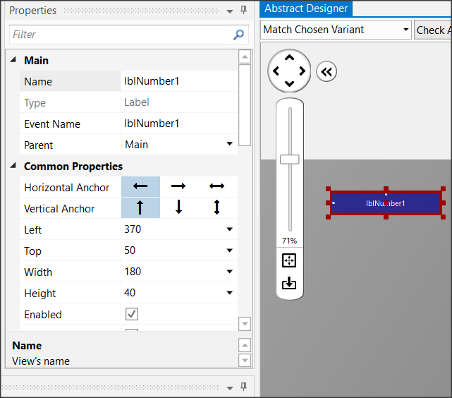

Figure Labels

* **Width**: 180
* **Height**: 30
* **Text**: First Number
* **Allignment**: CENTER_LEFT
* **Font**: SansSerif
* **Size**: 13

Experiment with the other settings and see it displayed in the preview pane.

Insert a second label or you can also dublicate the first one. Select it and press Ctrl-D. The second method gives a same label as the first one with the same properties except Name Property. Set “lblNumber2” as name and “Second Number” as Text and Create a third label with name “lblTotal” and Text: “Total”.

#### Inserting a Text Field.

Text Fields are used to import data into the program. There is no restriction on the type of data you can import. From View Menu choose TextField and set:

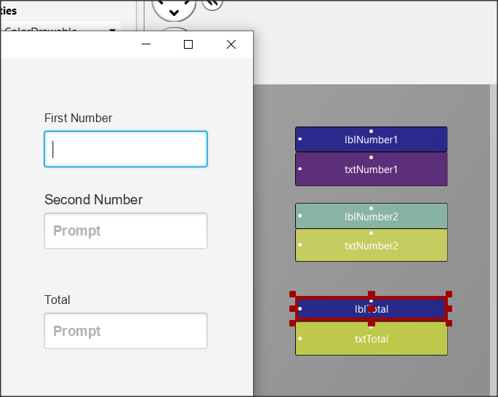

Figure Text Fields

* **Name**: txtNumber1
* **Width**: 180
* **Height**: 40
* **Font**: SansSerif
* **Bold**: checked

Place the textField underneath “First Number” label. Now put a same TextFIeld with name “txtNumber2” and put it underneath label “Second Number”. At the end create a third TextField with Name “txtTotal”. You will probably see something like the Figure 10 Text Fields

#### Inserting a button

Buttons in an app are used to enable functions. The program detects the click and then executes appropriate commands depending on the button pressed.

For each button you can set different features such as size, color, shape, etc. to stand out on your screen and be easily detected by users of your app.

From the Views menu select Button, and then set:

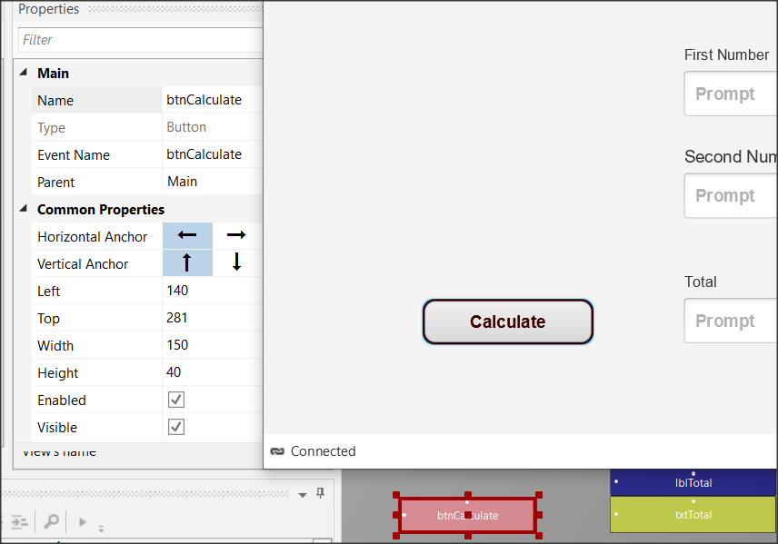

Figure Buttons

* **Name**: btnCalculate
* **Width**: 150
* **Height**: 40
* **Border Color:** #3C0000
* **Border Width**: 2
* **Corner Radius:** 20
* **Text:** Calculate
* **Text Color:** #FF3C0000
* **Font**: SansSerif
* **Size**: 15
* **Bold**: checked

**Remember**

**File -> Save** (or Ctrl – S) every time you make something valuable!



#### Inserting a Pane

You can use a Pane to visually group specific objects on the screen you're drawing. The pane displays a frame, and you can specify properties such as color, border, fill, etc. You can also use it at a very small height (1 or 2) to display a single line on your screen.

This example is used to draw a line before the total. From menu AddView insert Pane and set:

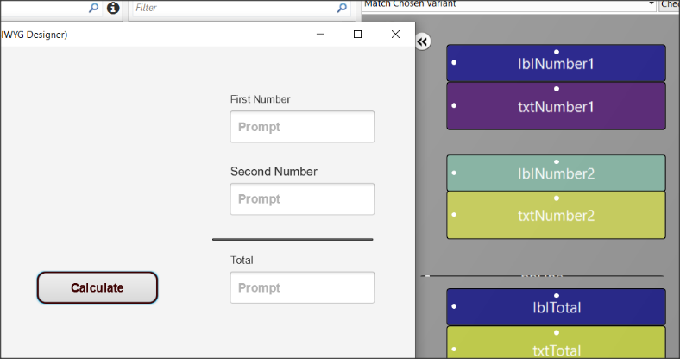

Figure Pane

* **Name**: pnLine
* **Width**: 180
* **Height**: 1
* **Border Color:** #000000
* **Border Width**: 2

Now from menu File save the form. The form has already a name (MainPage) so you don’t need to give an other name.

## Excercises

1. Use the designer to create the following wireframes.

**Teachers tip**

This is the fun part. You can also leave students free to experiment with views.



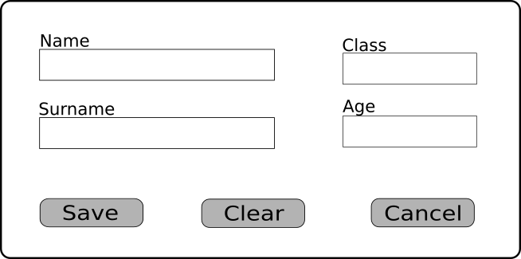

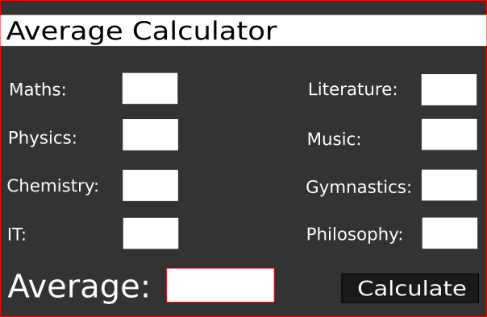

1. Think and design your own Dream Application. Give it a name, create a wireframe in your notebook and create the Design View.

# Lesson 6 – From Designer to Code

* Class_Globals
* Variables and Subs
* Passing Values to Code
* Events
* Attributes

What students should know

**2h**

Designing the app's appearance in Designer is the first step in the manufacturing stages. Often new developers turn to it to redesign, correct, or add individual information.

When the screen is ready the developer goes to the next stage of programming the functions. That is, everything that elements included in the design to gain functionality. In other words, text boxes can record data, buttons can activate functions, lists can display data, etc.

## Class_Globals

At the beginning of the code on tab B4XMainPage there is a set of variable declarations between Sub Class_Globals and End Sub.

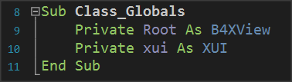As it has already been said in 3rd Lesson Sub is a set of code that performs a specific operation. The operation of the Class_Globals is to collect the declarations of variables that we want to be known throughout the code of the tab B4XMainPage, i.e. in each subprogram.

Picture Sub Class_Globals

In addition, if a variable statement starts with the public it will be available from other program "tabs".

## A deeper look at the use of variables.

In the following code you see three subprograms

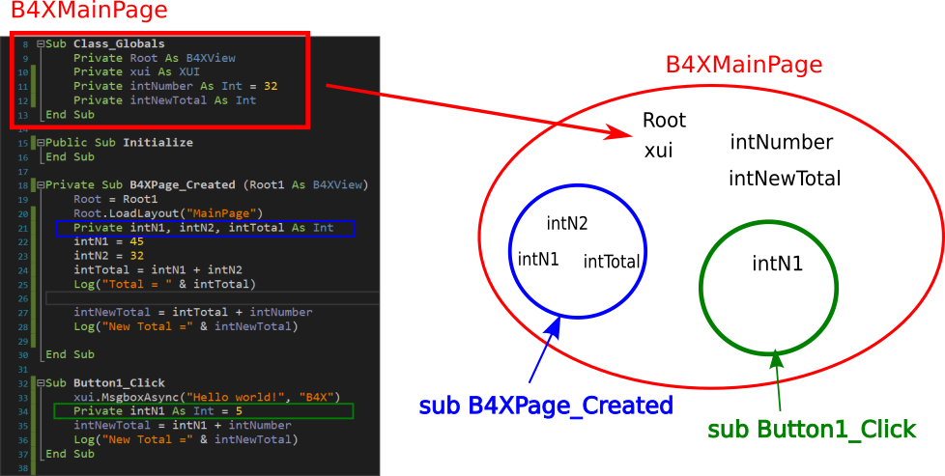

Picture Variables and Range

The intNumber, intNewTotal, Root, and xui variables declared within Class_Globals "live" within Module B4 XMainPage.

On the contrary, variables intN1, intN2, intTotal 'live' within the sub-program B4XPage_Created and for this reason No another subprogram may use them. At the same time, the variable **intN1** who lives in the **Button1_Click** **is not the same** with the one in **B4XPage_Created**, both has its own memory space, and both can have the same name.

**Teachers tip**

The use and range of variables is something that confuses new developers. Depending on your class, it is recommended to make examples of familiarity in their use.



## Passing Values to Code

The screen you have already prepared contains objects that you must declare as variables in Class _ Globals to use in the program.

In the example, in the previous lesson, some of the objects on the screen do not have to be included in the code.

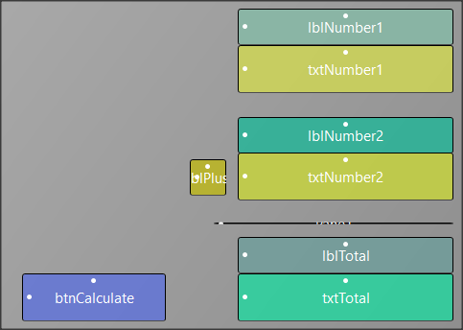

Picture Example 1 Designer View

So, all "labels" items in this application do not have to be managed by code as well as the pane element. While button and textFields must be added to schedule functions on them.

There are two ways to insert your objects into the code. The first is easily done through the designer with the following functions:

From the Tools menu select Generate Members

In Screen Generate Members just click on objects

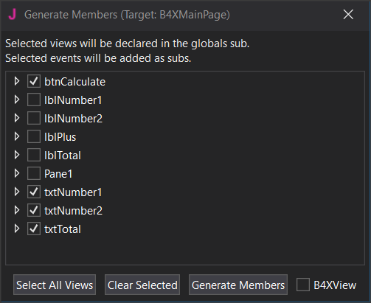

Picture 5 Generate Members

* btnCalculate
* txtNumber1
* txtNumber2
* txtTotal

and then click Generate Members.

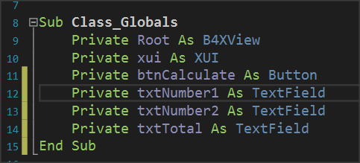

Picture 6 Class_Globals

Your code in the Class_Globals subprogram will be updated automatically with the variables.

**Remember**

Each object we import is of a certain type as well as the types of variables.



The second input solution is to write the variables yourself, paying attention so that the names of the objects on your screen are the same as those you write as a variable.

## Events

After you have declared the variables of the objects, the final stage is to enable the functions of the form.

This depends on how you've decided that each app works. In the example with the two numbers there is a button called Calculate and it is what will activate the addition as well as the appearance of the result on our screen.

The operation is triggered by a process called "**Event**. The programmer must detect the event of pressing the key Calculate and when this is done then do the relevant calculations and display the result.

**Remember**

There are hundreds of different events happening in one application; the developer determines how the program will react to each of them.



The detection of the event is easy and you just need to create a new subprogram that has the name of the event. This can be done at the same time as the declaration of the variables of our objects through the Designer.

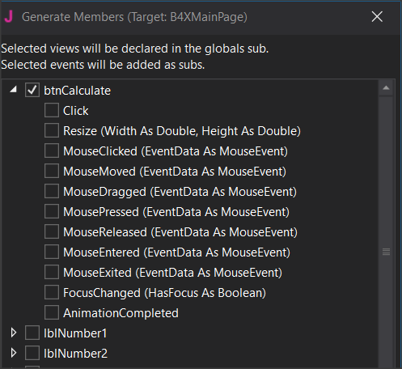

Picture 7 Setting Event

Open its list btnCalculate and several Events we’ll be available to choose. Just click on "Click” and "Generate Members”.

The subprogram for the **btnCalculate_**Click event has **already appeared.** Within it you will write the program code to complete.

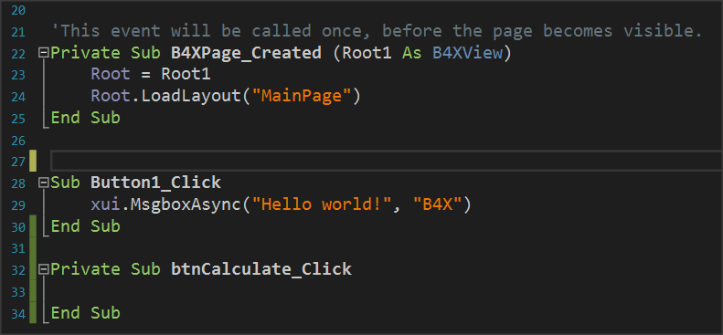

Picture 8 The Click Event

## Writing code in Event

Within an Event subprogram, all the functions associated with it are usually performed.

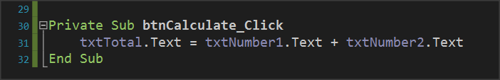

Picture 9 Calculating textFields

Essentially both are achieved with a single command. This is the command of Picture 9 Calculating textFields follows:

*The content of textField txtTotal* is equal to the contents of *txtNumer1* and *txtNumber2.*

### Properties

Each object you insert into your code has a number of different properties. For example properties can be the color, size, location content as they have been Described and in the previous lesson. These properties can provide information or change display issues. For example, the property txtNumber1.text provides information on the content of the object txtNumber1 or can set a value as content depending on how you use the. This information is type string.

**Remember**

You can do operations with string contents when they describe numbers.



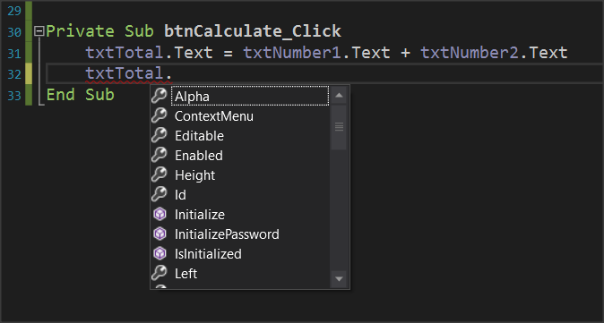

Picture 10 Object Properties

Let us now assume that we want to create a new function in the example where another key clears the form to write new numbers. The functions you will perform are as follows:

* Open Designer and add a new button named e.g. btnClear.
* Set it as a variable in Class_Global.
* Enter the event btnClear_Click.
* Set the text properties of txtNumber1, txtNumber2, txtTotal to "".

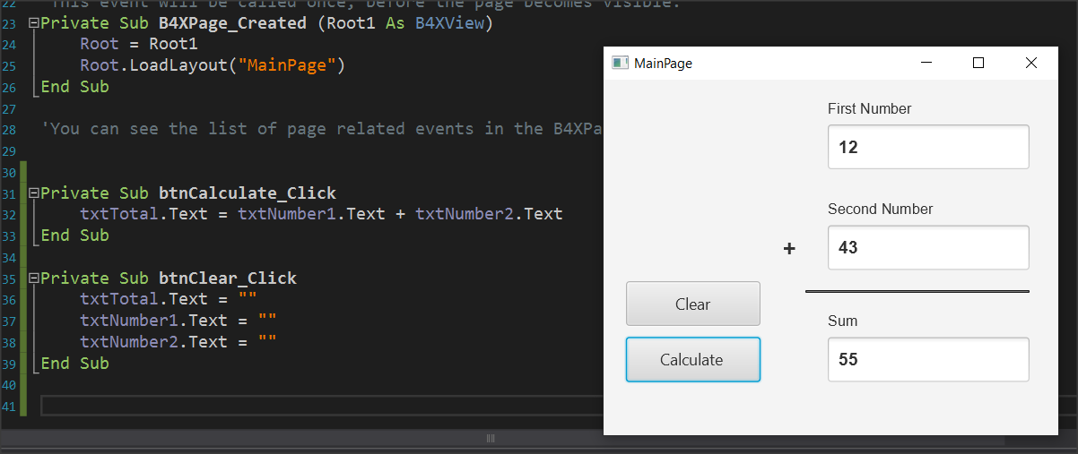

Picture 11 Clear Button and Code

When you press clear, the form will clear.

## Exercises

1. Extend the example to perform the four operations: Add, subtract, multiply, and divide at the click of an appropriate button. Add the appropriate objects to the designer and then complete the code.

2. In exercise 2 of the previous course continue and complete the application by activating its functions.

Take care that the numbers in lessons must be between 0-100. If not, you should show an error message.

# Lesson 7 – Conditional Statements

* Boolean Variables
* Relational Operators
* Logical Operators
* If Statement
* If-Else Statement
* If-Else-Else If Statement
* MAX Algorithms

What students should know

**4h**

## Logical Variables

So far, we have seen three types of variables integer, real, and string. As a type it is extremely simple because it can accept only two different values: True – False which in fact internally on the computer are translated into states 1 and 0 (leaked by current or not).

The statement of a logic (from now on we will call it Boolean) becomes like the other simple variables we have known:

**Private** intDistance = 100, intTotalTravel = 0 As **Int**

**Private** blnFlag  **As**  **Boolean** = False

**Private** blnDone As **Boolean**

## Comparative Operators

Comparative operators are used to make comparisons between values in the programming languages. They are the known mathematical symbols of inequalities only that on the computer are written in a slightly different way.

|  |  |  |
| --- | --- | --- |
| **Mathematical Symbol** | **B4X** | **Meaning** |
| = | = | Equality |
| ≤ | <= | Smaller or Equal |
| ≥ | >= | Greater or Equal |
| ≠ | <> | Different |
| < | < | Smaller |
| > | > | Larger |

Generally, to make a comparison you must compare variables or values of the same type. Eg. Integer values with integer values, real with real prices, etc. Also, in B4X you can compare numeric variables, such as integer variable and float, or Strings (strings) and numeric variables because internally the language converts strings into numbers.

**Remember**

The result of a comparison is always a logical value of True or False.



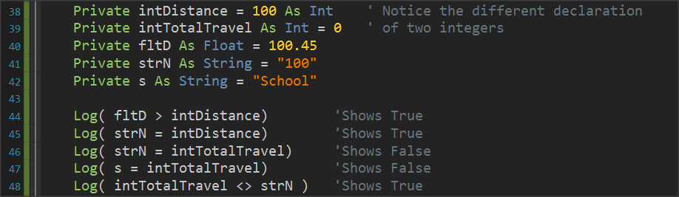

Picture 12 Variable Comparisons

## Logical Operators

Consider a sentence such as 'I am going to school now'.

Mathematician George Boole developed an algebra based on logical sentences.

In Mathematics and Mathematical Logic, Boolean Algebra is the algebra where the values of the variables are the true and false, usually represented by 1 and 0 respectively. Unlike elementary algebra where the values of variables are numbers and the main acts are addition and multiplication, in Boolean there are three main acts **And**, **OR** and Denial **No**.

**Remember**

**AND** (conjunction), denoted x AND y, satisfies x AND y = 1 if x = y = 1, and xANDy = 0 otherwise.

**OR** (disjunction), denoted x OR y, satisfies x OR y = 0 if x = y = 0, and x OR y = 1 otherwise.

**NOT** (negation), denoted NOT x, satisfies Not x = 0 if x = 1 and Not x = 1 if x = 0.



Example:

**1st Sentence**: Today it rains, **2nd Sentence**: *I am going to school*.

|  |  |  |  |  |
| --- | --- | --- | --- | --- |
| **Today it's raining.**  **(P1)** | ***I am going to school.***  **(P2)** | **P1 AND P2** | **P1 or P2** | **NO P1** |
| True | True | True | True | False |
| True | False | False | True | False |
| False | True | False | True | True |
| False | False | False | False | True |

From the table we observe that

* Two sentences that unite with the logical **AND** aretrue when it unites two truths only.
* Two sentences that are united by logical **OR** aretrue when even one sentence is true.
* The **logical** NO reverses the truth or lie of a sentence.

### Logical operators in programming

Logical operators are used in programming to create complex comparative expressions. This helps the developer optimize their code with fewer lines and simpler code.

In B4X logical variables are used as below.

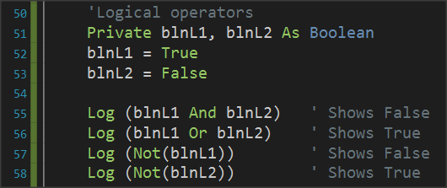

Picture 13 Use of Logical Acts

Notice that logical operations must link logical variables or logical expressions as we will see later.

### Examples of evaluation of logical sentences.

The following variables are given with their values:

**Private** intA = 10, intB = 20, = 30 **As** **int**

**Private** strName1 = “George”, strName2 = “Georgia”  **As**  **String**

**Private** blnA = True, blnB = False blnC = False **As** **Boolean**

Calculate the value of the following logical expressions.

1.

|  |  |  |
| --- | --- | --- |
| blnA | **AND** | blnB |
| True |  | False |
|  | **False** |  |
|  |  |  |

2.

|  |  |  |  |  |  |
| --- | --- | --- | --- | --- | --- |
| Inta | **>** | intC | **AND** | blnA |  |
| 10 |  | 30 |  | True |  |
|  | False |  |  |  |  |
|  |  |  | **False** |  |  |

3.

|  |  |  |  |  |  |  |
| --- | --- | --- | --- | --- | --- | --- |
| intA + intB | **>=** | intC | **AND** | (blnA | **OR** | blnB) |
| 10 + 20 |  | 30 |  | True |  | False |
|  | True |  |  |  | True |  |
|  |  |  | **True** |  |  |  |

4.

|  |  |  |  |  |  |  |
| --- | --- | --- | --- | --- | --- | --- |
| intA + intB | **>=** | intC | **OR** | (blnA | **AND** | blnB) |
| 10 + 20 |  | 30 |  | True |  | False |
|  | True |  |  |  | False |  |
|  |  |  | **True** |  |  |  |

5.

|  |  |  |  |  |  |  |
| --- | --- | --- | --- | --- | --- | --- |
| strName1 | **=** | “George” | **OR** | strName2 | **=** | “John” |
| George |  | George |  | Georgia |  | John |
|  | True |  |  |  | False |  |
|  |  |  | **True** |  |  |  |

## If command

Often as in life we ask questions so in programming there is a need for the developer to ask questions to check values or change the continuity of the program in different directions.

The **if command** is used to make the corresponding questions:

Its basic form is as follows:

**If** ( condition ) **Then**

Commands

**End If**

Where condition enter a comparative or logical expression studied above.

The meaning is: If condition is **TRUE** execute the commands between Then and End If

Examples:

**Private** intA = 10, intB = 20 **As Int**

**Private** fltA **As Float**

**If** intA > 0 **Then**

**Log**(intA & " is positive Number")

**End If**

**If** intA > 10 **Or** intB > 10  **Then**

**Log**("One or both numbers are greater than 10")

**End If**

**If** intA **Mod** 2 = 0 **Then**

**Log**(intA & " is Even number")

**End If**

## If – Else

The Else command adds the ability to **if** to execute code if its condition is not true.

Its basic form is as follows:

**If** ( condition ) **Then**

Commands

**Else**

Commands

**End If**

The meaning is: If condition is **TRUE** execute the commands between Then and Else otherwise Execute the commands between Else and End If.

Examples:

**Private** intA = 10, intB = 20 **As**  **Int**

**Private** fltA **As Float**

**If** intA > 0 **Then**

**Log**(intA & " is possitive Number")

**Else**

**Log**(intA & " is not possitive Number")

**End If**

**If** intA > 10 **Or** intB > 10 **Then**

**Log**("One or both numbers are greater than 10")

**Else**

**Log**("None of the two numbers are greater than 10")

**End If**

**If** intA **Mod** 2 = 0 **Then**

**Log**(intA & " is Even number")

**Else**

**Log**(intA & " is Odd number")

**End If**

## If – else - else if

Multiple **if** further extends the functionality of an **if** command by adding more than 1 control to the structure.

How to write:

**If** ( condition1 ) **Then**

Commands

**Else If** (condition2 )  **Then**

Commands

**Else If (** condition3 ) **Then**

Commands

**Else If (** condition4 ) **Then**

Commands

**...**

**Else**

Commands

**End If**

The function of the multiple if is summarized as follows:

1. The first condition runs, and if it is true, then the code it contains runs and if it is completed.
2. If the first **if** is false then the second is executed and if it is true it executes the code it contains and if it is completed.
3. Other checks are always performed when the previous ones are false.
4. If none of the checks are true then the **else** command is run which is optional.

Example 3

A fast-food chain has these meals:

|  |  |
| --- | --- |
| Meal | Price |
| Burger | 5$ |
| Pizza | 3$ |
| Hot Dog | 1,5$ |

Create a program that:

Reads the meal the customer wants. Prints the cost of the meal. Input example: "Hot Dog", Output: "Hot Dog 1,50$"

**Solution**

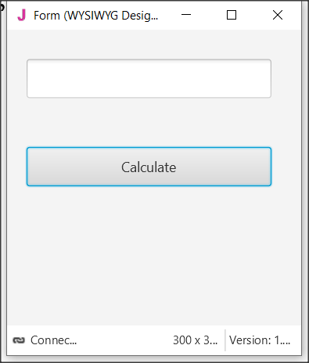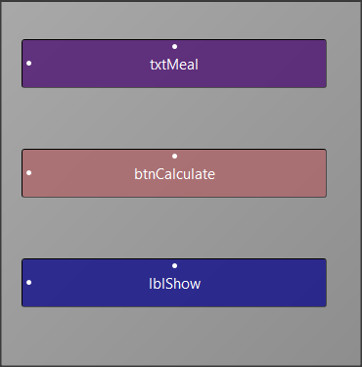

Picture The app screen

**Step 1**

Start a new project and give dimensions 300 x 300.

**Step 2**

In the designer design the app screen

**Step 3**

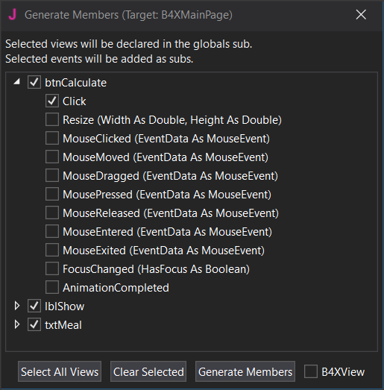Enter txtMetal , btnCalculate, lblShow , and btnCalculate_Click.

**Step 4**

The code you need to write is for btnCalculate_Click

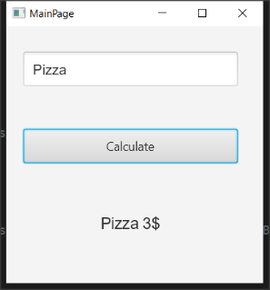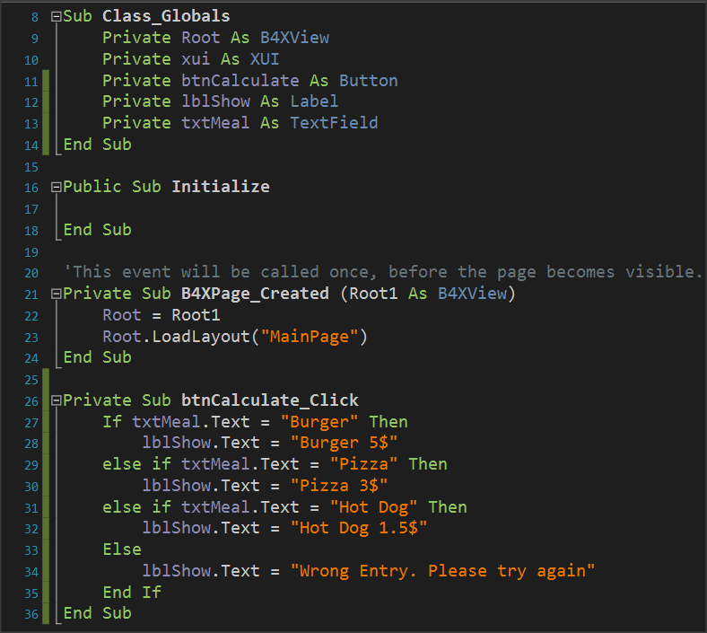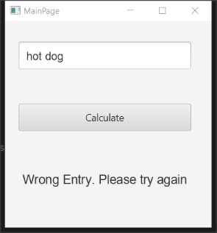

Note that the code considers capitals to be different from small letters. So he doesn't recognize the hot dog as a meal that should be written as a Hot Dog.

## Algorithms with if

Find Maximum Number

Read 3 integers and find the largest in three different ways

Method 3 – Max Algorithm

**Max = inta**

**If** intB > Max  **then**

MAX = intB

**End If**

**If** intC > Max  **then**

MAX = intC

**End If**

**Log(**Max**)**

Method 2 – Nested If

**If** Inta > intB **then**

**If** Inta > intC **then**

**Log**(Inta)

**End If**

**End If**

**If** IntB > IntA  **then**

**If** IntB > intC  **then**

**Log**(IntB)

**End If**

**End**

**If** IntC > IntA  **then**

**If** IntC > IntA  **then**

**Log**(IntC)

**End If**

**End If**

Method 1 – Simple If Statement

**If** Inta > intB  **AND** Inta > intC  **then**

**Log**(Inta)

**End If**

**If** intB > Inta  **AND** intB > intC  **then**

**Log**(intB)

**End If**

**If** intC > Inta  **AND** IntC > intB  **then**

**Log**(intC)

**End If**

## Exercises

1. Make the following suggestions in logical expressions.
   1. A belongs to space [-5, 6).
   2. a is less than 3 or more than 15.
   3. a is equal to b and c.
   4. a does not have a value of 3.
   5. A is less than 2 or b is greater than 78.
   6. a and b true and c false.
   7. the a true and one of the b, c true.

1. What is the logical result (true or false) of performing the following operations if the following variables have the values below?

A = 10, B = 2, C = -4, D = 9 and E = 1

* 1. (A>B) or (D=10)
  2. (D >= B) and (E <> C)
  3. no (E<=C) or (D<=C)
  4. no ((B<=C) and (D<2))
  5. no (no (B<=E) or not (C<=B))
  6. ((E<=A) and (E>=C)) and not (C>=A)
  7. no (no (A >= 2) and (C <>9))

1. A fast-food chain has these meals:

| **Meal** | **Price** |
| --- | --- |
| Burger | 5$ |
| Pizza | 3$ |
| Hot Dog | 1,5$ |

Create a program that:

Reads the meal the customer wants and second how many items of this meal needs.

Prints the cost of the meal.

Input example: "Hot Dog", 2

Output: " 2 x Hot Dog 3$"

1. You have consumed X amount of Mbps on Wikipedia and Y amount of Mbps on memes. The cost of visiting Wikipedia is 0,10$ per Mb and the cost for watching memes is 0,05$ per Mb. If total consumption is more than 100$ print "Too much consumption". If watching meme consumption is greater than reading Wikipedia consumption print "WOW MANY MEMES", "SUCH LOL"(in new line). Create a program that:
   1. Reads X (Wikipedia Mb consumption) and Y(watching meme Mb consumption)
   2. Calculates the total consumption.
   3. If total consumption greater than 100$ print proper message If watching meme consumption is greater than reading Wikipedia articles print proper messages
2. An internet cafe has 2 ways of charging. If the user is a member pays 2$/hour, Else the user pays 5$. Find if someone is a member or not and calculate the price based on how many hours the user spend. If the user is a member the tax is 10% else the tax is 20%. Create a program that:
   1. Reads how many hours the user spend
   2. Check if is a member.
   3. Add the proper tax fee.
   4. Print the total amount the user must pay Output: "The user is a member stayed 2 hours for 2$/hour plus the 10% the total amount is 4.4$"
3. You want to buy something from Amazon. The seller charges different prices for shipping cost based on location. For US it's 5$ for Europe it's 7$ for Canada it's 3$ for other places it's 9$. Create a program that:
   1. Reads the cost of the product.
   2. Reads your location.
   3. Print the amount of money you must pay.
   4. Output: "You have to pay 23$, 20$ for the product and 3$ for shipping cost".
4. A company sells a product for 0.70 € a piece if up to 200 pieces are ordered and for 0.50 € a piece if more than 200 pieces are ordered. Read the number of pieces ordered and calculate their value.
5. A cell phone company has the following billing policy.

|  | **Fixed cost 25$** |
| --- | --- |
| Call duration(in seconds) | Charge($/per second) |
| 1-500 | 0,01 |
| 501-800 | 0,008 |
| 801+ | 0,005 |

Create a program that:

* 1. Reads how many seconds was the calls duration.
  2. Calculates the monthly bill for the subscriber.
  3. Prints the total amount.
  4. Output: "total amount: 48$"
  5. Notice that that the charge for the first 500 seconds it's 0,01$ then for the next 501 to 800 seconds it's 0,008 and then it's 0,005$

1. In the qualifying races in the long jump at the Olympic Games, an athlete makes 3 initial attempts and if he has a performance of more than 7.50 meters, then he is entitled to continue and make another 3 more attempts. Read the first 3 attempts of an athlete and print a message whether he is entitled to continue or not and if he is entitled to find and print the best effort of the athlete.

**You can use method Visible = True or False to hide or show labels, textFields and Buttons.**

1. In a municipality there are parking spaces for a short period of time. Parking charges are staggered, as shown in the table below:

|  |  |
| --- | --- |
| **Parking time** | **Charge per hour** |
| Up to 1 hour 3.50 € | |
| The next 2 hours | 8.00 € |
| The next 2 hours | 12.00€ |
| Over 5 hours | 15.00 € |

Make a program that reads the duration someone left his car in parking and calculates the total cost.

# Lesson 8 – Subroutines

* What is a subroutine.
* Declaring a Sub
* Passing Values
* Returning Values from a sub

What students should know

**3h**

In computer programming, a subroutine is a sequence of program instructions that performs a specific task, packaged as a unit. This unit can then be used in programs wherever that task should be performed.

Subroutines may be defined within programs, or separately in libraries that can be used by many programs. In different programming languages, a subroutine may be called a routine, subprogram, function, method, or procedure. In general, to create a subprogram, the developer should keep the following in mind:

The subprogram should only do one task.

Be relatively small and ideally no larger than a screen so that it can be read easily.

Have such a name that refers to its function.

## Create a subprogram in B4J

You have Button1_Click already encountered subprogram in B4J that the language has prepared. Notice that events like Button1_Click are also a routine to serve the event.

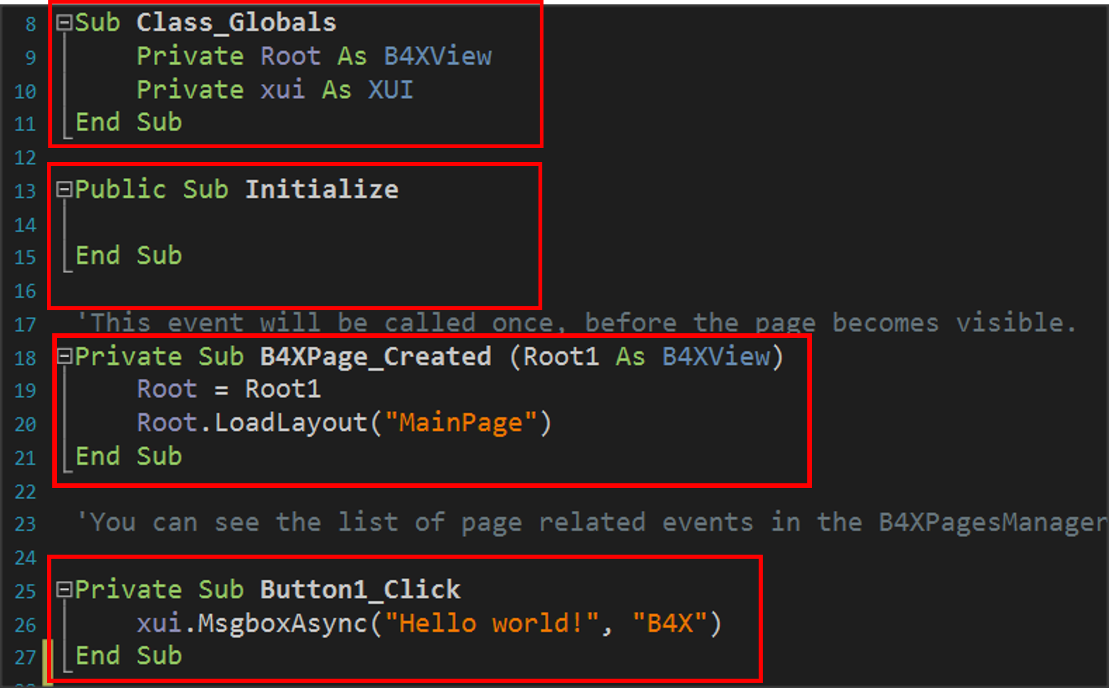

Picture Subprograms

### Example 1

Suppose a function needs to be performed, such as adding two numbers given by the user. As a program it is very simple and generally does not need a subprogram for such a function. Here we will use a subprogram to understand how it is used and operated.

The two integers intA and intB have been declared in the program, values have been assigned, and then the showSum1 routine is called.

This is done by writing the name of the routine (which the developer decides) and then in parentheses the variables whose values it must know to function.

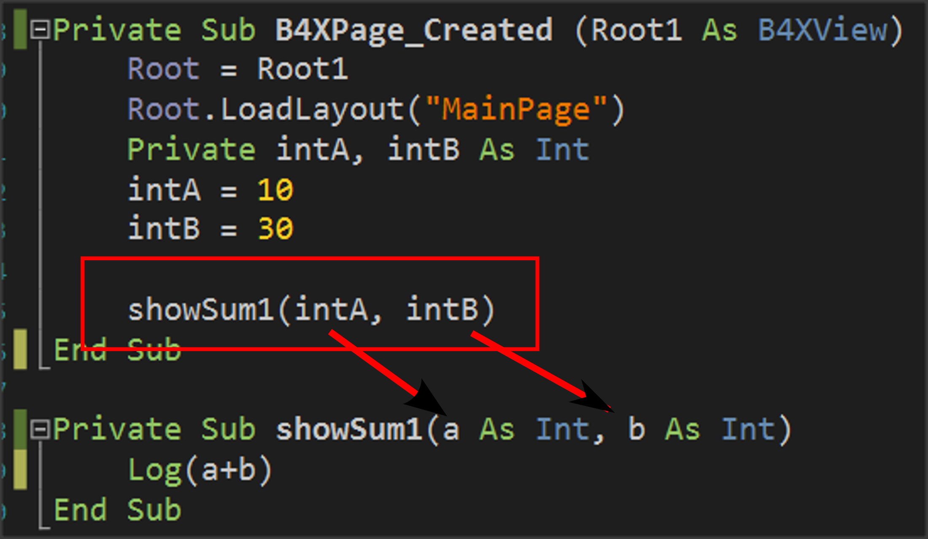

Picture Calling a subprogram

The subprogram is written before or after the current subprogram:

It always starts with the **Private** statement which means that it is a subprogram that will be known only in the code (B4XmainPage) or **Public** for the subprogram to be known in other parts of our application.

The Sub statement which means subroutine and

In parentheses, the names of the variables that will receive the data from the call point are indicated.

Notice in the image that this data enters in the order written when calling the routine, i.e. the value of the intA will enter in variable a and the value of the variable intB will enter in variable b.

**Remember**

Variables exchanged between subprograms during their call are called **parameters**.



The subprogram now works with data contained within parameters a and b not the intA and IntB.

## The memory of the subprogram in B4X

Each subprogram has its own memory space to store their variables. An exception to this rule is the **Class_Globals** subprogram, whose data is known to all B4XMainPage routines and can be reported to them by name.

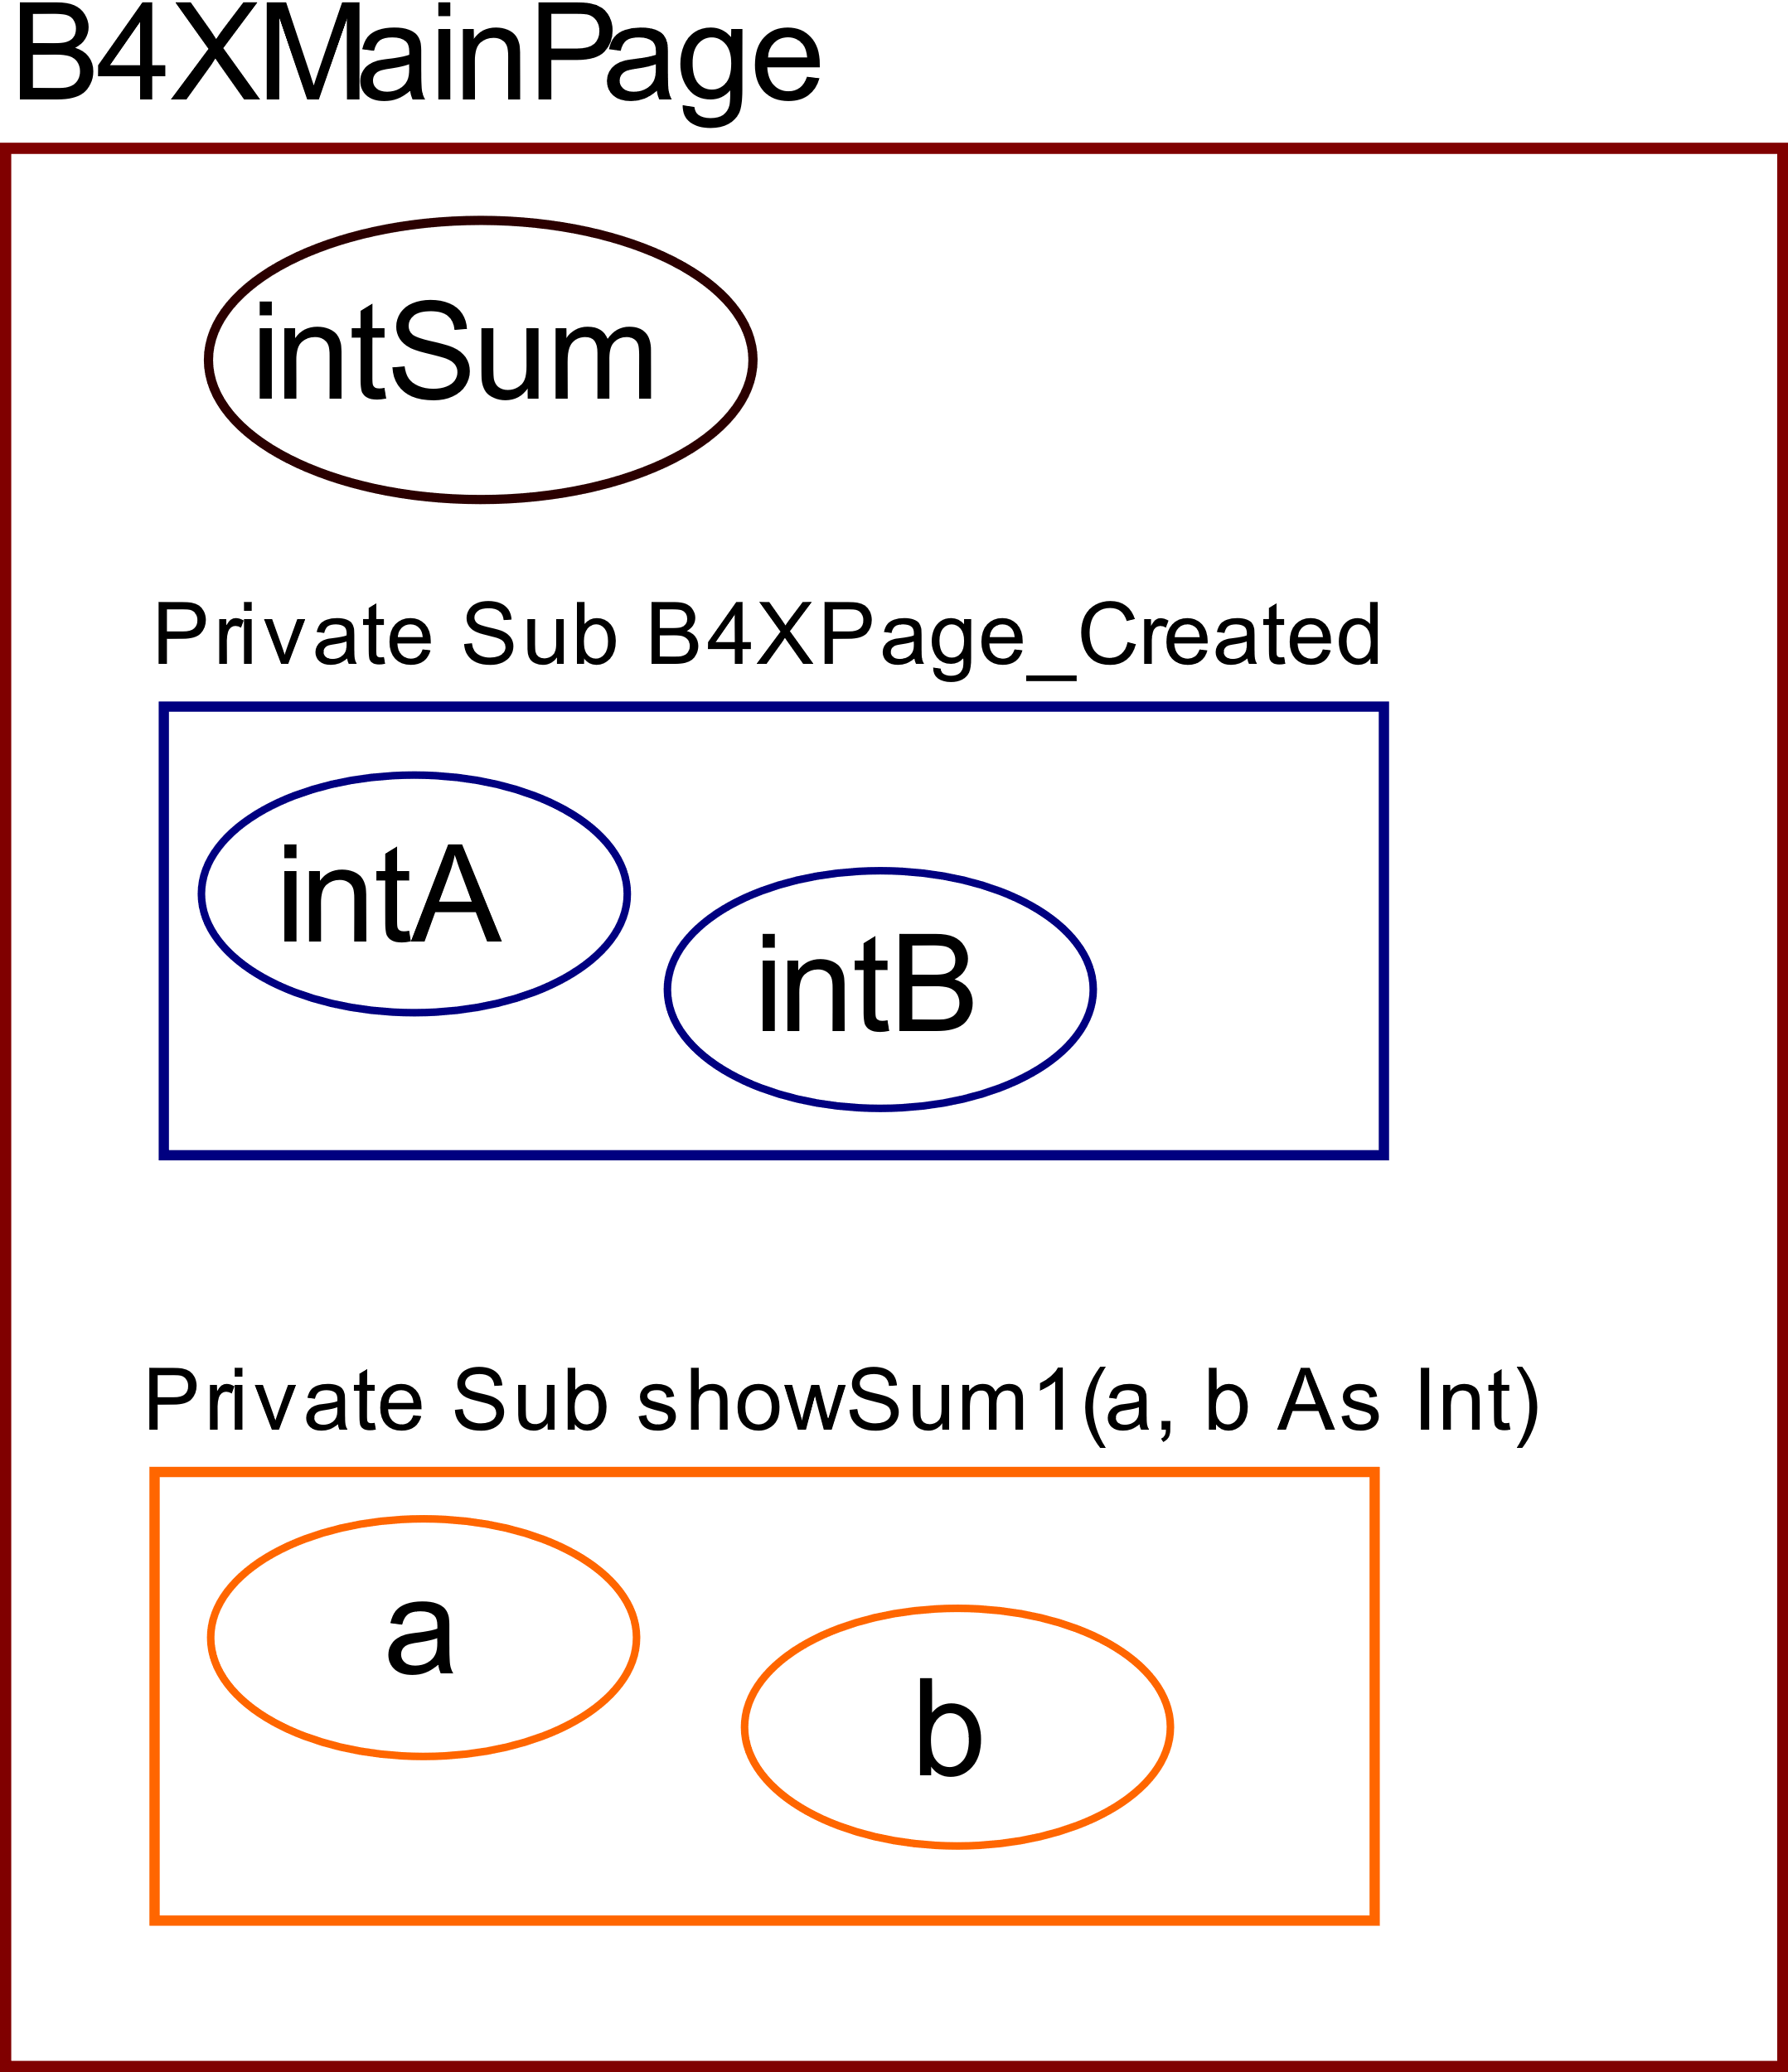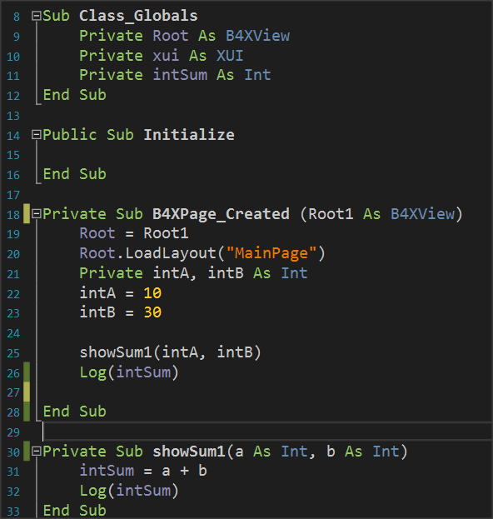

Picture The Memory

From the image code you can notice that the variable intSum is known in both subprograms and is used simply by writing its name. In B4X these variables are displayed in a different color so that the developer can Distinguish easily. On the contrary, variables declared within the remaining variables live only within them and another subprogramm cannot use them by name.

**Remember**

Variables declared within Class_Globals are known in all subprograms and are called **Global.**

The variables declared within the subprograms are called **local** and are not known in the rest program.



## Return a value from a subprogram.

A subprogram can return a value to the code that calls it. This is done through the subprogram name itself as follows:

The program must be declared as a variable type.

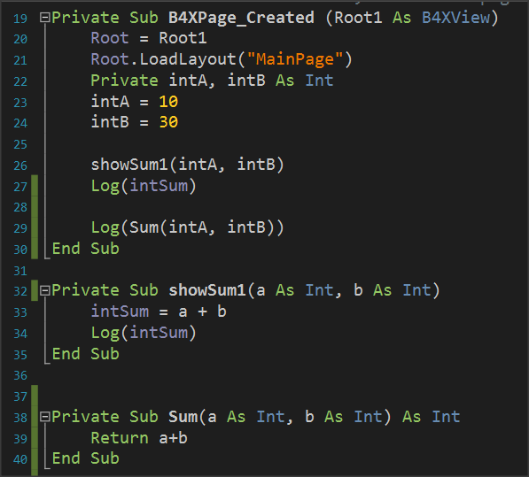

In addition, the return command must be used within the subprogram to return the calculated value.

Finally, the code that called the subprogram accepts back the value calculated and can use it like any variable.

Picture 18 Returning Values back to program.

**Remember**

Often routines that return values to the code that calls them **are** also called Functions.



## Example 2

Write a subprogram that accepts 3 integer variables and returns the largest value.

Three integer variables (Inta, intB, intC) are declared within subprogram B4XPage_Created.

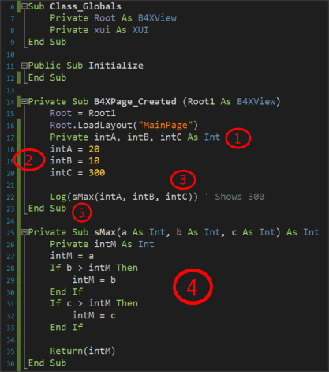

Picture Example 2

Values are assigned to the three variables.

The sMax subprogram is called with parameters the three variables.

The subprogram applies the MAX algorithm for the three variables a, b, c and returns the intM value calculated.

Finally, the highest value appears on the Log screen.

**Remember**

We love subprograms because:

* It is boring to always write the same code.
* It is faster than anyone can type.
* It is helping not to repeat the same mistakes. You have done it once!
* Cool programmers write subprograms.



## Exercises

**Teachers tip**

Encourage students to solve all exercises and discus the solution in class. Dedicate at least 1 hour to explain them.



1. Write a program that calculates the area of a circle. The user must enter the radius of a circle in an appropriate textField, and then using a subprogram to calculate and return the area.
2. Write a program that calculates the solution of the secondary equation ax2 + bx + c = 0.
   1. The user must enter the equation coefficients in appropriate TextFields.
   2. The result appears in one, or two textField depending on the value of the Discriminant.
   3. The Discriminant must be calculated with a subprogram that returns its value.
   4. It will not be permissible to calculate the Discriminant factor unless all the fields of factors a, b, c are filled in.

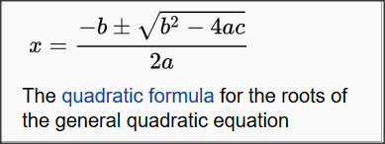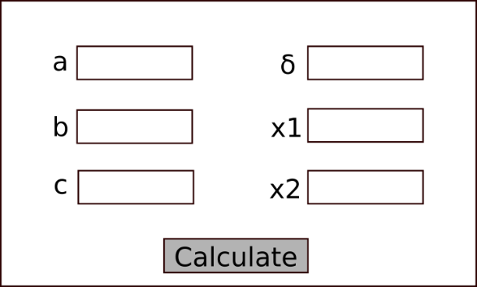Note to display the error message use **xui.MsgboxAsync("Message","Title")**

Picture Source: Wikipedia.org

Picture Wireframe

1. Make a program that uses the turtle and draws squares with a side given by the user. Create a subprogram that accepts the side and then draws the square starting from where the turtle is already located and moving clockwise.
2. One theatre has three categories of tickets, Arena, Gallery, Proscenium. Each ticket costs 20, 30, 40€. Make a program that:
   1. Reads the code 1, 2, 3 representing respectively the categories.
   2. Reads the number of seats he wants.
   3. Calculate the value of tickets with a subprogram that returns the amount, and which will be displayed in an appropriate textField

# Lesson 9 – Classes

* What is a Class?
* What is an Object?
* What are Attributes and Methods?
* Create and use simple class with B4J.

What students should know

**3h**

Often in programming there is the need to describe similar items in a single way. For example, pupils of a school. Each student is known to have a full name, home address, class to attend, some grades, etc. To monitor and manage this information, a programmer must organize them with systematic way.

**Teachers tip**

Classes are a tricky subject of programming. Avoid many details and you do not need to go into issues such as inheritance, encapsulation, etc.



## Classes

In the previous example with students, we could say that each student has the following information.

|  |  |
| --- | --- |
| **Student** | |
| 1 | Registry Number |
| 2 | Name |
| 3 | Surname |
| 4 | Address |
| 5 | Phone |
| 6 | Email |

At the same time, we need functions such as:

* New Student Registration
* Change Student Information
* Student Transfer
* Show Student Information
* Delete Student

Thus, for three students we could have the following elements:

|  |  |  |  |  |  |  |  |
| --- | --- | --- | --- | --- | --- | --- | --- |
| **Student 1** | |  | **Student 2** | |  | **Student 3** | |
| 1 | 125310 |  | 1 | 125311 |  | 1 | 125312 |
| 2 | Augusta |  | 2 | Maria |  | 2 | Muḥammad |
| 3 | Ada Byron |  | 3 | Curie |  | 3 | al-Khwarizmi |
| 4 | London |  | 4 | Warszawa |  | 4 | Khwarazm |
| 5 | 37535795 |  | 5 | 678433 |  | 5 | 646456456 |
| 6 | ada@lon.uk |  | 6 | maria@wars.pol |  | 6 | algor@khwa.pe |

From the above we conclude that essentially for students we have similar data and similar actions that we can apply to them. Grouping all student data and functions into an independent and single code is called class. Every student Called **Object** or **Instance** of the class. Also, the variables that characterize the student surname, Registry number etc. Called **Properties** and the functions Described **Methods**.

**Remember**

We call **class** the grouping of data and functions into a single and independent code.

**Object** or **Instance** of the class are all independent elements that result from the use of the class.

Variables for an object are called **properties.**

The functions applied to an object are called **methods.**



Some of the advantages of using classes are flexibility in the use of code, speed and ease in developing programs and reusing code in other programs.

## Example of class in B4J

A library has a set of books which it lends to readers who subscribed in the library. Each book has features such as title, author, publisher, year of publication. Also, the Insert Book, Show Book Items, Change Book Items functions apply to each book.

Create an application in B4J that implements the Book class with the properties and methods mentioned above.

### Implementation methodology

1. Create a new application B4XPages and give the name “library”.
2. 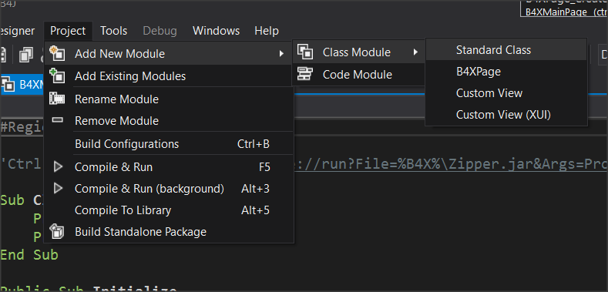From menu Project – Add New Module – Class Module menu select Standard Class.
3. In the dialog box, name clsBook (i.e. class Book)
4. A new code tab named clsBook will be created.

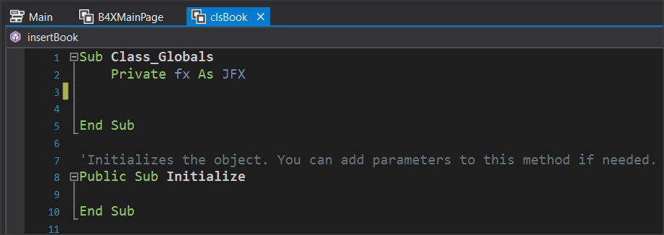

1. Within the Class_Globals routine, add all the variables that will be the properties of the class.
   1. Book Title
   2. Author Name
   3. Publisher
   4. 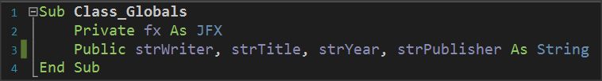Release Date
2. Finally, you must implement the subprograms that will implement the methods:
   1. Insert a book,
   2. Show Book Items,
   3. Change Book Items

**Teachers tip**

Be careful to explain that all the variables and methods you create are public so that objects can use them.



### Insert a book.

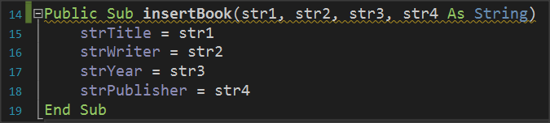This is a subprogram that accepts 4 string data as parameters and then assigns it in the order that it is inserted into the subprogram into the variables strTitle, strWiter, strYear, strPublisher.

### Show Book Items.

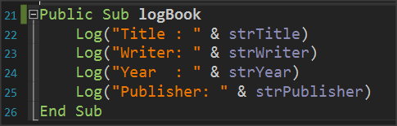The subprogram displays with log command the properties of the Books class or in other words the variables that describe the class.

### Change book items.

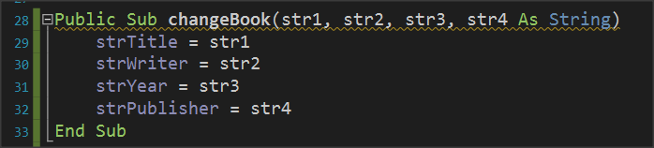The method of changing items accepts as parameters new elements for the class and changes the property values of the corresponding properties.

### The Initialize subprogram.

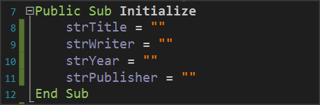The Initialize routine is used to give initial values to variables or do any other functions required when creating an object from a class.

### Use Class

Back on tab B4XMainPage it's time to use the clsBook class.

1. First create clsBook objects.

where book1, book2 are two clsBook objects with all the properties and methods discussed previously.

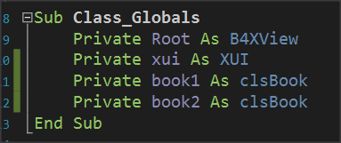

### Use of methods

The first method to be used in objects is the initialize method.

**Remember**

Initialize is not optional method. It’s the first method you must use before do anything with an object



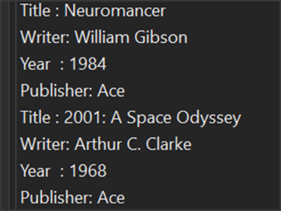The InsertBook method then enters values for the two books in the object properties.

End the logbook method displays the contents of the properties of each book.

**Remember**

Each property can be called by writing the object name, then a period and the method name. Some methods need parameters to work while others don't.



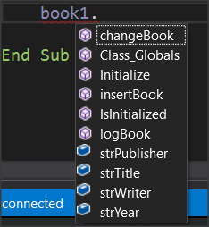Each time you write an object name and pressing the period B4X displays a window with all available properties and methods of the class. The IsInitialized method checks whether the object is initialized and exists in all classes that you create.

## Getters and Setters

Most of the time the properties of an object are kept private in order to avoid changes beyond what is allowed. This process is called encapsulation. To allow the use of private properties, the language uses public processes called get and set followed by the property name.

In the example of books, additional methods will be created as follows:

**Sub Class_Globals**

**Private** fx **As JFX**

~~Public strWriter, strTitle, strYear, strPublisher As String~~

**Private** strWriter, strTitle, strYear, strPublisher **As String**

**End Sub**

**Public Sub** getWriter() **As String**

**Return** strWriter

**End Sub**

**Public Sub** setWriter(w **As String**)

strWriter = w

**End Sub**

**Public Sub** getTitle() **As String**

**Return** strTitle

**End Sub**

**Public Sub** setTitle(t **As String**)

strTitle = t

**End Sub**

**Public Sub** getYear() **As String**

**Return** strYear

**End Sub**

**Public** **Sub** setYear(y **As** **String**)

strYear = y

**End** **Sub**

**Public** **Sub** getPublisher() **As** **String**

**Return** strPublisher

**End** **Sub**

**Public** **Sub** setPublisher(p **As** **String**)

strPublisher = p

**End** **Sub**

Also, to insert a book using the insert method can be done:

**Public Sub** insertBook(str1, str2, str3, str4 **As String**)

**setTitle**(str1)

**setWriter**(str2)

**setYear**(str3)

**setPublisher**(str4)

**End Sub**

The previous change to the insertBook method does not exclude its use and by directly assigning the properties of the classes as previously presented. Using set methods, you can integrate additional controls into the data you are about to enter.

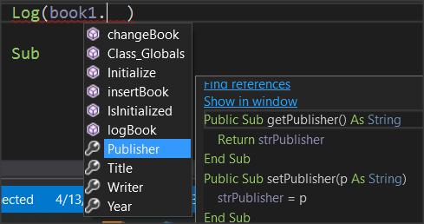Finally, when you want to use the get and set do it by writing the name that follows the get and set.

For example, to set another value to the author of book1 you can simply write:

book1.Writer = "Wil. Gibson"

Log(book1.Writer)

## Exercises

1. In the first example of the course, implement in B4J the Student class with properties:

* Registry Number
* Name
* Surname
* Class
* Phone
* Email

and methods

* New Student
* Show Student
* Change Class
* Change Phone

1. If only one teacher teaches a specific course in a school implement the Course class with properties
   1. Lesson
   2. Class
   3. Hours
   4. Professor

and methods

1. New Lesson
2. Change Hours
3. Change Professor
4. Show Lesson
5. A store has computers for sale. For each computer are recorded:
   1. The type (desktop, laptop),
   2. the model,
   3. its price,
   4. Its cpu (I3, i5, i7, i9)

Create a class that implements a computer with the above properties and methods that you will create. Be careful to check that the values entered in the type and cpu are those in the parenthesis.

# Lesson 10 – B4XPages

* What is a B4XPage
* How to Create and Delete a B4XPage
* Passing Values within Pages

What students should know

**3h**

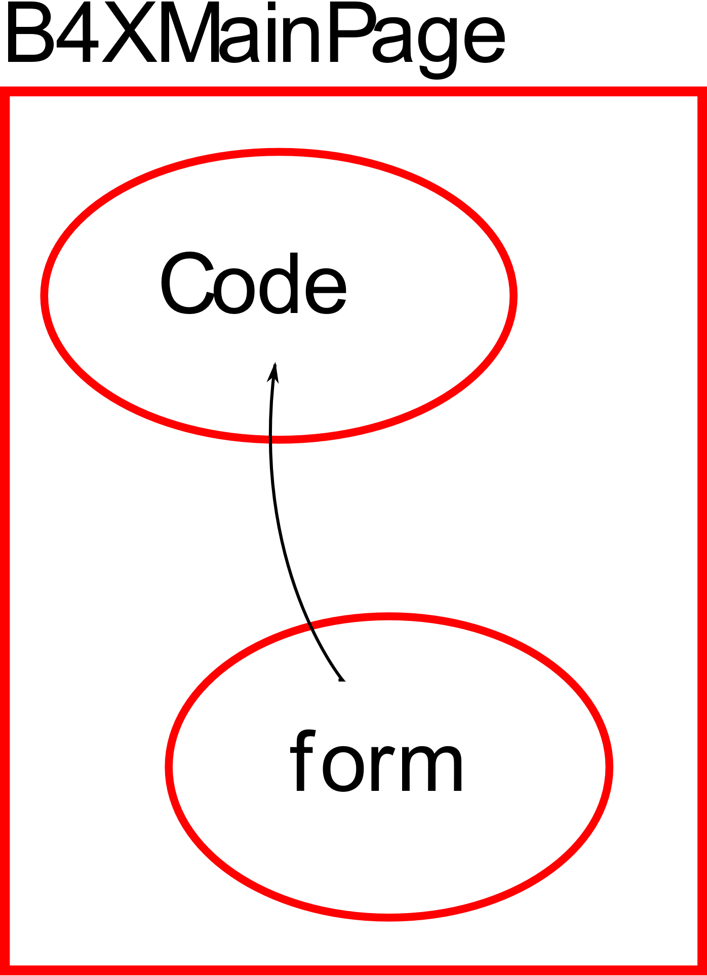B4XPages is a software library. Includes classes and procedures to create multiple application communication forms with the user. Also, it helps to transfer applications to different platforms using the B4A, B4i and B4J tools.

Every application you have created so far with B4J already includes a B4XPage. This is B4XMainPage which is always the user's first contact form with the application. More generally, each B4XPage manages all the codes required for the GUI (Graphics User Interface) to work.

## The structure of an application's folders

When you start a new program with B4XPage, the following folder structure is created.

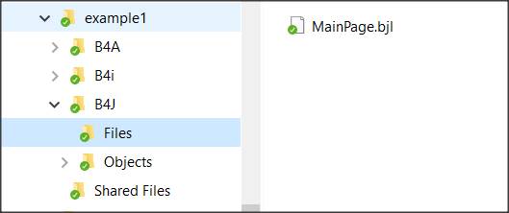Each of the three folders B4A, B4i And B4J include the relevant codes in order to create applicat **MainPage.bjl** ions, Android, Ios computers (Windows, Linux platforms) respectively.

Figure example1 folders

Specifically, in the **B4J** folder there is the “Files” folder where it contains all the files created with the Designer as well as any other files that must be used during the execution of the code e.g. images. **MainPage**.**bjl** is the file that was created automatically during the creation of the application and is its home screen. The Shared Files folder also includes files that the three different applications can share if the developer **chooses** to create an application for both Android, IOS and PC.

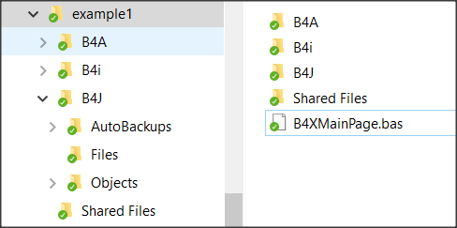The application's home folder contains all the files that create the different B4XPages of our application.

Figure B4XPage files

The first page that is created must have the name **“B4XMainPage.bas”** and cannot be changed; all other pages are named by the developer.

## Starting an application with B4XPage.

When creating a new application with B4Xpage, the language has already prepared the first page and as mentioned its name in the application folder is B4XMainPage.bas. Also, it has created a form (or GUI screen) to communicate with the user (named MainPage.bjl). Eventually, a mechanism called B4XPagesManager undertakes to manage the pages.

**Sub** Class_Globals

**Private** Root **As** **B4XView**

**Private** xui **As** **XUI**

**End Sub**

**Public Sub** Initialize

**End Sub**

**Private Sub** B4XPage_Created (Root1  **As**  **B4XView**)

Root = Root1

Root. LoadLayout("MainPage")

**End Sub**

### What is Root

The Root variable is an object of class B4XView. Undertakes to perform all display-related tasks in the various forms created by the developer (also associated with code sharing in B4J, B4A, B4i). Therefore, the Root object instructs the MainPage form to load with the Root.LoadLayout("MainPage" method).

### Create a new B4XPage

**Step 1.**

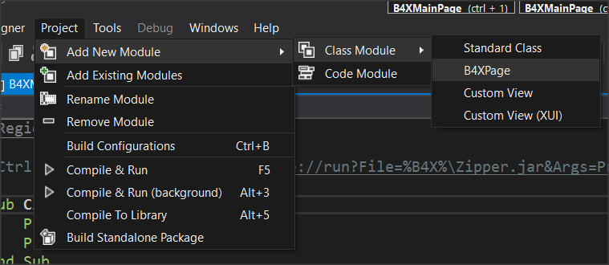After Create an app select from the menu Project – Add New Module – Class Module – B4XPage And Give the name B4XPage1.

Picture Create B4XPage

## 

A class with a name “B4XPage1” will be created, and some necessary codes to get started. The user communication screen (GUI) has not yet been created at this point. This should be done by the Designer later.

**Sub** Class_Globals

**Private** Root  **As**  **B4XView** 'ignore

**Private** xui  **As**  **XUI** 'ignore

**End Sub**

'You can add more parameters here.

**Public Sub** Initialize  **As**  **Object**

**Return Me**

**End Sub**

**Private Sub** B4XPage_Created (Root1  **As**  **B4XView**)

Root = Root1

'load the layout to Root

**End Sub**

Picture The new B4XPage

**Step 2.**

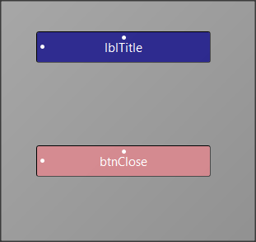Open Designer and from the menu File select New.

Picture Form

From the Variants tab, specify the dimensions of the form you want to design, and then select a label and button to insert into your form as in the Picture 24.

**Step 3.**

Use the menu Generate Members to insert the two objects into your code as well as the Click of the button. Remember that this action must be applied when you are in the code of the B4XPage1.

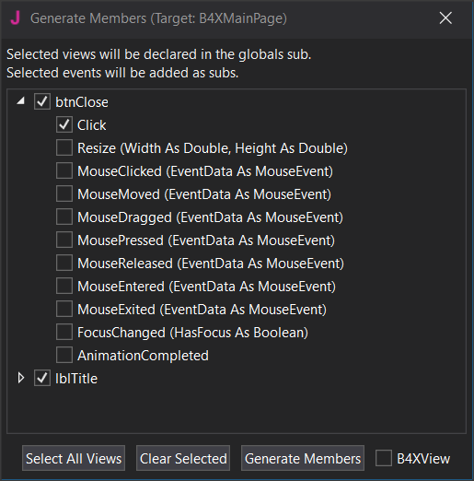

Picture Generate Members

From the file menu save your form named frmPage1. (You can give any name you want, and it serves the needs of the application).

The following code (Picture 26) will now be created, and the file will have been displayed frmPage1.bjl in the folder files.

Picture frmPage1

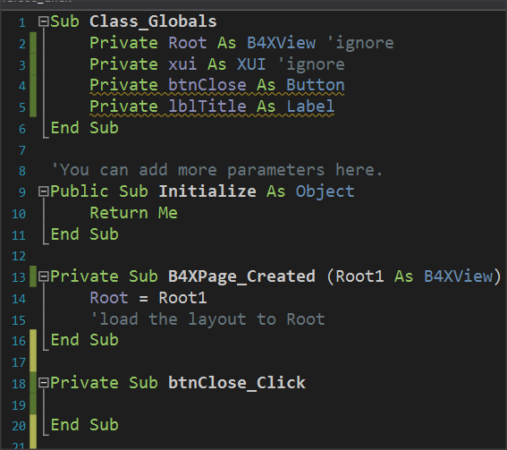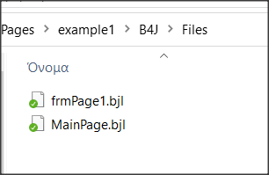

**Step 4.**

To link the form frmPage1 with the B4XPage1 you must now call the property Root.LoadLayout("frmPage1") within the event B4XPage_Created.

**Private Sub** B4XPage_Created (Root1  **As**  **B4XView**)

Root = Root1

'load the layout to Root

Root.LoadLayout(“frmPage1”)

**End Sub**

The next steps include method’s programming and depend on the purpose of the application you are building.

In our example, suppose you want to move to the B4XPage1 screen with one click in B4XmainPage’s button and then click the button you placed to return to the home page.

## Call a new B4Xpage.

Each new B4XPage you create is a class. Therefore, before you can use it, you must create an object based on it. The creation is usually done in the B4XPage that will call the new one. So, in the previous example we write in B4XmainPage (Picture 27):

1. 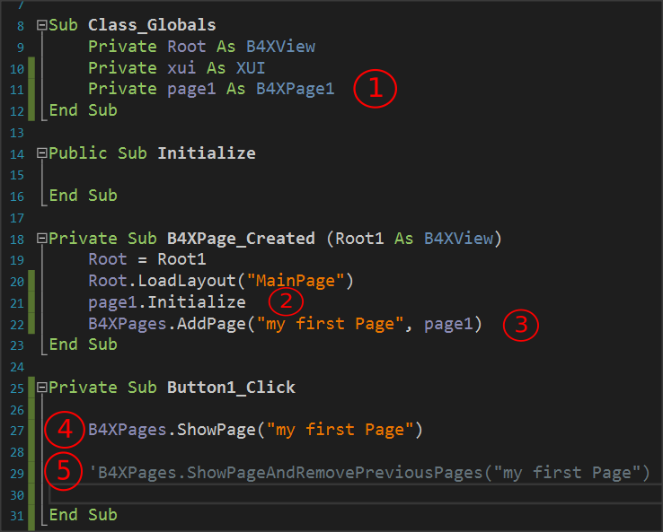Set a class object B4XPage1.

Picture Create B4XPage

1. Initialize page 1. Runs the Initialize routine within class B4XPage1.
2. Create an ID for the new page object. (In the example is "my first Page")
3. Call the new page while the home page remains open.
4. Second way to call a page where the home screen closes and only the new page remains open.

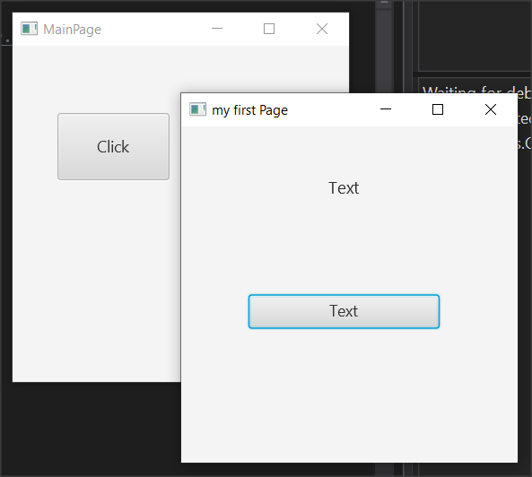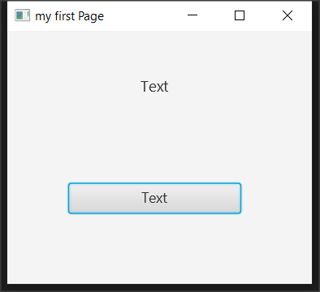

Picture 28 Two methods to open a B4Xpage

## Close a B4XPage.

When a B4XPage is called, the program control passes to that page. Therefore, for the page to close, an event must occur, such as pressing a button or the close button in the top right of the window. More generally, it also depends on how the screen was opened:

|  |  |
| --- | --- |
| **When opened with:** | **Usually closes with:** |
| B4XPages.ShowPage("my first Page") | B4XPages.ClosePage(Me) |
| B4XPages.ShowPageAndRemovePreviousPages("my first Page") | B4XPages.ShowPageAndRemovePreviousPages("MainPage") |

The first way closes the current form while the second way essentially calls the home page again while closing the current one.

## Transfer information between pages

For one page to have access to data from another, those pages must have variables declared with the keyword Public. The pages objects themselves when they are created either in the MainPage or elsewhere have also been declared as Public.

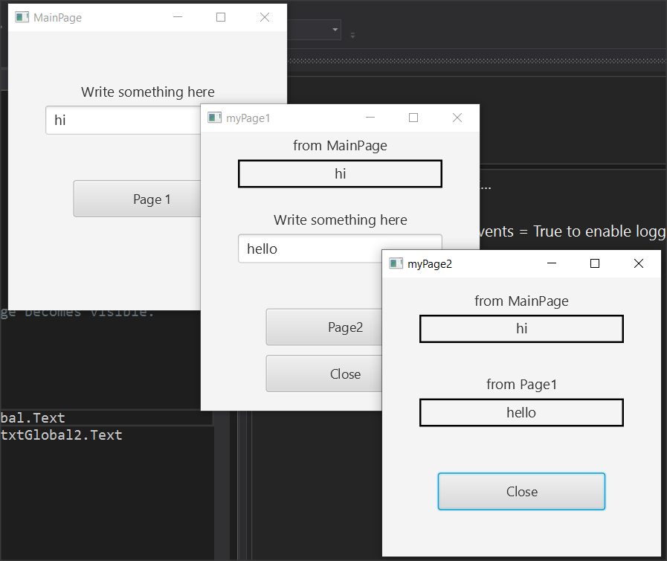

Picture Example 2

**Example 2**

For the purposes of this example, you will use the application of example 2. This includes MainPage, B4XPage1 and B4XPage2. Forms have also been created in the Designer. Open example 2, run it, and observe its operation.



As you run the application, notice that text from textFields is transferred to the following pages. This is because both page1 and page2 and both TextField are declared public.

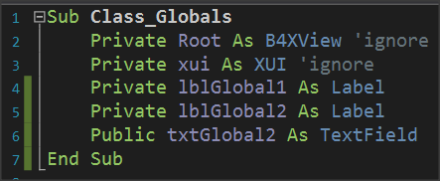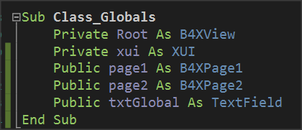

Picture 30 Public declarations in MainPage and Page1

In order page1 to have access to the txtGlobal1 variable, it must also use it by indicating the name of the page on which it was created:

lblGlobal1.Text = **B4XPages.MainPage**.txtGlobal.Text

where lblGlobal1 is a label that displays the content read on the page1 screen.

Similarly, Page2 has access to MainPage's txtGlobal1 and Page1's txtGlobal2 variables as follows:

lblGlobal1.Text = **B4XPages.MainPage**.txtGlobal.Text

lblGlobal2.Text = **B4XPages.MainPage.page1**.txtGlobal2.Text

where lblGlobal1 and lblGlobal2 are two labels that display the contents of the two Public Variables on the page2 screen.

## The Life of B4XPages

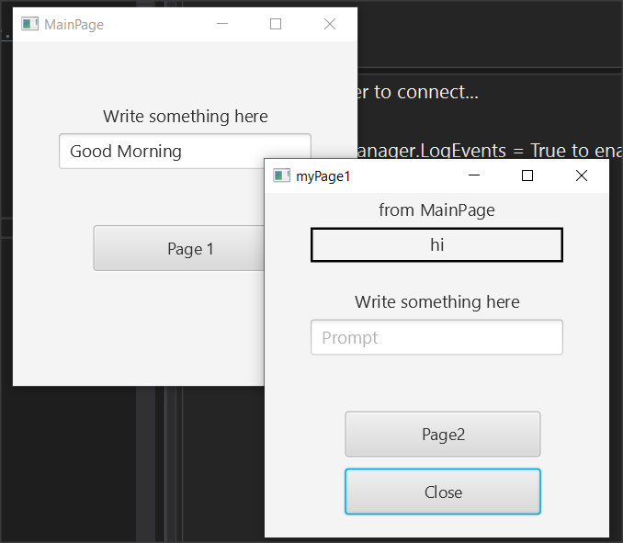In the previous example, try closing all windows except MainPage and type in new text and press the button to page1. You will notice that the value displayed by the MainPage it is not the new but still shows the first one.

Picture B4XPage life

This is because B4Xpages remain in computer memory and each time they are called the event B4XPage_Create does not run again. To read the global variables again from MainPage you can run event **B4XPage_Appear** and in there use the variables from MainPage:

**Private Sub B4XPage_Appear**

lblGlobal1.Text = B4XPages.MainPage.txtGlobal.Text

**End Sub**

Unlike B4XPage_Create that runs only once on the first call of the page, B4XPage_Appear runs every time the window appears in the foreground, so you can use it whenever the page returns to transfer variables from other forms.

## Exercises

1. The little encyclopedia of dogs. Create an application where three different breeds of dogs are displayed on a home page and after the user clicks on the corresponding name display information about the breed along with two photos.

*You can use TextArea in designer to make bigger text areas with scroll bar.*

1. Build an application that solves:
   1. the primary equation ax+b=0,
   2. the secondary equation ax a2+bx+c=0 and
   3. calculates the hypotenuse of a triangle given the dimensions of the two vertical sides.

*It is given that the square root of an x number is calculated by sqrt(x).*

1. 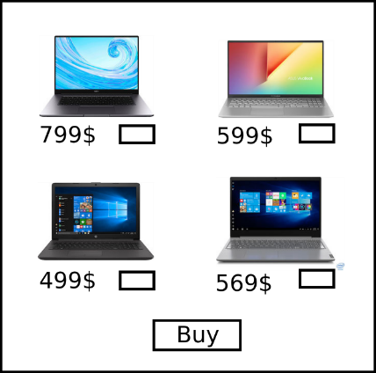Build an app that creates a virtual store as follows: The home screen will show images of 4 different objects, such as laptops and a TextField for each item where customer writes the quantity. Then pressing the Buy button, the program on a new page displays the Total Value and quantity of items selected. *Except MainPage you will need only one more.*

# Lesson 11 – First Project

* Use previous knowledge to create your first big application.

What students should know

**5h**

## Mobile Phones shop application.

A store sells cell phones. The following characteristics are recorded for each phone:

* Model Name
* Screen size,
* Memory capacity,
* RAM,
* Processor
* Warehouse Pieces
* Operating System (Android, IOS)
* Device Price

Build and application with the following:

* 1. Create a class with Phone **name** and properties of the above attributes.
  2. Create the methods.
     1. Initialize (Initialize all string properties with "" and all numeric values with 0.
     2. New model (With value input operations on a new object)
     3. Phone sale (accepts a number of pieces and subtracts this quantity from the total quantity of the model)

1. Add 8 different objects for mobile phones with the following elements (The features presented are not real but written for the needs of the task):

|  |  |  |  |  |  |  |  |  |
| --- | --- | --- | --- | --- | --- | --- | --- | --- |
|  | **Model Name** | **Screen** | **Capacity** | **Ram** | **Cpu** | **Os** | **Store** | **Price** |
| 1 | Yallomi | 6.53'' | 64 | 4 | Mediatek | Android | 12 | 150$ |
| 2 | Smith | 6.67" | 64 | 4 | Qualcomm | Android | 4 | 220$ |
| 3 | Taurus | 6.1 | 128 | 4 | Bionic | Ios | 7 | 780$ |
| 4 | Talisman | 5.8’’ | 64 | 4 | Mediatek | Android | 12 | 150$ |
| 5 | Cranberry | 5.8’’ | 32 | 3 | Mediatek | Android | 16 | 130$ |
| 6 | OzOn | 5.8’’ | 32 | 2 | Mediatek | Android | 16 | 90$ |
| 7 | H2O | 5.8’’ | 64 | 3 | Qualcomm | Android | 2 | 170$ |
| 8 | Zeus | 6.67’’ | 128 | 6 | Qualcomm | Android | 4 | 650$ |

*For each page below, it is recommended that you draw a sketch either on paper or with the help of the Inkscape program. You can download it for free from* [*https://inkscape.org/.*](https://inkscape.org/)

1. Create appropriate home screen with the following options.
   * Sell a mobile phone.
   * Warehouse Status.
   * Total Store Revenue.
2. If "Sell Mobile" is selected, then create new B4XPage, and show the names of the eight models and their prices. Don’t forget to sketch it first.

**Teachers tip**

Maybe, you have to help students to call objects from main page.



* 1. Clicking on each phone displays a new screen showing the device's features along with two photos of it. In addition, the feature screen also displays a button to sell the device with number of pieces and a back button.
     1. If the “back” button is pressed, then return to the previous screen.
     2. If the “sell” is pressed, check if the pieces are available in the warehouse or show an error message. On a new screen request the buyer's details:

Customer Name:

Surname

Address

Phone

* + 1. In the same screen display the number of pieces he chose to buy as well as the total price.
    2. When Sell button Pressed subtract the quantity purchased from the warehouse and return to the app's home screen.

1. If Warehouse Status is selected, display mobile models on a new screen(B4XPage) along with the rest quantities in the warehouse.
2. If "Total Store Revenue" is selected, the store's receipts will be displayed on a new page(B4XPage) until this time.

**Teacher’s tip**

At the next few pages, you will find, some documents to help students to work we this first project. In power point presentation there are all solution steps and you can find the code in folder lesson11. The solution is not “optimal” but a solution that students should understand.



Timetable

|  |  |
| --- | --- |
| Project |  |
| Date |  |
| Student |  |

**Organize your time - What to do and when**

|  |  |  |  |  |  |  |  |  |  |
| --- | --- | --- | --- | --- | --- | --- | --- | --- | --- |
|  | **Hours** | | | | | | | | |
|  | **1** | **2** | **3** | **4** | **5** | **6** | **7** | **8** | **9** |
|  |  |  |  |  |  |  |  |  |  |
|  |  |  |  |  |  |  |  |  |  |
|  |  |  |  |  |  |  |  |  |  |
|  |  |  |  |  |  |  |  |  |  |
|  |  |  |  |  |  |  |  |  |  |
|  |  |  |  |  |  |  |  |  |  |
|  |  |  |  |  |  |  |  |  |  |
|  |  |  |  |  |  |  |  |  |  |
|  |  |  |  |  |  |  |  |  |  |

Wireframe Sketching

|  |  |
| --- | --- |
| Form Name |  |
| Date |  |
| Student |  |

|  |  |  |  |  |  |  |  |  |  |  |  |  |  |  |  |  |  |  |  |  |  |  |  |
| --- | --- | --- | --- | --- | --- | --- | --- | --- | --- | --- | --- | --- | --- | --- | --- | --- | --- | --- | --- | --- | --- | --- | --- |
|  |  |  |  |  |  |  |  |  |  |  |  |  |  |  |  |  |  |  |  |  |  |  |  |
|  |  |  |  |  |  |  |  |  |  |  |  |  |  |  |  |  |  |  |  |  |  |  |  |
|  |  |  |  |  |  |  |  |  |  |  |  |  |  |  |  |  |  |  |  |  |  |  |  |
|  |  |  |  |  |  |  |  |  |  |  |  |  |  |  |  |  |  |  |  |  |  |  |  |
|  |  |  |  |  |  |  |  |  |  |  |  |  |  |  |  |  |  |  |  |  |  |  |  |
|  |  |  |  |  |  |  |  |  |  |  |  |  |  |  |  |  |  |  |  |  |  |  |  |
|  |  |  |  |  |  |  |  |  |  |  |  |  |  |  |  |  |  |  |  |  |  |  |  |
|  |  |  |  |  |  |  |  |  |  |  |  |  |  |  |  |  |  |  |  |  |  |  |  |
|  |  |  |  |  |  |  |  |  |  |  |  |  |  |  |  |  |  |  |  |  |  |  |  |
|  |  |  |  |  |  |  |  |  |  |  |  |  |  |  |  |  |  |  |  |  |  |  |  |
|  |  |  |  |  |  |  |  |  |  |  |  |  |  |  |  |  |  |  |  |  |  |  |  |
|  |  |  |  |  |  |  |  |  |  |  |  |  |  |  |  |  |  |  |  |  |  |  |  |
|  |  |  |  |  |  |  |  |  |  |  |  |  |  |  |  |  |  |  |  |  |  |  |  |
|  |  |  |  |  |  |  |  |  |  |  |  |  |  |  |  |  |  |  |  |  |  |  |  |
|  |  |  |  |  |  |  |  |  |  |  |  |  |  |  |  |  |  |  |  |  |  |  |  |
|  |  |  |  |  |  |  |  |  |  |  |  |  |  |  |  |  |  |  |  |  |  |  |  |
|  |  |  |  |  |  |  |  |  |  |  |  |  |  |  |  |  |  |  |  |  |  |  |  |
|  |  |  |  |  |  |  |  |  |  |  |  |  |  |  |  |  |  |  |  |  |  |  |  |
|  |  |  |  |  |  |  |  |  |  |  |  |  |  |  |  |  |  |  |  |  |  |  |  |
|  |  |  |  |  |  |  |  |  |  |  |  |  |  |  |  |  |  |  |  |  |  |  |  |

Classes

|  |  |
| --- | --- |
| Class Name: |  |
| Date: |  |
| Student: |  |
| **Attributes:** | 1. |
|  | 2. |
|  | 3. |
|  | 4. |
|  | 5. |
|  | 6. |
|  | 7. |
|  | 8. |
|  |  |
| **Method** |  |
| **Description:** |  |
|  |
|  |
| **Method** |  |
| **Description:** |  |
|  |
|  |
| **Method** |  |
| **Description:** |  |
|  |
|  |
| **Method** |  |
| **Description:** |  |
|  |
|  |

B4XPages

|  |  |
| --- | --- |
| B4XPage Name: |  |
| Date: |  |
| Student: |  |
| **Public Variables:** | 1. |
| 2. |
| 3. |
| 4. |
| 5. |
| 6. |
| 7. |
| 8. |
| 9. |
| 10. |
|  |  |
| **Event** |  |
| **Description:** |  |
|  |
|  |
| **Event** |  |
| **Description:** |  |
|  |
|  |
| **Event** |  |
| **Description:** |  |
|  |
|  |

# Lesson 12 – Loops

* What are Loops?
* Do While
* Do Until
* For – Next
* Algorithms with loops

What students should know

**4h**

Repetitive structures are one of the most basic functions of a programming language. A loop in a computer program is a directive that repeats until a specified condition is reached. In a repeat structure, the loop poses a question. If the answer requires action, it runs. The same question is asked over and over again until no further action is required. Every time the question is asked it is called repetition.

A computer programmer who has to use the same lines of code multiple times in a program can use a loop to save time, space, ease of programming.

**Remember**

Repeats have to end at some point or it's a programming error. A repetition that never ends is called an endless loop. In this case the computer is trapped in a perpetual repetition of the same functions without "awareness" of vanity!



In B4X there are four repeat **commands**: For, Do While, Do Until, for each.

## The Do While command

Suppose you would like to display on the screen with the command log numbers from 1 to 5 below each other. The code you should write to B4J would be as follows:

Log(1)

Log(2)

Log(3)

Log(4)

Log(5)

You realize that if you had to keep printing numbers then you would have to continue writing log commands for as many numbers as you need.

The command Do While is stated as follows:

Picture Command Do While

**Do While** *Condition*

Commands

...

**Loop**

**As long as** the condition is true

Execute the Commands

...

**Go back to condition.**

In the example with the five numbers and using Do While the code is written:

**Private** i as Int = 1

**Do While** *i <=*  *5*

**Log**(i)

i = i + 1

**Loop**

Variable **i** counts how many times the loop will run.

The Condition also examines whether the contents of the counter exceeded the limit set by the developer, i.e. 5, and if this happens, the repetition stops.

Before the loop iteration end, the repeat counter is increased by +1. This value is also called Step.

The step can be positive or negative, but it can never be 0 because then the repetition would run forever.

**Remember**

When the counter starts at a value less than the final value then the **step must** be **positive.**

When the counter starts from a value greater than the final value then the **step must** be **negative.**



Examples of the command Do While.

**Example 1**

Show all integers from 100 to 1



**Private** i as **Int** = 100

**Do** While *i >= 1*

**Log**(i)

i = i - 1

**Loop**

In the example the repeat counter it starts at a large value (100) and ends at a small (0) before the repetition is complete. Attention in this case to the **Step** is **Negative** (-1).

**Example 2**

Show all even numbers from 1 to 100



**Private** i as **Int** = 1

**Do While** *i*  *<= 100*

**If** I mod 2 = 0 **then**

**Log**(i)

**End if**

i = i + 1

**Loop**

**Private** i as **Int** = 2

**Do While** *I <= 100*

**Log**(i)

i = i + 2

**Loop**

Here are two solutions presented the first uses a command if in loop to check whether the number is even and only then executes the command Log. In the second algorithm has changed the **starting value** of the i in 2 and the **Step** increases by 2 which creates a faster algorithm to run.

**Example 3 – Sum Algorithm**

Make a program that for ten numbers entered, the program calculates their sum. These numbers are considered to range between -100 and 100



The function will be used for the purposes of the example. It is used as follows:

**Remember**

The **Rnd command (First Value, Last Value)** returns a number between the First and Last value.

e.g. A = Rnd(1, 10) returns a number between 1 and 10 in variable A



**Private** I  **As**  **Int** = 1

**Private** A **as Int**

**Private** intSum  **as Int** = 0

**Do While** *i*  *<= 10*

A = **Rnd**(-100, 100)

intSum = intSum + A

i = i + 1

**Loop**

**Example 4** **– Algorithm Count.**

Make a program that for ten numbers entered, the program end calculates the number of negatives. These numbers are considered to range between -1000 and 1000



**Private** I  **As**  **Int** = 1

**Private** A **as Int**

**Private** intCounter  **as Int** = 0

**Do While** *i*  *<= 10*

A = **Rnd**(-100, 100)

**If** A < 0 **then**

intCounter = intCounter + 1

**End If**

i = i + 1

**Loop**

**Private** I  **As**  **Int** = 1

**Private** A **as Int**

**Private** intMax, intMin  **as Int**

A = **Rnd**(-100, 100)

intMax = A

intMin = A

**Do While** *i*  *<=*  *9*

A = **Rnd**(-100, 100)

**If** intMax < A **then**

intMax = A

**End If**

**If** intMin > A **then**

intMax = A

**End If**

i = i + 1

**Loop**

1. First read a number outside the while.
2. Set as the starting value in the intMax end intMin variable the first number since there is no one else to compare.
3. For each new number it is checked   
   if it is less than intMin then intMin replaced by A   
   if the new A is greater than intMax the intMax is replaced with the new A.

**Example 5 - Maximum Algorithm - Minimum**

Make a program that for ten numbers entered the program counts the largest and smallest numbers. These numbers are considered to range between -1000 and 1000



## Loops with unknow repeats.

Often in programming we do not know from the beginning the number of repetitions. This usually happens when the repeat depends on the value taken from user or on values calculated during the repeat.

**Example 6 – Non-specific number of repetitions**

Create a program that constantly reads numbers and calculates the Averages of the even. The program stops when a number less than 0 is entered.



1. The condition checks whether the total has not reached the limit of 200.
2. A number is read and then program calculates the sum. Condition checked again by Do While.

**Private** A **as Int**

**Private** intSum  **as Int**  **= 0**

**Do While** i*ntSum <= 200*

*A = Rnd(-100, 100)*

intSum = intSum + A

**Loop**

**Example 7 – Non-specific number of repetitions**

Create a program that reads numbers and calculates their sum. The program stops when the sum exceeds 200.



1. First read a number outside the replay.
2. The DoWhile condition checks whether the number A is within the limits.
3. A new number is read before the end of the iteration.

**Private** A **as Int**

**Private** intCount  **as Int**  **= 0**

A = **Rnd**(-100, 100)

**Do While** *A*  *>*  *0*

**If** A mod 2 = 0 **then**

intCount = intCount + 1

**End If**

A = Rnd(-100, 100)

**Loop**

## The Do Until command.

The operation of the Do Until is like the Do While. The only difference is the condition which controls when a repetition will end as opposed to the Do While which controls how long it will work. In both cases the check shall be carried out at the beginning, in which case the code shall not be executed if the Condition is False.

**Remember**

The condition of Do Until is the denial of Do While.



**Private** i as **Int** = 100

**Do Until**  *i*  *<*  *1*

**Log**(i)

i = i - 1

**Loop**

**Example 1**

Show all numbers from 100 to 1



**Private** i as **Int** = 1

**Do Until**  *I*  *> 100*

**If** I mod 2 = 0 **then**

**Log**(i)

**End if**

i = i + 1

**Loop**

**Private** i as **Int** = 2

**Do Until** i  *>*  *100*

**Log**(i)

i = i + 2

**Loop**

**Example 2**

Show all even numbers from 1 to 100



**Private** I  **As**  **Int** = 1

**Private** A **as Int**

**Private** intSum  **as Int** = 0

**Do Until**  *I*  *>*  *10*

A = **Rnd**(-100, 100)

intSum = intSum + A

i = i + 1

**Loop**

**Example 3 – Sum Algorithm**

Make a program that for ten numbers entered, the program calculates their sum. These numbers are considered to range between -100 and 100.



**Example 4** **– Algorithm Count**

Make a program that for ten numbers entered, the program calculates the number of negatives. These numbers are considered to range between -1000 and 1000.



**Private** i  **as**  **Int** = 1

**Private** A **as Int**

**Private** intCounter  **as Int** = 0

**Do Until**  *i*  *>*  *10*

A = **Rnd**(-100, 100)

**If** A < 0 **then**

intCounter = intCounter + 1

**End If**

i = i + 1

**Loop**

**Private** I  **As**  **Int** = 1

**Private** A **as Int**

**Private** intMax, intMin  **as Int**

A = **Rnd**(-100, 100)

intMax = A

intMin = A

**Do Until**  *I*  *>*  *9*

A = **Rnd**(-100, 100)

**If** intMax < A **then**

intMax = A

**End If**

**If** intMin > A **then**

intMax = A

**End If**

i = i + 1

**Loop**

**Example 5** **- Maximum Algorithm - Minimum**

Make a program that for ten numbers entered, the program counts the largest and smallest numbers. These numbers are considered to range between -1000 and 1000.



**Private** A **as Int**

**Private** intCount  **as Int**  **= 0**

A = **Rnd**(-100, 100)

**Do Until**  *A*  *<*  *0*

**If** A mod 2 = 0 **then**

intCount = intCount + 1

**End If**

A = Rnd(-100, 100)

**Loop**

**Example 6 – Non-specific number of repetitions**

Create a program that constantly reads numbers and calculates the Averages of the even. The program stops when a number less than 0 is entered.



**Example 7 – Non-specific number of repetitions**

Create a program that reads numbers and calculates their sum. The program stops when the sum exceeds 200.



**Private** A **as Int**

**Private** intSum  **as Int**  **= 0**

**Do Until**  *intSum*  *>*  *200*

*A = Rnd(-100, 100)*

intSum = intSum + A

**Loop**

## For Loop

The for loop is probably the simplest repeat command.

**for** i = n1  **to**  n2  **Step**  n3

Commands

...

**Next**

Where:

i the Counter variable

n1 the initial value of the Counter

n2 the final value

n3 step of repetition

* At the beginning of repetition, variable ‘i’ accepts n1.
* Executes commands within the repetition.
* At the end of the repetition the value of ‘i’ increases or decreases by n3
* Check if ‘i’ has exceeded the final value n2.
  + if the step is positive and ‘i’ is less than or equal to the final value then the repeat runs again
  + If the step is negative and ‘i’ is greater than or equal to the final value, then the repeat runs again.

**Remember**

In relation to **Do While** and **Do Until** the **For** command:

* Do not needs to initialize the counter.
* Do not needs to set the step change operation.
* It is always for measurable repeats (however, you can use the exit command to get out of it at any time).



### Examples for

**Private** I **As** **Int**

**For** i = 100 **to** 1 **step** -1

**Log**(i)

**Next**

**Example 1**

Show all numbers from 100 to 1



**Example 2**

Show all even numbers from 1 to 100



**Private** I  **As**  **Int**

**For** i = 1  **to**  100

**If i**  **mod 2 = 0 then**

**Log**(i)

**End If**

**Next**

## Exercises

1. Write a program that reads an integer K between 1 and 200 and calculates the sum of 1+2+3+...+K.
2. Write a program that the user will give numbers and calculate the average of the above numbers. The program ends by entering zero.
3. A consumer wants to buy toys for gifts to 10 children. It also wants their total price not to exceed 200€. Make a program that:
   1. Enter the cost of the game (random number between 10-50 ,command Rnd(10, 50) )
   2. Calculate the total cost of games purchased so far,
   3. Check if the money has run out.
   4. Finally show the total cost of the games and their number.
4. A leap year (also known as an intercalary year or bissextile year) is a calendar year that contains an additional day (or, in the case of a lunisolar calendar, a month) added to keep the calendar year synchronized with the astronomical year or seasonal year. A year is a leap year when:

if (year is not divisible by 4) then (it is a common year)

else if (year is not divisible by 100) then (it is a leap year)

else if (year is not divisible by 400) then (it is a common year)

else (it is a leap year)

Make a program that shows the leap years between 1900 and 2100

(<https://en.wikipedia.org/wiki/Leap_year>)

1. Build a program with the help of the turtle that creates polygons with a number of angles that the user enter in an appropriate field. The program will include a design start button and a screen cleaning button that when pressed cleans the screen and the turtle will placed in center of screen.
2. Draw the following shapes with the turtle:

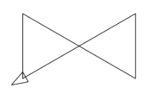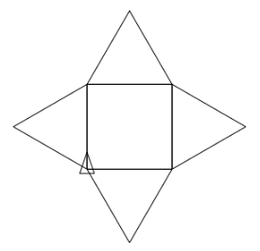



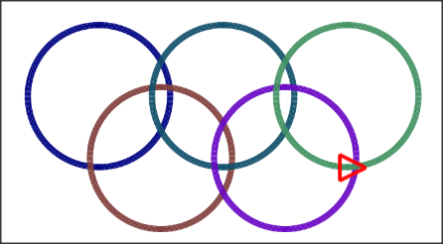

# Lesson 13 – XUI Views

* What is a library.
* XUI library.
* Dialogs
* Templates

What students should know

**3h**

Each programming language has libraries. In general, a library includes collections of code, structures, classes, methods that can be used by developers to facilitate the process of developing a program.

## Libraries in B4X

Libraries are generally divided into internal libraries and are those that are installed together with the language and external ones created by the developer himself or found from other sources (e.g. Github). To use a library, you only need to select it from the corresponding Libraries list in B4X.

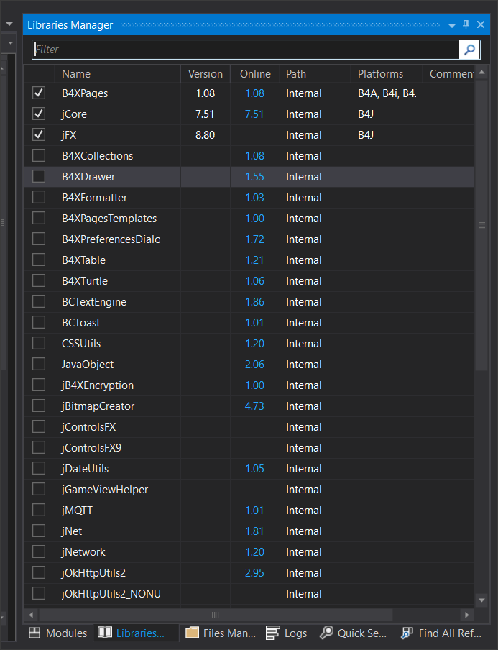

Picture Libraries

The list of libraries contains useful information. These are:

* the current version of the library that is installed,
* The latest version published in order to update our language.
* Whether it is an internal library or an external library.
* Which platforms it concerns.

To use a library, you must have been informed about the functions it performs as well as the data and methods it uses. For each library there is relevant information about its use through the language website at <https://www.b4x.com/android/documentation.html>.

External libraries should always be copied all in a specific folder on your computer. From Menu “Tools”, “Configure Paths”, “Additional Libraries” select the folder in which they will be stored.

**Teacher’s tip**

Below are some important views. Other very important ones are absent from this list, such as ComboBox, which we will refer to in more extensively in the next chapters.



## The XUI Views library

The purpose of the XUI Views library is to offer a common way to create applications for b4j, b4a and b4i.

This library is associated with creating forms and views that are included in them. Includes:

* **Views** (objects)
  + B4XComboBox - Cross platform ComboBox / Spinner / ActionSheet.
  + ScrollingLabel - A label that scrolls the text when it is wider than the label.
  + AnotherProgressBar - Vertical or horizontal animated progress bar.
  + B4XLoadingIndicator - 6 different animated loading indicators.
  + RoundSlider - A round slider.
  + SwiftButton - 3d button
  + AnimatedCounter
  + B4XFloatTextField - A TextField / EditText with a floating hint
  + B4XSwitch - Nice looking two state control.
  + B4XPlusMinus - Allows the user to select a number or item from a previously set list.
  + B4XBreadCrumb - Navigation control.
  + B4XSeekBar - Horizontal or vertical seek bar / slider.
  + MadeWithLove - Show your love to B4X :)
  + B4XImageView - ImageView with useful resize modes.
  + XUIViewsUtils - Static code module with various utility methods.
* **Dialogs** (Dialog Boxes)
  + A class that provides the features required to show a dialog. There are three methods to show dialogs: Show - Shows a simple dialog with text, ShowCustom - Allows you to pass a layout of your own and show it as a dialog, ShowTemplate - Shows a dialog based on a template class. See the source code for the template structure. It is quite simple.
* **Templates**
  + B4XDateTemplate - Based on AnotherDatePicker.
  + B4XColorTemplate - Color picker.
  + B4XLongTextTemplate - Scrollable text.
  + B4XListTemplate - A list of items. The user can choose one of the items.
  + B4XSignatureTemplate - Captures the user signature and adds a timestamp to the bitmap.
  + B4XInputTemplate - Template for text and numeric inputs.
  + B4XSearchTemplate - A list with a search field.
  + B4XTimedTemplate - A template that wraps other templates and creates a dialog that closes automatically after the set time with a nice, animated progress bar.

## Using XUI Views

To use the XUI Views first you need to check her name on the library tab. Then go to the Designer to create the objects you want.

**Example**

The following program shows the use of:

**ScrollingLabel**

**B4XFloatTextField**

**RoundSlider**

**AnotherProgressBar**

**B4XSwitch**

**B4XImageView**



### Scrolling Label

Scrolling label is a text label where it can move text so that it can appear in its entirety.

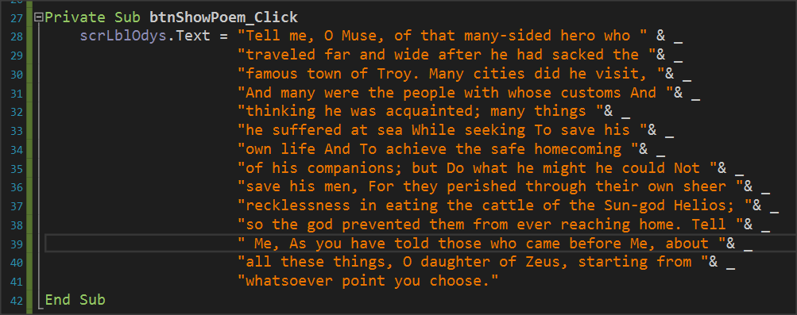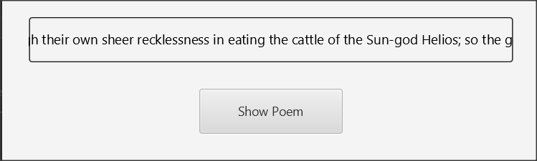

Picture Scrolling Label

It is mainly used for very large texts or to display a running message on the screen.

### B4XFloatTextField

B4XFolatTextField creates a text box on the screen to insert data. Its use is similar to the simple text box, but in addition it displays a label that helps the user identify the field without inserting an additional label before the field ( Hint Text).

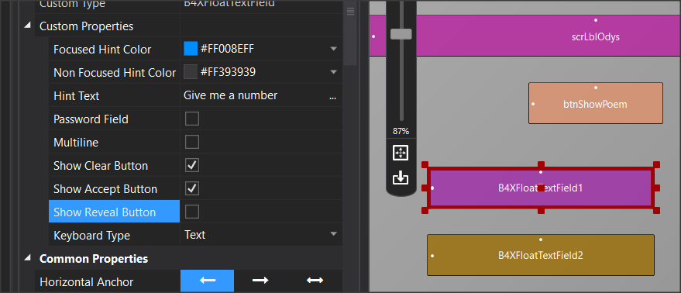

Picture B4XFloatTeextField

Additionally, it displays the appropriate controls to delete or enable this field (Show Clear Button, Show Accept button). Finally, it allows the Keyboard Type property to enter text, either integer numbers or decimal numbers.

### RoundSlider

RoundSlider is a controller that moves with the mouse around a circle. Each point in the cycle, it displays a value from a range of values that you have selected in the Minimum – Maximum properties in Designer.

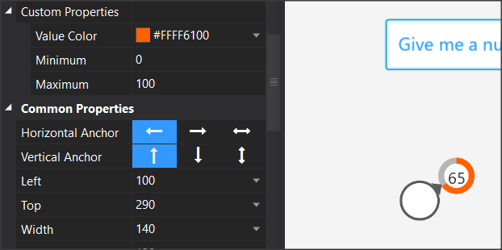

Picture RoundSlider

Each time the RoundSlider value changes, the "_ValueChanged" event is triggered, and gives value of which the developer can use.

### AnotherProgressBar

AnotherProgressBar displays a bar that vary between 0 and 100 and is suitable for displaying percentages or other proportions. Using it is simple, after you declare the variable that corresponds to the item, use the property ".value" to set a value.

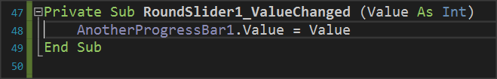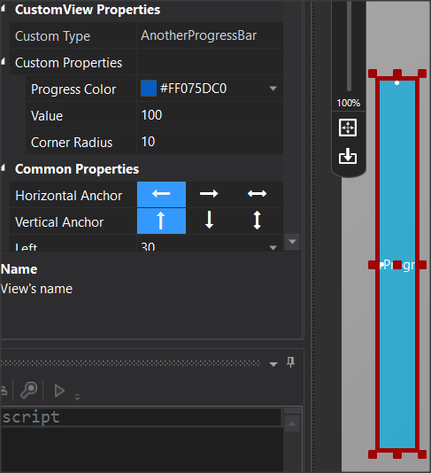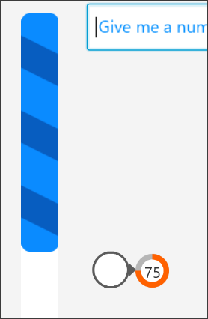

Picture AnotherProgressBar

In the example of the image, progressBar vary depending on the value it receives from RoundSlider.

B4XSwitch

B4XSwitch creates a sliding button on the screen.

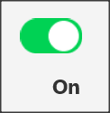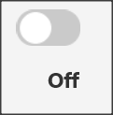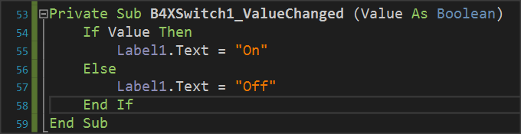

Picture B4XSwitch

In the example of the image when the returned value is true then a label displays the text "On" otherwise displays "Off".

### B4XImageView

B4XImageView displays an image. Provides the ability to choose how the image is displayed either by code or by the object's options in Designer.

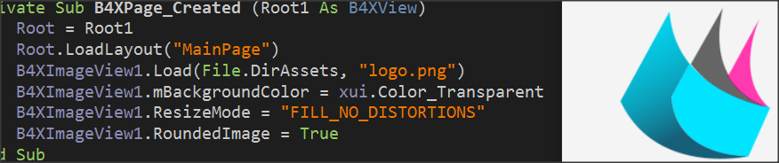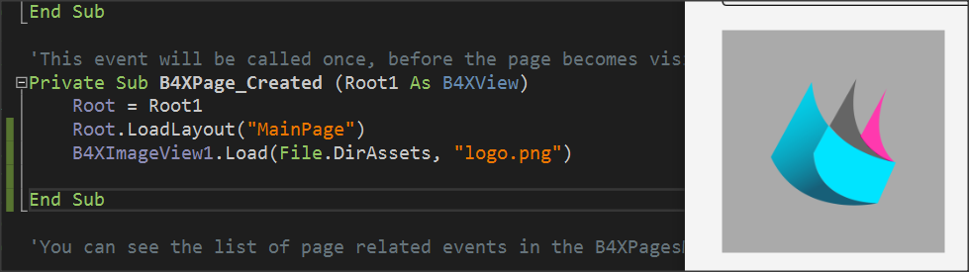

Picture B4XImageView

In the Load command, in addition to the image name, the folder where the image is stored must be declared first. In this case, the Files (Files.DirAsset) folder is declared as in the image below:

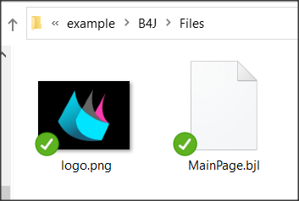

Picture Files Folder (DirAsset)

This folder is not accessible for writing new files when the application is created. In the course of the files, we will refer in greater detail to the folders.

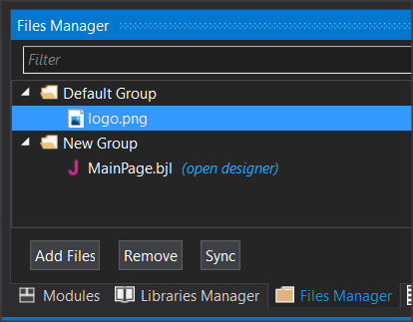

Picture Files Manager

To display an image stored in the Files folder, it must also be declared on the File Manager tab of the language.

## B4XDialogs

Dialog boxes are screens that appear to inform the user of an event or to get data from users without the need to create another B4XPage.

### MsgBoxAsync

Already in previous courses you used the command xui.MSgBoxAsync which displays a simple message on the screen.

Picture 42 MsgBoxAsync

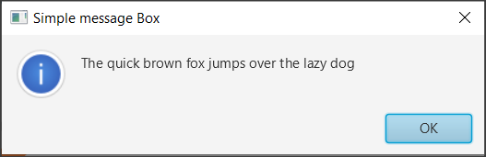

As shown in Picture 42 window. The command also displays an OK button to close the message and return to the program.

### MsgBox2Async

Using MsgBox2Async is more complex and allows the programmers to display a message and then choose between three different functions by pressing a corresponding button.

Picture 43 MsgBox2Async

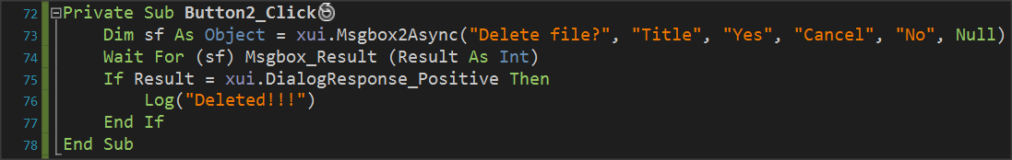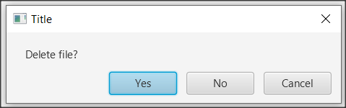

MsgBox2Async returns an object (“sf” in the example) that waits for a response event from user.

* **DialogResponse_Positive** (if “Yes” was pressed in the example)
* **DialogResponse_ Negative** (if " No" key was pressed)
* **DialogResponse_Cancel** (if "Cancel" was pressed)

The above values are controlled by an if command and appropriate actions are performed accordingly.

The words that appear on the action buttons can be changed but always have the same order as a “Positive”, “Cancel”, “Negative”.

You can skip a button simply by writing a blank string "" at the corresponding point when the button will not appear in the dialog box.

The last parameter allows you to display an icon to the left of the message, and Null displays nothing.

### Wait For

Wait For freezes the execution of an operation until an event is activated.

***Wait For*** (<sender>) <event signature>

Where **sender** is the object for which an event is waiting to be activated and

**Event signature** the event that was activated where in the case of MsgBox2 Async are the DialogResponse_Positive, DialogResponse_Cancel, DialogResponse_Negative.

The event is then checked with an if command.

## CustomDialog

Creating a Custom dialog box includes several steps that start with the Designer.



Picture 44 Steps to create Custom Dialog.

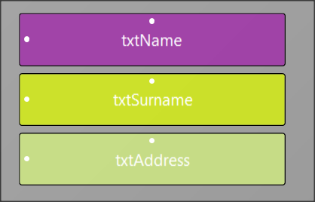Continuing the first example create a new form in Designer and save under the name frmInsStudent. Also create corresponding variables for Text Fields from Generate Members.

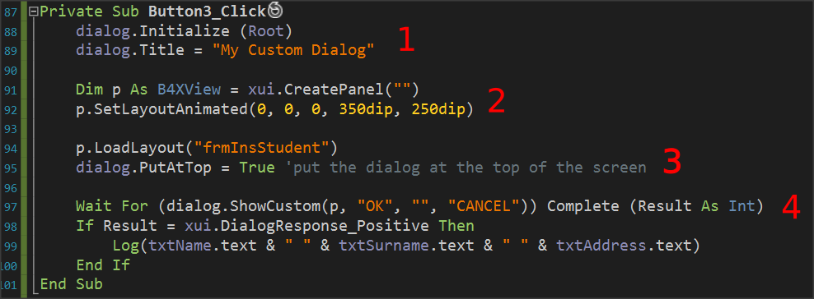

Picture 45 Custom Dialog

1. Set an object named dialog type B4XDialog within globalSub, and then use the command “dialog.Initialize(Root)” to initialize it. “dialog” sets a title in the dialog box that you are about to create.
2. Set a pane in which to display the items on the form you designed and set its dimensions in pixels.
3. Load your form with the “p.LoadLayout” command where “p” the pane you set before and then set to appear at the top above all other windows.
4. Wait for a button to click and check the results.

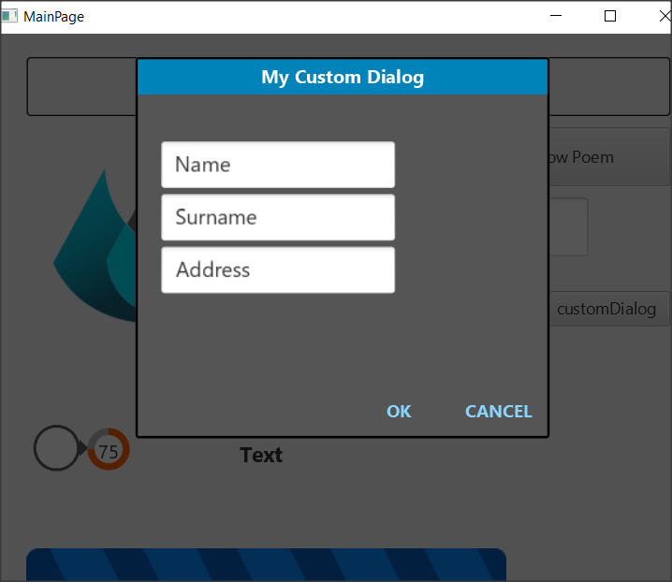

Picture 46 The dialog box

## Templates

The B4X has ready-made templates for creating dialog boxes, some of which are:

* B4XDateTemplate
* B4XColorTemplate
* B4XLongTextTemplate

**Teacher’s** **tip.**

**Additional functions will be used in next chapters as concepts such as lists, dictionaries, etc. have not yet been discussed.**



### B4XDateTemplate

Creates a Dialog box to select a date. This box only needs a cancel button because when a date is selected it automatically returns the relevant value to the program. When the form opens, it has already marked the current date in a different color.

B4XDateTemplate based on a dialogue template that should be declared and initialised as in the Custom Dialogs

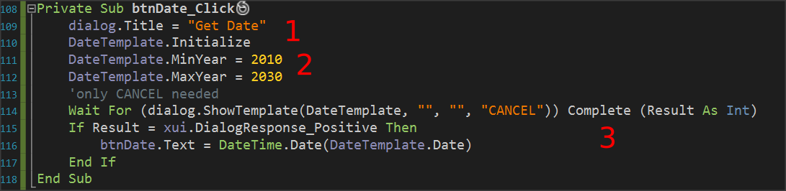

Picture 47 Create Date Dialog Box

1. Initialize and set a title in the dialog. In the example initialization done in Class_Globals Sub.
2. Specify whether you want years limits.
3. Wait for the date to be selected, and if selected, display it as a name on the “btnDate” or use it according to your needs.

**Remember**

The date is returned to Ticks which represent milliseconds from 1/1/1970. These milliseconds are converted to a date with the “DateTime.Date” command.



### B4XColorTemplate

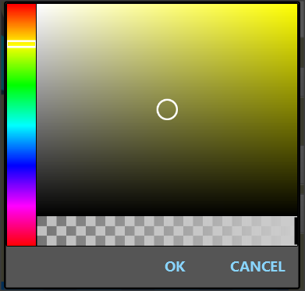B4XColorTamplate is similar to that of the day. Once again the code is waiting with the Wait For command to make a color selection, and when pressed OK returns a color number.

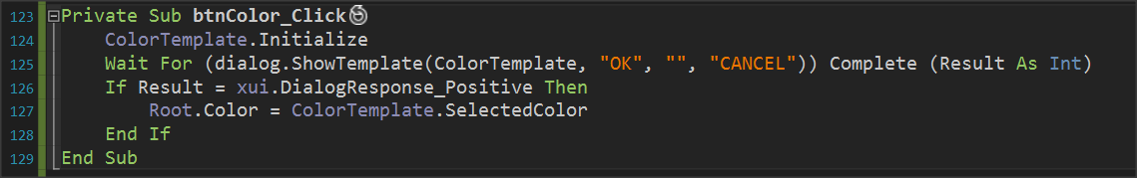

Picture Create Color Template

The example uses the color to change the background of the home page with the “Root.Color”.

### B4XLongTextTemplate

B4XLongTextTemplate displays a window on the screen to display long text. Also, it displays a navigation bar to scroll the text.

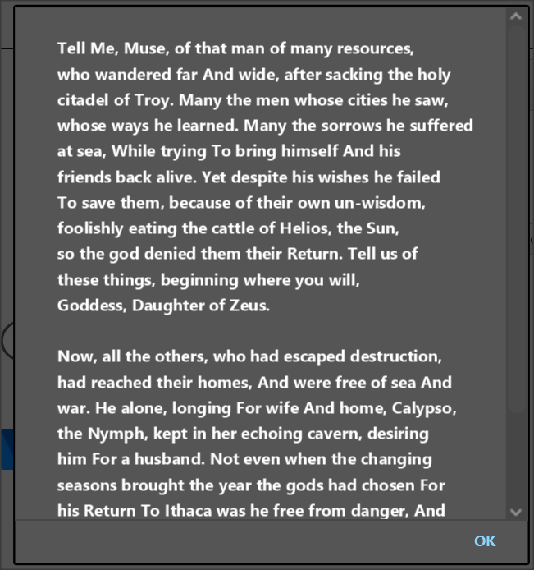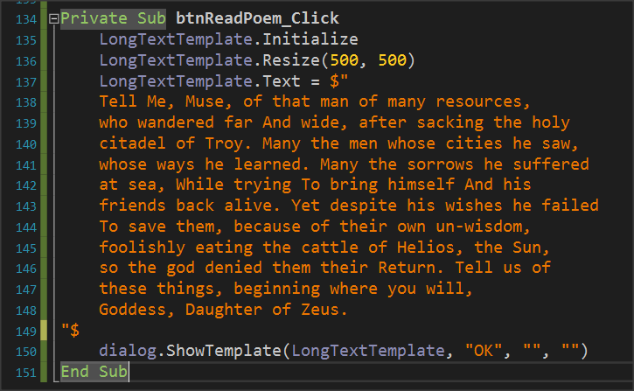

Picture LongTextTemplate

As in previous templates, set a variable of type B4XLongTextTemplate, and then after you initialize it you can set a size for the window that you are going to create with the “Resize” command.

Finally, set the Text property to the text you want to display and call “ShowTemplate”.

## Exercises

1. Create a program that asks for two dates between 2000 and 2021 and shows the distance between them in days, months and years.

Tip:

DateUtils.PeriodBetween(date1, date2).Days

DateUtils.PeriodBetween(date1, date2).Months

DateUtils.PeriodBetween(date1, date2).Years

1. Create a program that reads the following customer information:
   1. Name
   2. Surname
   3. Phone
   4. Phone Account (in € )

Then create a button on the form that says payment and if pressed display the message "Do you want to pay?" If answered yes set 0 to the variable corresponding to the Phone Account.

1. Create a program that for 5 books displays a summary of them in an appropriate window. Books must be selected from an equal number of buttons with book’s images on them. The summaries and images of 5 books can be found in the supporting material of the exercise.
2. Create a form that contains the following items:
   1. Name
   2. Surname
   3. Phone

It also includes a switch that when the form is open has a light_Gray background color with text fields in White while when closed it has dark gray background with light_Gray text Fields. Also include a label to say day or night with black or white letters each.

*Tip: Use* ***JFX library*** *to set floatTextFields colors*

**Private** fx **As** JFX ‘ *in Class_Globals*

lblDayNight.TextColor = fx.Colors.Black ‘ *Where you want to change color*

1. A water tank is 5 meters height and has a base of 3x3 meters. Make a program that,
2. continues reads the level height in meters and display a bar, represent the height. Text field will not allow any texts but only decimals values.
3. If water height is above 5 meters show message "Danger Water Leak!".
4. If the level Is less than 0.5 meters display a message. "Warning there is not enough water in the tank.
5. In every change show the total amount of water in cubic meters.

# Lesson 14 – Arrays

* One dimensional Arrays
* Basic Operations with arrays
* MAX – MIN item
* Linear search
* Binary search
* Sorting with Bubble Sort
* Sorting with Selection Sort

What students should know

**4h**

A common problem in computer programming is managing a large amount of data. When a problem consists of 6-7 variables, it is easy to declare and use them. What happens when there is a need to use multiple similar data at the same time? For example, 100 students and 100 grades, how can two hundred variables with names and grades be declared and how can a programmer manage so many data?

One of the solutions that computer science provides to said problem is the use of tables. In general, the table term defines a set of data of the same type that is placed one after the other in computer memory. So, the developer can find them simply by moving from one location to another without specifying separate names.

|  |  |  |  |  |  |  |  |  |  |  |  |  |  |  |  |
| --- | --- | --- | --- | --- | --- | --- | --- | --- | --- | --- | --- | --- | --- | --- | --- |
| ***Grades*** | | 98 | 76 | 86 | 45 | 32 | 77 | 56 | 99 | 34 | 71 | 47 | 82 | 69 | 88 |
|  |  | 0 |  |  |  |  |  |  |  |  |  |  |  |  | 13 |

Picture 50 Table named "Grades" and 14 places for grades

In Picture 50 you can see an example table with 14 student grades in a lesson. All points are placed in continuous positions and there is only one name (Grade). The programmer, to refer to memory locations in a table, should just indicate its name and then write, in parentheses, the number of the cell in which the data they need is located. Thus, for example, to display the first element of the table, they simply write "Grades(0)" where 0 is the first position of the table.

### Declaring Tables

A table is declared like other variables.

**Private** Grades(14) **As Int**

Here, Grades is the name of the table and the number in parentheses represents the number of positions in the table. Once a table is declared with a certain size, it cannot be changed within the code unless it is re-declared with a new size.

## Functions in tables

### Insert items into a table.

To insert an item into a table, you only need to assign a value to the corresponding place in the table. E.g.

Grades(0) = 89

The process can continue the same way, but it is easier to create a repeating process to fill the table. In the case of the Grade table in B4X it could be:

**Private** Grades(14) **As Int**

**For** i = 0 **To** 13

Grades(i) = Rnd(1,100)

**Next**

The above code fills the table with random numbers from 1 to 100. Notice that the position measurement starts at number 0. The variable **i** which identifies each time the position of the table we use is called **Index** of the table. Moving the index i with a repeat command you can access each location in the table.

|  |  |  |  |  |  |  |  |  |  |  |  |  |  |  |  |
| --- | --- | --- | --- | --- | --- | --- | --- | --- | --- | --- | --- | --- | --- | --- | --- |
| ***Grades*** | | 89 |  |  |  |  |  |  |  |  |  |  |  |  |  |
|  | | 🡹 |  |  |  |  |  |  |  |  |  |  |  |  |  |
|  |  | I |  |  |  |  |  |  |  |  |  |  |  |  | 13 |

Picture 51 Insert items into a table

A second way to insert items into a table is as follows:

**Private** Grades()  **As Int**

Grades **= Array As Int**(19,43,12,65,23,87,45,65,87,23,56)

This size of the table is not specified in its statement, but during a fill by inserting items with the **Array command.**

It is obvious that you can have tables of any type, for example strings, floats etc, but never mix up the types in a table.

### Display items in a table.

Using the Log command, you can easily print an item in a table or the entire table using one iteration.

**Log**(Grades(0)) ‘ Shows the 1st item of Array Grades

**For** i = 0 **to** 13

**Log**(i & “: “ & Grades(i))

**Next**

The example above starts an iteration that uses an i index to display the current index value of the table.

Attempting to use an out-of-bounds index leads to a collapse of the program, so it is very important that you pay attention to the use of indexes and table boundaries.

### Show items in reverse order

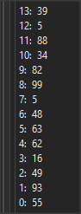The following code shows the table items from end to beginning:

**For** i = 13 **to** 0 **Step** -1

**Log**(i & “: “ & Grades(i))

**Next**

Generally, you can move your index as you want in a repeat to display or use any items in the table you want.

### Find Total and Average Table Items

The rules applicable to repetitive procedures for algorithmic techniques generally apply to tables with few variations. Thus, the sum of the elements requires an extra variable that will hold the sum, which we usually call "sum", and a repeat in the table.

**Private** intSum  **As Int**  = 0

**Private fltAverage**  **as Float**

**For** i = 0 **to** 13

intSum **=**  intSum  **+**  Grades(i)

**Next**

fltAverage = intSum / 14

**Log**(intSum & fltAverage)

### Find Maximum and Minimum

Finding the maximum or minimum item of a table makes use of an additional variable commonly called Max or Min, respectively. This variable initially assigns the developer the first value of the table, and then checks all other values with Max (or Min). If an element greater than Max (or less than Min) is found, Max (or Min) is replaced with the new item.

**Private** intMax, intMin  **As Int**

intMax = Grades(0)

intMin = Grades(0)

**For** i = 0 To 13

**If** intMax < Grades(i) **Then**

intMax = Grades(i)

**End If**

**If** intMin > Grades(i) **Then**

intMin = Grades(i)

**End If**

**Next**

**Log**("Max = " & intMax)

**Log**("Min = " & intMin)

## Search Algorithms

Searching for an item in a table refers to scanning a table in search of an item that meets a specific condition.

In this unit, we will discuss serial and binary search algorithms.

### Serial Search

It is the easiest but also the slowest way to search. It involves scanning all items in a table to find the item being searched. The following code shows the positions in the table that contain the key value.

'Find all positions with key value

**For** i = 0 **To** 999

**If** Grades(i) = key  **Then**

**Log**("found in : " & i & "position")

**End If**

**Next**

When it is necessary to find the first location that a value is displayed, a logical variable (found) should be declared, the value of which we will reverse if the item is found.

**Private** found **As Boolean** = False

i = 0

**Do While Not** (found) **And** i <= 999

**If** Grades(i) = key  **Then**

**Log**("found in : " & i & "position")

found = True

**End If**

i = i + 1

**Loop**

**If Not(**found)  **then**

**Log**(“Not found”)

**End If**

### Binary Search

Binary Search applies only to sorted tables. The basic philosophy of the method includes examining the middle value. If the item, we are looking for is smaller than the central one then the search continues on the upper half of the table. Contrarywise, if it is greater, the bottom half is searched. In the following example, there is a Grade table with 10 values sorted in ascending order.

|  |  |  |  |  |  |  |  |  |  |
| --- | --- | --- | --- | --- | --- | --- | --- | --- | --- |
| **Binary Search** | | | | | | | | | |
| key value = 80 | | | | | | | | | |
| *1* | 47 | 🡨Up | 47 |  | 47 |  | 47 |  |  |
| *2* | 58 |  | 58 |  | 58 |  | 58 |  |  |
| *3* | 62 |  | 62 |  | 62 |  | 62 |  |  |
| *4* | 69 |  | 69 |  | 69 |  | 69 |  |  |
| *5* | 74 | 🡨Cent | 74 |  | 74 |  | 74 |  |  |
| *6* | 79 |  | 79 | 🡨Up | 79 | 🡨Up, Cent | 79 |  |  |
| *7* | 80 |  | 80 |  | 80 | 🡨Bot | 80 | 🡨Up, Cent, Bot |  |
| *8* | 83 |  | 83 | 🡨Cent | 83 |  | 83 |  |  |
| *9* | 88 |  | 88 |  | 88 |  | 88 |  |  |
| *10* | 95 | 🡨Bot | 95 | 🡨Bot | 95 |  | 95 |  |  |
|  | 1 |  | 2 |  | 3 |  | 4 |  |  |

1. Initially the first and last cell of the table are entered in the Up and Bot variables. The center of the table is then determined as the quotient of the integer division (Up+Bot)/2.
2. Check the Grades(Cent) with key and if it is smaller, the Bot is transferred above the Cent. Otherwise, the Up is transferred below the Cent.
3. Repeat the steps above until the item is found or Up location to be larger than the Bot.

### Sort

There are several sorting algorithms in a table that you can use. In this unit, we will discuss Bubble and Selection Sort.

#### Bubble sorting

Bubble sorting is a simple sorting algorithm that repeatedly steps through the array, compares adjacent elements, and swaps them if they are in the wrong order. The pass through the list is repeated until the array is sorted. The algorithm, which is a comparison sort, is named for the way smaller or larger elements "bubble" to the top of the list.

Example Bubble Sort

A table named Grades with 5 integer grades is given.

**Private** Grades() **As Int**

Grades = Array As Int(65,12,19,43,23)

|  |  |  |  |  |  |  |  |  |  |  |  |  |
| --- | --- | --- | --- | --- | --- | --- | --- | --- | --- | --- | --- | --- |
| 1st Pass | | | | | | | | | | | | |
|  |  |  |  |  |  |  |  |  |  |  |  |  |
| 1 | 65 |  | 65 |  | 65 |  | 65 |  | 65 | 🡨 k-1 | 12 |  |
| 2 | 12 |  | 12 |  | 12 |  | 12 | 🡨k-1 | 12 | 🡨K | 65 |  |
| 3 | 19 |  | 19 |  | 19 | 🡨k-1 | 19 | 🡨K | 19 |  | 19 |  |
| 4 | 43 |  | 43 | 🡨k-1 | 23 | 🡨K | 23 |  | 23 |  | 23 |  |
| 5 | 23 | 🡨 K | 23 | 🡨 K | 43 |  | 43 |  | 43 |  | 43 |  |
|  |  |  | 1 |  | 2 |  | 3 |  | 4 |  |  |  |

Initially, the algorithm starts from the last position of the table and compares sequentially with the previous

1. The first comparison is made with the values of cells 5, 4 where the Grades(5) is less than The Grades(4) and thus the two cells swap values.
2. The next step compares cells 4 and 3 where Grades(4) is not smaller than Grade(3) and does not change anything in the table.
3. For positions 3 and 2 the values in the table do not change either.
4. And in the last step, the 2nd to the 1st position is compared and a swap occurs again.

The first pass is implemented with the following code.

**Private** Grades()  **As** Int

**Private** temp **As Int**

Grades = **Array As Int**(19,43,12,65,23)

**For** k = 4 **To** 1 **Step** -1

**If** Grades(k) **<** Grades(k-1) **Then**

temp **=** Grades(k)

Grades(k) **=** Grades(k-1)

Grades(k-1) **=** temp

**End If**

**Next**

The smallest item has been transferred to the top of array.

|  |  |  |  |  |  |  |  |  |  |  |  |  |
| --- | --- | --- | --- | --- | --- | --- | --- | --- | --- | --- | --- | --- |
| 2nd Pass | | | | | | | | | | | | |
|  |  |  |  |  |  |  |  |  |  |  |  |  |
| 1 | 12 |  | 12 |  | 12 |  | 12 |  | 12 |  |  |  |
| 2 | 65 |  | 65 |  | 65 |  | 65 | 🡨k-1 | 19 |  |  |  |
| 3 | 19 |  | 19 |  | 19 | 🡨k-1 | 19 | 🡨K | 65 |  |  |  |
| 4 | 23 |  | 23 | 🡨k-1 | 23 | 🡨K | 23 |  | 23 |  |  |  |
| 5 | 43 | 🡨 K | 43 | 🡨 K | 43 |  | 43 |  | 43 |  |  |  |
|  |  |  | 1 |  | 2 |  | 3 |  |  |  |  |  |

In the second pass of the table, the same procedure is performed except that the checks between the cells end up up to the 2nd position after the smallest element has already been climbed to the first.

|  |  |  |  |  |  |  |  |  |  |  |  |  |
| --- | --- | --- | --- | --- | --- | --- | --- | --- | --- | --- | --- | --- |
| 3rd Pass | | | | | | | | | | | | |
|  |  |  |  |  |  |  |  |  |  |  |  |  |
| 1 | 12 |  | 12 |  | 12 |  | 12 |  |  |  |  |  |
| 2 | 19 |  | 19 |  | 19 |  | 19 |  |  |  |  |  |
| 3 | 65 |  | 65 |  | 65 | 🡨k-1 | 23 |  |  |  |  |  |
| 4 | 23 |  | 23 | 🡨k-1 | 23 | 🡨K | 54 |  |  |  |  |  |
| 5 | 43 | 🡨 K | 43 | 🡨 K | 43 |  | 43 |  |  |  |  |  |
|  |  |  | 1 |  | 2 |  |  |  |  |  |  |  |

|  |  |  |  |  |  |  |  |  |  |  |  |  |
| --- | --- | --- | --- | --- | --- | --- | --- | --- | --- | --- | --- | --- |
| 4rth Pass | | | | | | | | | | | | |
|  |  |  |  |  |  |  |  |  |  |  |  |  |
| 1 | 12 |  | 12 |  | 12 |  |  |  |  |  |  |  |
| 2 | 19 |  | 19 |  | 19 |  |  |  |  |  |  |  |
| 3 | 23 |  | 23 |  | 23 |  |  |  |  |  |  |  |
| 4 | 54 |  | 54 | 🡨k-1 | 43 |  |  |  |  |  |  |  |
| 5 | 43 | 🡨 K | 43 | 🡨 K | 54 |  |  |  |  |  |  |  |
|  |  |  | 1 |  |  |  |  |  |  |  |  |  |

Passes continue until the classification of the table is completed. Notice that each time fewer positions are checked since at each pass the smallest one rises to the surface (bubbles).

Generally, these passages are as large as the size of the table -1. In the example for a table of 5 items, 4 passes were made. The completed code is as follows:

**Private** Grades() **As** Int

**Private** temp **As Int**

Grades = **Array As Int**(19,43,12,65,23)

**For** i = 1 **to** 4 ‘i counts the different pass

**For** k = 4 **To** i  **Step** -1

**If** Grades(k) **<** Grades(k-1) **Then**

temp **=** Grades(k)

Grades(k) **=** Grades(k-1)

Grades(k-1) **=** temp

**End If**

**Next**

**Next**

#### Selection Sort

The algorithm divides the array list into two parts: a sorted part of items which is built up from left to right at the front (left) of the array and a subarray of the remaining unsorted items that occupy the rest of the array. The algorithm proceeds by finding the smallest (or largest, depending on sorting order) element in the unsorted subarray, exchanging (swapping) it with the leftmost unsorted element (putting it in sorted order).

Implemented according to the steps below

1. Select the minimum item
2. Exchange of the minimum with the first item
3. Repeat steps 1 and 2 for the rest of the table items

|  |  |  |  |  |  |  |  |  |  |  |  |  |  |  |  |  |
| --- | --- | --- | --- | --- | --- | --- | --- | --- | --- | --- | --- | --- | --- | --- | --- | --- |
|  | | | | | | | | | | | | | | | | |
|  |  |  |  |  |  |  |  |  |  |  |  |  |  |  |  |  |
| 1 | 65 |  | 65 | Swap | 12 |  | 12 |  | 12 |  | 12 |  | 12 |  | 12 |  |
| 2 | 12 | 🡨Min | 12 | 65 |  | 65 | Swap | 19 |  | 19 |  | 19 |  | 19 |  |
| 3 | 19 |  | 19 |  | 19 | 🡨Min | 19 | 65 |  | 65 | Swap | 23 |  | 23 |  |
| 4 | 43 |  | 43 |  | 23 |  | 23 |  | 23 | 🡨Min | 23 | 65 |  | 65 | Swap |
| 5 | 23 |  | 23 |  | 43 |  | 43 |  | 43 |  | 43 |  | 43 | 🡨Min | 43 |
|  | 1 |  | 2 |  | 1 |  | 2 |  | 1 |  | 2 |  | 1 |  | 2 |  |

**Private** Grades() **As Int**

Grades = **Array As Int**(65,12,19,43,23)

**Private** intMin, intMinPos  **As Int**

**For** k = 0 **To** 4

intMin = Grades(k)

intMinPos = k

**For** i = k **To** 4 ‘Find the minimum from position k to 5th

**If** intMin > Grades(i) **Then**

intMin = Grades(i)

intMinPos = i

**End If**

**Next**

Grades(intMinPos) = Grades(k)

Grades(k) = intMin

**Next**

## Exercises

* 1. Write a program that fills a table named **A(**50) with random integers from 1 to 100.
  2. Calculate and display the sum of table A(50) in even positions.
  3. If the sum of the first 25 positions in the table is equal to the sum of the last 25 items, show the message "Equal totals".
  4. If A(1)=A(50), A(2)=A(49), A(3)=A(48)... A(25)=A(26), then displayed the message "Table symmetrical"
  5. Find the maximum value and the locations of the table that it is located in.
  6. Create a subprogram that sorts Table A
  7. Create a subprogram that accepts a table and an integer and applies binary search for that number to the table. Finally, return the location where the number was found or 0.
  8. Using the two previous subprograms, sort table A, and then search for item 67 and display appropriate messages whether it was found or not.
  9. The average temperature per day for one year is stored in a table Temperature(365). If you consider these temperatures to be integer values between 1 and 40 oC, find and display the frequency of each temperature.
  10. In the previous table **Temperature** find the second highest temperature of the year.

# Lesson 15 – Lists

* What is a list?
* Basic Operations with lists

What students should know

**2h**

A list is a set of nodes arranged linearly (one after the other). Each node contains, in addition to its data, a pointer pointing to the next node. The pointer of the last node does not point to a node and it is NULL.

## Create a list

A list in B4X is declared as follows:

**Private** Islands **As List**

Islands.**Initialize**

Where Islands the name of the list created. In addition, a list to be used must be initialized using the initialize method.

Items are imported into the list using the Add method, which adds a new item to the end of the list.

Islands.**Add**(“Piraeus”)

Islands.**Add**(“Paros”)

Islands.**Add**(“Thira”)

Islands.**Add**(“Crete”)

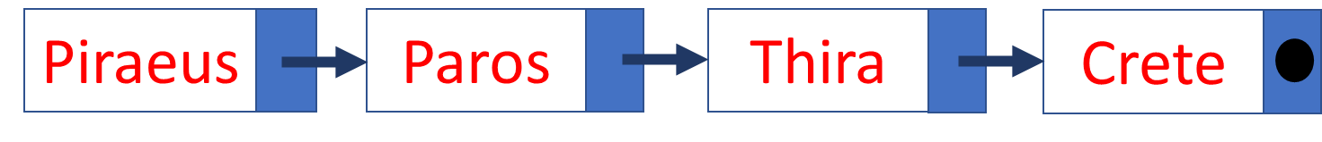

You can also insert items in a table at the end of the list with the AddAll command.

Islands.**AddAll**(Array as String(“Piraeus”, “Paros”, “Naxos”, “Crete”))

**Remember**

List items counts from 0. So, a list with 4 elements has the element(0) until element(3)



## Insert an item in a specific location

To insert between two elements a third you can use the **InsertAt** property

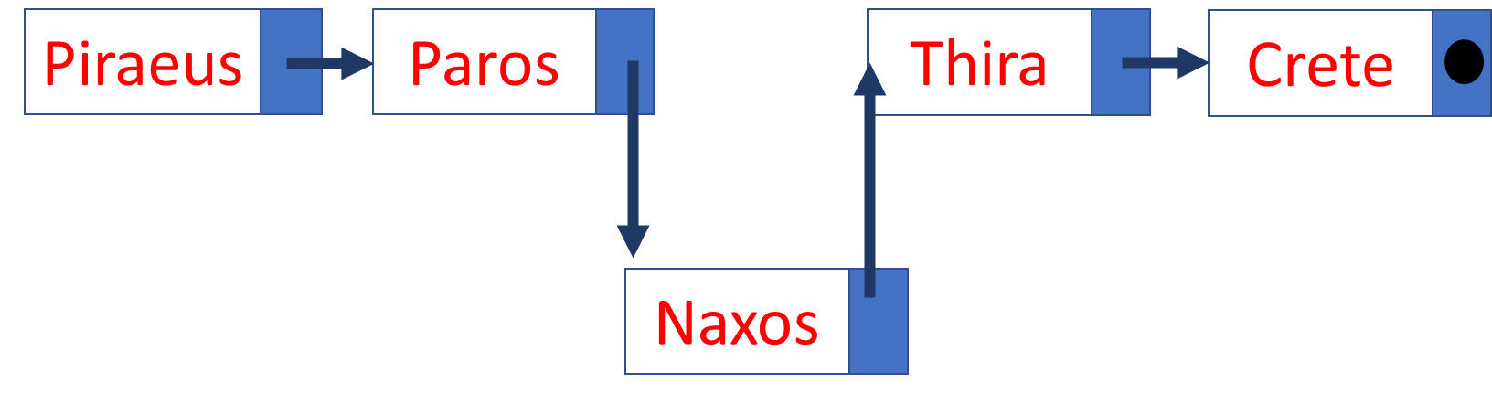

Islands.**InsertAt**(2, “Naxos”)

In the above example is inserted between Paros and Thira the island of Naxos in 3rd place.

## Remove an item from a specific location

The RemoveAt command removes a list item from a specific location.

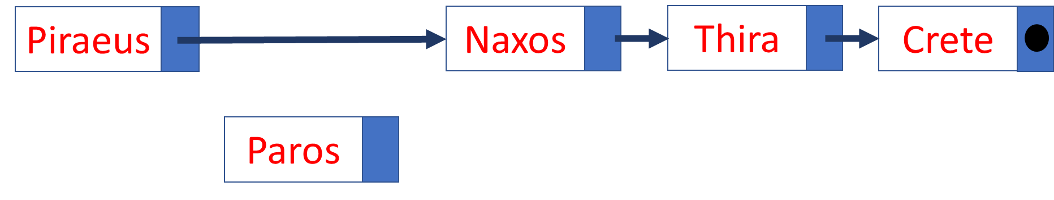

Islands. RemoveAt(1)

In the example above, Paros’s island is removed from the list.

## Change position value

With Set command you to change one value of a location with another value that you enter.

Islands.Set(4, “Rhodes”)

Here the value of 5th place changes to "Rhodes".

## More commands in lists

1. List size.



Islands.**Size**

In the list of the image returns the value 5.

1. Sort a list. You can sort a list in ascending or descending order with sort

Islands.**Sort**(True) ' Sortby ascending order

Islands.**Sort**(False) ' Sortin descending order

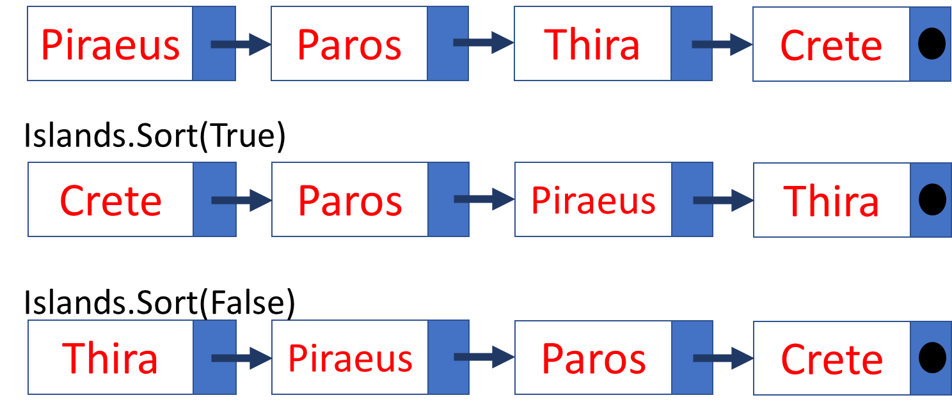

1. Empty List

A list empties with the Clear command

Islands.**Clear**

1. Move through a list

Moving within a list with a repetitive command

**For** i = 0 **to** Islands.**Size** – 1 ‘Remember it begins from 0

**Log**(islands.**Get**(i))

**Next**

1. You can take advantage of the values in a list by assigning its values to other variables:

**For** i = 0 **to** Islands.**Size** – 1

**Private** isle **As String**

Isle = islands.**Get**(i)

**Log**(Isle)

**Next**

1. Insert other types of items

A list can store items of any simple or complex type you want. For example, each item in a list could be an object or an entire table.

In the following example, each item in a list is an integer table:

'Create a list of arrays

**Private** StudentsGrades **As List**

StudentsGrades.Initialize

**For** j = 0 **To** 4

**Private** Grades(5) **As Int**

**For** i = 0 **To** 4

Grades(i) = Rnd(1, 100) 'Create 5 random Grades For student

**Next**

StudentsGrades.Add(Grades)

**Next**

'Show Students Grades

**For** j = 0 **To** StudentsGrades.Size - 1

**Log**("Student: " & j)

**Private** stGrades(5) **As Int** = StudentsGrades.Get(j)

**For** I = 0 **To** 4

**Log**(stGrades(i))

**Next**

**Next**

1

2

3

4

5

1. The list is declared and initialized
2. For 5 elements in the list, an equal number of tables are created with random numbers between 1 and 100
3. Each table is placed at the end of the list with the Add command
4. For all items in the list, a table is filled by the item in the list
5. The table we got from each item is displayed.

## Exercises

* 1. Create a list of Country and Capital Names. For example, you can use the following countries.

|  |  |
| --- | --- |
| CUBA | HAVANA |
| CYPRUS | NICOSIA |
| CZECHIA | PRAGUE |
| EGYPT | CAIRO |
| KENYA | NAIROBI |
| MEXICO | MEXICO CITY |
| PERU | LIMA |
| VIETNAM | HANOI |
| PORTUGAL | LISBON |

Source: <https://www.boldtuesday.com/pages/alphabetical-list-of-all-countries-and-capitals-shown-on-list-of-countries-poster>

* 1. Display the names of countries starting with the letter "P"
  2. In an appropriate text field, enter name of a country and then search the list if that country exists and display the capital city.
  3. Make a button to show a dialog asking for new country and capital and add it to list.

# Lesson 16 – Maps

* What is a map?
* Basic Operations with maps
* For Each command

What students should know

**2h**

A map is a collection that contains pairs of keys and values. For example, records in a phone book or a dictionary can be a map. Other times it is also referred to by the name dictionary.

Figure 3 Yellow Pages Map



Each key is unique so you can refer to it uniquely. This means that if you add a key/value pair (entry) and the collection already contains an entry with the same key, the previous entry will be removed from the map.

The value can be any type from a simple variable to an object.

## Create a map

A map is declared in B4X as below:

**Private EnglishGreek** As  **Map**

**EnglishGreek**.Initialize

**Private EnglishItalian** As **Map**

**EnglishItalian**.Initialize

Where **EnglishGreek** the name of the first map was created and EnglishItalian the second. In addition, a map to be used must be initialized.

## Insert items into Map

Put method allow to add keys/values to a map. For example the two maps bellow use the put method.

|  |  |  |  |  |
| --- | --- | --- | --- | --- |
| English | Greek |  | English | Italian |
| Memory | Memory |  | Memory | Memoria |
| Screen | Screen |  | Screen | Schermo |
| Printer | Printer |  | Printer | Stampante |
| Programming Language | Programming Language' |  | Programming Language | Linguaggio di Programmazione |
| Map 1 EgnlishGreek | |  | Map 2 **EnglishItalian** | |

The Put method is stated as follows:

**<map name>.put(key, value)**

The following example creates two Maps with key words from The English language and values in Greek and Italian.

**Private EgnlishGreek** As  **Map**

**EgnlishGreek**. Initialize

**Private EnglishItalian** As **Map**

**EnglishItalian**. Initialize

**EgnlishGreek**. Put("Memory","Memory")

**EgnlishGreek**. Put("Screen", "Screen ")

**EgnlishGreek**. Put("Printer ","Printer")

**EgnlishGreek**. Put("Programming Language", "ProgrammingLanguage"))

**EnglishItalian**. Put(“Memory”, "Memoria")

**EnglishItalian**. Put(“Screen”, "Schermo")

**EnglishItalian**. Put(“Printer”, "Stampante")

**EnglishItalian**. Put(“Programming Language”, "Linguaggio di Programmazione")

## Use a map value

To use a value from a map, you only need to use the Get command.

**<map name>. Get(Key As Object)**

GRWord = EnglishGreek.Get("Screen")

**Log**(GRWord) *' Shows Screen*

ITWord = EnglishItalian.Get("Screen")

**Log**(ITWord) *‘Shows Schermo*

Returns Value with Key “Screen” in Variable GRWord From map EnglishGreek, and the Value which Corresponds In Key “Screen” From map EnglishItalian In Variable ITWord.

**Remember**

The type of variable that the value accepts from the map must be the same type As the value. Key types must always be string or number.



If the key does not exist on the map, then Null is returned

ITWord = EnglishItalian.Get("Keyboard")

Log(ITWord) ‘Shows null

## Indexes in Maps

You can use indexes as in lists to access either the key or key value.

**<map name>. GetKeyAt(Index As Int)**

Key = EnglishItalian. GetKeyAt(2)

Log(key) ‘ Shows Printer

**<map name>. GetValueAt(Index As Int)**

Value = EnglishItalian.GetValueAt(2)

Log(Value) ‘ Shows Stampante

Also, the GetKeyAt and GetValueAt commands can be used in a iterative process to get all map values:

**For** i = 0 **To** EnglishGreek.Size - 1

**Log**(EnglishGreek.GetValueAt(i))

**Next**

The above iteration shows the values of map EnglishGreek.

## The command “for each”

One iteration command that has not been discussed so far is the command **for each**. This command creates an iteration that accepts items from a list of values such as a map for example.

**For Each** word As **String In** EnglishItalian.Values

**Log**(word)

**Next**

The above iteration defines a variable which (the word in the example) will accept each time the value of the current position. You do not need a counter or step like for loop. Next steps give next map values and stops when map keys end.

**For Each** key As **String In** EnglishItalian.Keys

**Log**(key)

**Next**

Displays the keys stored in the map.

To get both keys and values at the same time you can use the command for each as below:

**For Each** key As **String In** EnglishItalian.Keys

**Log**(key & EnglishItalian.Get(key))

**Next**

## Check key existence

If you are looking for a key, you can scan the table to find out if it exists or not, but it's easier and faster to use the **ContainsKey command**

**<map name>. ContainsKey(Key As Object)**

**If** EnglishGreek.ContainsKey("Keyboard") **Then**

**Log**("There is already an entry with this key !", "")

**Else**

**Log**("There is not such a key!", "")

**End If**

## Delete Key and Empty Map

The Remove command deletes a key (and of course its value from a Map)

**<map name>. Remove(Key As Object)**

EnglishGreek. Remove("Memory")

Deleting all items from a Map is done with the Clear command.

EnglishGreek. Clear

## Exercises

1. Create a map with Country names as keys and their capitals as values.

CUBA HAVANA

CYPRUS NICOSIA

CZECHIA PRAGUE

EGYPT CAIRO

KENYA NAIROBI

MEXICO MEXICO CITY

PERU LIMA

VIETNAM HANOI

PORTUGAL LISBON

Source:<https://www.boldtuesday.com/pages/alphabetical-list-of-all-countries-and-capitals-shown-on-list-of-countries-poster>

1. Add 3 countries with their capitals.
2. Display the names of countries and their capitals by using the **for each** command
3. Create a new map that contains the names of the capitals as keys and values country’s names.
4. In an appropriate text field, enter the name of a city and then display the country that owns the city.

# Lesson 17 – Files

* What is a file?
* File location in B4J
* File Methods

What students should know

**2h**

File we call a collection of data with similar content that is stored in the permanent space usually on the computer's hard disk. It is one of the most important features of programming languages since while all caching is done with central memory, after an application is completed its data should already be stored permanently.

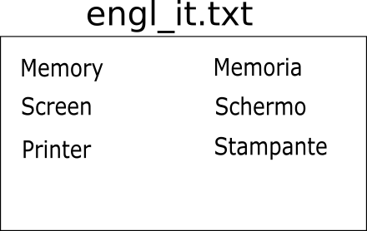

Picture File engl_it.txt

Generally, the files are divided into databases and simple files which we will examine.

## Storage Folders

Each operating system has many different folders to store applications data or other files. In order for B4J to work with files independently of the operating system, it uses keywords that refer to a specific type of folder.

### File.DirAssets

Includes files contained in the application files folder that have been added by B4J file management during the development phase of an application. These files are read-only and no file can be added while the application is running. Files are usually written by the developer so that after installing the application they can be copied to other folders for use.

### xui.DefaultFolder

Returns the folder where the application data is stored like File.DirData do. You are first required to call the SetDataFolder command once before using it.

xui.SetDataFolder(AppName As String)

### File.DirData

Returns the folder where the application data is stored and is suitable for creating files and storingdata.

In a Windows environment, returns the "user data folder" that is usually in the path

*C:\Users\[user name]\AppData\Roaming\[AppName]*

On non-Windows operating systems, returns the folder where the application is installed

### File.DirApp

Returns the folder where the application is installed. In Windows, this folder is usually Program Files and is read-only.

### File.DirTemp

Returns the Temporary Files folder.

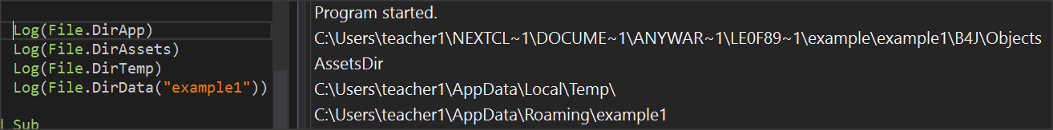

Picture 53 Directories commands

You can use the above commands in combination to declare a new folder within the previous ones. For example,

**Private** strFolder  **As String** = File.DirTemp & “lesson17\”

Log(strFolder)

Displays C:\Users\<*user name*>\AppData\Local\Temp\lesson17\

## Create folders

You can create a new folder with the

**File.MakeDir (Parent As String, Dir)**

File.MakeDir(File. DirTemp, “lesson17")

Creates a folder named lesson17 within C:\Users\teacher1\AppData\Local\Temp\ of the previous example.

## Check file existence

Before you use a file, usually the first task to do is to check for existence. The command is

**File.Exists (Dir As String, FileName As String)**

And returns truth or lie that you can control it with a command if.

**Private** fn  **as String** = “mydata.txt”

**If** File.Exists(File.DirTemp, fn) **Then**

**Log**("File " & fn & " Exists")

**Else**

**Log**("There is no File: " & fn)

**End If**

## Create and write to a file

The command to create a file is:

**File.OpenOutput** (Dir As String, FileName As String, Append As Boolean)

**Private** fn  **as String** = “mydata.txt”

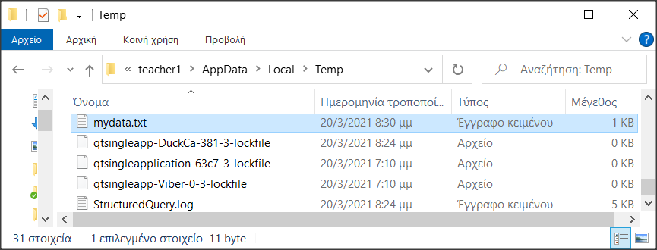File.OpenOutput(File.DirTemp, fn, True)

Picture 54 mydata.txt inside temp folder

If the file does not exist then it is created.

The logical value True or False in the third parameter refers to whether the file is opened for write by erasing the older data or will add to existing records.

## Writing and reading data

You can write or read data from one word to more complex structures such as lists and maps.

### String-type variables

File.WriteString (Dir As String, FileName As String, Text As String)

**Private** fn  **as String** = “mydata.txt”

Private msg As String = "Hello World"

File.WriteString(File.DirTemp, fn, msg)

Writes a string variable to the file. Attention the file is created from the beginning even if it already existed. So, its data is deleted.

For a file that already exists you can read its data and transfer it to a string variable with the command

**File.ReadString** (Dir As String, FileName As String) As String

Private fn as String = “mydata.txt”

Private strFileContent As String

strFileContent = File.ReadString(strFolder, fn)

### Lists

To write a list to a file, use the command:

**File.WriteList(Dir As String, FileName As String, List As List)**

File.WriteList(strFolder, "mydata.txt", List1)

With the above command each item in the list is converted to string and a new row is created in the file.

To read a list from a file, use the command:

**File.ReadList (Dir As String, FileName As String)**

List1 = File.ReadList(File.DirRootExternal, " mydata.txt")

The command creates a new item in the list per line of the file.

### Maps

An entire map is recorded in a file with the command

**File.WriteMap(Dir As String, FileName As String, Map As Map)**

File.WriteMap(File.DirInternal, “file.txt", map1)

The most common function is to create a configuration file for application.

A map is read with the command

**ReadMap(Dir As String, FileName As String)**

map1 = File.ReadMap(File.DirInternal, "file.txt")

The order of the items is not necessarily the same as the order of the file but this does not matter in a map.

## Exercises

The Lesson17-ex1 program is given, which creates a list of football teams and a brief history of them.

1. Create a map with a key to the group name and values its history.
2. Create a file that stores the above map named teams.txt
3. Create a string from all map keys and values. Use & CRLF to add a new line at the end of each line
4. Write string in a new file with name teams2.txt
5. Open with an external editor (such as notepad++) teams.txt and teams2.txt and examine their differences.

# Lesson 18 – Complex Data Types, Files & Views

* Type declaration
* Arrays of Type
* List of Type
* Map of Type
* KVS Files
* CustomListView
* B4XComboBox

What students should know

**4**

Often a developer wants to group variables related to each other. For example, a student has a First Name, Last Name, Address, Phone, etc. It can of course create separate variables for each different element of the student but it is more convenient to create a new data type that contains all these values together.

## The type statements

The described data type is called **type** and is stated as follows:

*Type Student(LastName As String, FirstName As String, Address As String, PhoneNumber As String)*

Notice that the keyword “Type” is first written, then a name is written for the new variable that is created, and finally in parentheses all variables included in the new type. Type declaration is always written in Class_Globals and it is Public.

In the student's example, the statement Type Becomes:

**Sub** Class_Globals

**Type** Student(LastName  **As String**, FirstName **As String**, _

Address **As String**, PhoneNumber  **As String**)

**End Sub**

A new data type has now been created called Student and you can declare new variables based on this.

**Sub** Class_Globals

**Type** Student(LastName  **As String**, FirstName **As String**, _

Address **As String**, PhoneNumber  **As String**)

**Public** Student1 **As Student**

**End Sub**

The “*Student1*” variable is now a Student-type variable, and to access its data you use the variable name with one period and then the name of the items included in the type statement e.g.

Student1.LastName = “Ioannidis”

Student1.FirstName = “Alkinoos”

Student1.Address = “Athens, Greece”

Student1.PhoneNumber = "+303465854234”

You can create as many variables of the Student type as you want and assign each other.

Private Student2 as Student

Student2 = Student1

Here the Student2 variable now contains exactly the same data as the Student1 variable.

### Show Items

You can use the Log command to display the contents of Student1, but the result will be something like the following:

Log(Student1)

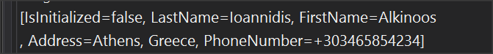

To display or use all elements of a type, use the entire name along with the item.

Log(Student1. LastName & “ “ & Student1.FirstName)

It is usually helpful to create a routine that accepts a type variable and then displays or processes the type elements.

**Private Sub** LogStudent(st  **As** Student)

**Log**(st.FirstName)

**Log**(st.LastName)

**Log**(st.Address)

**Log**(st.PhoneNumber)

**End Sub**

## Table of a type

You can also create tables of Type where it will include more students. For example,

**Sub** Class_Globals

**Type** Student(LastName  **As String**, FirstName **As String**, _

Address **As String**, PhoneNumber  **As String**)

**Public** Students(10)  **As Student**

**End Sub**

The Student(10) statement creates a table of 10 Students. Each item can be used with a for loop or with a separate reference to each with its index.

Students(0). LastName = “Paul”

Students(0). FirstName = “Belmond”

## List of Type

A list can contain variables of Type.

**Sub** Class_Globals

**Type** Student(LastName  **As String**, FirstName **As String**, _

Address **As String**, PhoneNumber  **As String**)

**Public** listStudents  **As List**

**End Sub**

**Private Sub B4XPage_Created (Root1 As B4XView)**

**...**

**...**

**listStudents.Initialize**

**listStudents.Add(Student1) ‘ Add Student to list**

**‘Get list items and log**

**For i = 0 To** listStudents**.Size-1**

**Private** st  **As Student**

st **=** listStudents**.Get(i)**

**LogStudent(**st**)**

**Next**

**End Sub**

**Private Sub** LogStudent**(**st  **As Student)**

**Log**(st.FirstName)

**Log**(st.LastName)

**Log**(st.Address)

**Log**(st.PhoneNumber)

**End Sub**

## Maps of Type

Using map to store type data is also possible as long as you have a unique key for each type variable you enter.

In the case of Students it could be for example an ID number, a registration number, an email account, etc.

**Sub** Class_Globals

**Type** Student(id **As String**, LastName  **As String**, _

FirstName **As String**, Address **As String**, PhoneNumber  **As String**)

**Public** mapStudents  **As**  **Map**

**End Sub**

**Private Sub B4XPage_Created (Root1 As B4XView)**

Student1.ID = "FXA47345S3"

Student1.LastName = "Ioannidis"

Student1.FirstName = "Alkinoos"

Student1.Address = "Athens, Greece"

Student1.PhoneNumber = "+303465854234"

mapStudents**.Initialize**

mapStudents**.Put(**Student1**.** ID**,**  Student1**)**

**End Sub**

In this way it is now easy to find a student with a key ID number by calling the Get method.

## Save to KVS files

The files discussed in Chapter 17 refer to text files that often do not serve to store complex structures such as type declarations, Lists, and Maps. Another type of files supported by B4J is key value store (KVS) files.

The way they work is similar to that of maps. All you need is a key and the structure you want to save. KVS files essentially hide a database, but the important thing is that the developer doesn't need to know any of them as long as he uses the appropriate methods.

The commands in the KVS files are as follows:

### Declare a KVS file

To declare a KVS file, you must use the KeyValueStore library to which you click in the library tab.

Then create a **KeyValueStore** variable**.**

**Private** kvsFile  **As KeyValueStore**

### Initialize the KVS file

The Initialize method defines the folder in which the file will be saved and the name it will have.

File.**MakeDir**(File.**DirTemp**, "lesson18")

kvsFile.**Initialize**(File.DirTemp & "lesson18", "kvsData.dat")

**Log**(File.**DirTemp** & "lesson18")

The above commands create a folder named lesson18 within the temp folder, create a file named "kvsData.dat” and finally displays the path of the file on the Log screen.

**Remember**

The file to be created cannot be opened with another viewer (for example notepad++) but must always be used by the program you built.



### Insert items into a KVS file

The Put method is used to import the data into a KVS file. Each insertion that is **made** is called Record. A prerequisite is that you have decided on a unique key so that you can refer to the record later. The following example insert the Student1 variable with the student's ID number as a key.

kvsFile.**Put**(Student1.ID, Student1)

This way you can write any data type such as Lists, Maps, Strings, simple variables (numbers), types, and tables (only tables from bytes or objects), as well as combinations (one list of maps for example).

Type declarations should be declared always in B4XMainPage.

Maps can also be stored using the PutMapAsync method. It is also the best way to save map since it enters the map key as the key of the record.

kvsFile.**PutMapAsync**(mapStudents)

### Retrieving items from a KVS file

The Get method retrieves an item from a KVS file. The returned value is an object. In other words, be careful to assign the returned value to a variable of the same type.

The following example reads from a KVS file the record of a Student.

**Student3 = kvsFile.Get("FS23534X21")**

LogStudent(Student3)

The value "FS23534X21" is the key to the record and the Routine LogStudent has described previous where accepts a Student and displays with command Log its contents.

**Remember**

If the key does not exist, then there is a problem with the operation of the program. The existence of the record must be checked before you assign it to a variable. This can be done with ContainsKey method.



You can read an entire map using the **GetMapAsync** method**.** This command accepts a list of keys as a parameter and returns a map with the keys and their corresponding values.

**Log**("Show keys")

**Private** keys **As List** = kvsFile.ListKeys

**For** i = 0 **To** keys.**Size**-1

**Log**(keys.**Get**(i))

**Next**

Finally, following the above code, GetMapAsync becomes:

**Wait** **For** (StudentFile.**GetMapAsync**(keys)) **Complete** (mapSt **As** **Map**)

To write a map in a kvs file use:

**Wait For** (StudentFile.PutMapAsync(keys)) **Complete** (Succes **As Boolean**)

### Check the existence of a record

To check the existence of a key in a KVS file, you must use the ContainsKey method.

**If** kvsFile.**ContainsKey**("FS23534X21") **Then**

Student3 = kvsFile.**Get**("FS23534X21")

**Else**

**Log**("Wrong id key")

**End If**

ContainsKey returns True after it finds the key in the file.

### Delete KVS file content

The remove method deletes a key along with its value from a KVS file, and the DeleteAll method deletes all data.

kvsFile.Remove ("FS23534X21")

kvsFile.DeleteAll

**Remember**

It always a good practice to close file you don’t need any more with method .close



## More Views

Two important views that will help to display or select elements from complex types, lists , and maps structures are **CustomListView** and **B4XComboBox**.

### CustomListView

Creates a list of items that you can select by clicking the mouse.

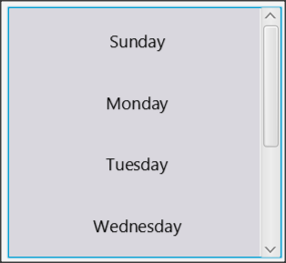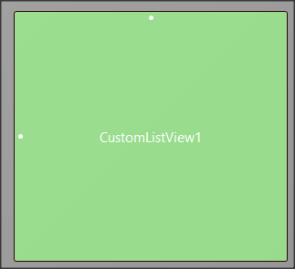

The returned value is a value that you specified at the time ListView was created.

Sub **Class**_**Globals**

Private Root As **B4XView**

Private xui As **XUI**

Private lstItems As **List**

1

Private CustomListView1 **As CustomListView**

Private lblDate As **Label**

End Sub

**Private** Sub B4XPage_Created (Root1 As **B4XView**)

Root = Root1

Root.**LoadLayout**("MainPage")

lstItems.**Initialize**

2

lstItems.**AddAll**(**Array As String**("Sunday", "Monday", _

"Tuesday", "Wednesday", "Thursday", "Friday", "Saturday"))

**For** i = 0 **To** lstItems.Size-1

3

CustomListView1.AddTextItem(lstItems.**Get**(i), i)

**Next**

**End Sub**

4

**Private** Sub CustomListView1_ItemClick(Index As Int, Value As Object)

lblDate.Text = Value

**End Sub**

1. Declare a CustomListView variable
2. Create a list structure that contains the items that will appear in CustomListView
3. Scan the entire list and each item is placed in CustomListView1 using the  **AddTextItem** method**.**

**AddTextItem** accepts a value that will display and an index that corresponds to the value you want to display. The above example corresponds to the values from 0 to 6 for the days from Sunday to Saturday.

1. When an item in the list is clicked,the **_ItemClick** eventtriggered**.** The example shows the index of the item that was clicked on the lblDatetag.

Additional methods of CustomListView are the following:

* **Clear** As String

Deletes all CustomListView components

* **GetValue** (Index As Int) As Object

Returns the value for the index value specified in the parenthesis.

* **Size** As Int [read only]

Returns the number of items.

#### Mark a list item

As mentioned earlier when clicking an item in a list, the event _ItemClick triggered. In order for this item to remain marked, the developer must either use some of the ready-made tools provided by the language (e.g. the CLVSelections library) or write his own code. The following algorithm assumes that you have set a variable in Class_Global named selectedItem of type Int.

**Private** **Sub** CustomListView1_ItemClick (Index **As** **Int**, Value **As** **Object**)

**If** selectedItem = -1 **Then**

**1**

**Private** p **As B4XView** = CustomListView1.**GetPanel**(Index)

p.GetView(0).**Color** = xui.**Color_Blue**

selectedItem = Index

**Else**

**2**

**Private** p **As B4XView** = CustomListView1.**GetPanel**(selectedItem)

p.GetView(0).Color = xui.**Color_White**

**If** selectedItem = Index **Then**

selectedItem = -1

**Else**

**3**

**Private** p **As B4XView** = CustomListView1.**GetPanel**(Index)

p.GetView(0).Color = xui.**Color_Blue**

selectedItem = Index

**End If**

**End If**

**End Sub**

The original value of selectedItem was set to -1 where it means that nothing is selected. The code uses two commands:

**Private** p **As B4XView** = CustomListView1.**GetPanel**(Index)

p.GetView(0).**Color** = xui.**Color_Blue**

Each item in a list is created by the language within a box called panel. You can set the color by accessing the box using the GetPanel(Index) method where Index the current value of the line that was clicked. Then the p.GetView(0).Color defines the color the developer wants to set. Then:

1. If an item in the list is clicked, the routine checks the value of the selectedItem, and if that is -1 then sets a Blue background color in the clicked line and sets selectedItem to the value of the Index that gives the event _ItemClick
2. If selectedItem already has a value, a white color is set as the background in the box, and then there are two cases
   1. If Clicked the already selected item, the item stops being selected and selectedItem becomes -1
   2. If Clicked another item, the new item gets blue color and selectedItem gets the value of the Index.

### B4XComboBox

B4XComboBox displays a drop-down list of items. The user can click one of them and select it. Unlike CustomListView, the returned value is always a number for the order in which the item is placed in The ComboBox, so the developer must then be able to map the value to a structure.

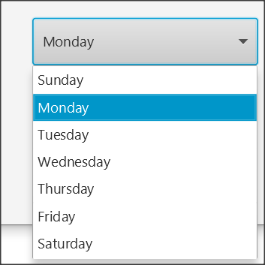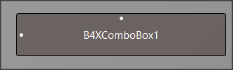

Sub Class_Globals

Private Root As **B4XView**

Private xui As **XUI**

Private lstItems As **List**

1

Private B4XComboBox1 As **B4XComboBox**

Private lblCmbDate As **Label**

End Sub

Private Sub B4XPage_Created (Root1 As **B4XView**)

Root = Root1

Root.**LoadLayout**("MainPage")

lstItems.**Initialize**

2

lstItems.**AddAll**(Array As String("Sunday", "Monday", _

"Tuesday", "Wednesday", "Thursday", "Friday", "Saturday"))

3

B4XComboBox1.**SetItems**(lstItems)

End Sub

4

Private Sub B4XComboBox1**_SelectedIndexChanged**(Index As  **Int**)

lblCmbDate.**Text** = Index

End Sub

1. Declare a type **B4XComboBox variable**
2. Create a list structure that contains the items that will appear in B4XComboBox
3. Place the items in the list in B4XComboBox. Caution does not require iterative structure as in CustomListView
4. If an item is selected, **the _SelectedIndexChanged** event is triggered and returns the index of the selected item.

## Exercises

1. Create a type named **Customer** and variables

ID, FirstName, LasName, Phone

1. Create a list of Customers with the following items

|  |  |  |  |
| --- | --- | --- | --- |
| **Id** | **FirstName** | **LasName** | **Phone** |
| A3473 | John | Smith | 4563454 |
| B1753 | Selim | Al Huarizmi | 6532578 |
| C6544 | Mateo | Sandor | 7345346 |
| C6323 | Lucía | Graham | 1231345 |
| F1462 | Noam | Bell | 6978323 |

1. Save the list to a KVS file
2. Build a button that when clicked fills a CustomListView with customers information.
3. Build an insert button that, when clicked, displays an appropriate DialogBox that prompts for new customer information and add them into CustomListView.
4. Save the new client to the KVS file as well.
5. When a customer cklicked display a confirmation message for deleting customer and in case of positive feedback delete the customer from CustomListView and KVS File.

# Lesson 19 – Final Project

**10h**

* Use previous knowledge to create your final Project.

What students should know

**Dear Teacher**

The solution proposed concerns the knowledge gained during the course. You can extend the questions as you want depending on your class level and available time.

To study how a school library can be created you can read the book "Setting Up and Running a School Library by Nicola Baird" here https[://files.Eric.Ed.](https://files.eric.ed.gov/fulltext/ED536911.pdf) [Gov/Fulltext/Ed536911.Pdf](https://files.eric.ed.gov/fulltext/ED536911.pdf)

The names of the books and authors come from the Gutenberg Project <https://www.gutenberg.org/ebooks/offline_catalogs.html>

Publishers' names and release dates are random as well as students' names.

*Prokopis Leon, pliroforikos[at]gmail.com*



## Create a School Library Application

A school library has a set of books which it lends to students in the three classes. The books are placed on shelves numbered from 1 to 60.

For each book, the following information is recorded:

* Code
* Title
* Writing by Syed syd
* Release Year
* Publisher
* Shelf

For students, the following are recorded:

* Registry Number
* Name
* Surname
* Class
* Phone Number

Make the application described below:

## Files

Two text files named are given books.txt and students.txt (inside the materials folder).

Some of the file elements are:

**books.txt**

30;The Life of Abraham Lincoln;Henry Ketcham;1866;New Public publ.;54

31;Christopher Columbus; Mildred Stapley;1954;Cider publ.;43

32;The Adventures of Ferdinand Count Fathom; Tobias Smollett;1982;Orange punl.;32

33;Tales of the Jazz Age;F. Scott Fitzgerald;1944; Gutenberg publ.;5

34;The Old Stone House;Anne March;1904;Orange punl.;50

Each book is described in the following fields which we distinguish from each other with the character ";":

* Id
* Title
* Writer
* Year
* Publisher
* Shelf

**students.** **txt**

1001;Jude;Segers;A;7900209

1002;Desire;Cid;A;7047635

1003;Madelyn;Pittard;A;9011036

1004;Lorita;Tomczak;A;6677490

1005;Lynwood;Posey;A;9014379

1006;Nella;Felps;A;8423818

Each student is described in the following fields which stand out from each other with the character ';':

* Id
* First Name
* Last Name
* Class
* Phone Number

Implement a function that inserts the above text files into two maps With Names mapBooks And mapStudents key the first column of each file where it represents the Id of the book and the student respectively. The values of each item will be a Type as described below.

**Teachers tip**

Before you can read the files you need to read all the content like a string and then check its characters one by one and place them in a table of items that you will later write on the map. A string is checked using the <string> method. **CharAt**(index).



**Example Of Student**  **Map**

|  |  |  |  |  |  |
| --- | --- | --- | --- | --- | --- |
| **Key** | **Type** | | | | |
| **Id** | **FirstName** | **LastName** | **Class** | **Phone** |
| 1001 | 1001 | Jude | Segers | A | 7900209 |
| 1002 | 1002 | Desire | Cid | A | 7047635 |
| 1003 | 1003 | Madelyn | Pittard | A | 9011036 |

## Data

### Types

1. Create Type Book

Type Book with elements:

* + - Id
    - Title
    - Writer
    - Year
    - Publisher
    - Shelv

**Functions:**

* + Insert Book
  + Delete Book

1. Create Student Type

**Properties**:

* + Id
  + First Name
  + Last Name
  + Class
  + Phone Number

**Functions:**

* + Insert Student
  + Delete Student

Each student who has borrowed books has their own KVS file with name “ID number.dat”. For example, the student with ID 21 has a file named “21.dat”. The file writes the books borrowed by the student with a map structure. For example, if you have borrowed two books you should have a Map of the following structure:

(“11”, “03/27/2021”)

(“14”, “04/01/2021”)

Where the first number is the ID of the book borrowed and is also the key of the map while the borrowing date is saved as a value.

## Screen Design and Functions.

The program must have a central menu of buttons to call appropriate administrative screens. Specific:

1. **Book.**

Includes a CLV list of library books to be loaded from the books.txt and book insert and delete buttons.

When the Insert button is pressed, create a dialog asking for new book items to be inserted into the file.

When the Delete key is pressed, delete the book selected from the list.

1. **Student**

Includes a CLV list of school students that will be loaded from the students.txt file and insert and delete buttons.

When the Insert button is pressed, create a dialog asking for new student information and store it into students.txt.

When the Delete key is pressed, delete that student from the list together and the books they borrowed assuming they return them.

1. **Lending**

The lending screen includes a ComboBox containing the student's name and a CLV list of library books.   
There is also a button Lend when its’ click triggered:

**If there is a student's file**

It will load the entire map from the file

It will add a new key with the ID of the book borrowed and value the borrowing date.

It will re-save the map

**If there is no student file**

It will create the file

It creates a Map with the borrowing information(ID and date)

It will save the file

**Consider that there are as many copies as you need from each book.**

1. **Return**

The lending screen includes a ComboBox containing the student's names and a CLV list of books borrowed. Also, there is a button called “Return”.

If return_click triggered then it will delete this book from the student's list as well as from the student's file.

If he hasn't borrowed another book, program will delete and the file too.

## Cheat Sheet

1. How to declare a type

**Sub** Class_Globals

**Type** Student(LastName  **As String**, FirstName **As String**, _

Address **As String**, PhoneNumber  **As String**)

**Private** Student1 **As Student**

**End Sub**

1. How to read a file on a string

stFile = File.**ReadString**(File.**DirAssets**, "students.txt")

1. Check character by character a string that contains a file and place it in a list of tables.

**Private** i **As Int** = 0

**For** j = 0 **To** stFile. **Length**-1

**If** stFile.**CharAt**(j) <> ";" And stFile.**CharAt**(j) <> CRLF **Then**

stud(i) = stud(i) & stFile.CharAt(j)

**Else if** stFile.CharAt(j) = ";" **Then**

i = i + 1

**else if** stFile.CharAt(j) = CRLF **Then**

i = 0

retList.**Add**(stud)

**Private** stud(5) **As String**

**End If**

**Next**

1. Convert a list of tables to a map

For i = 0 To lst.**Size**-1

**Private** stud(5) **As String**

stud = lst.**Get**(i) ‘ Create an array from list item

**Private** st  **As Student** ‘ Student is type declaration

st.**Initialize**

st.ID = stud(0) ‘Put every array item into type

St.FirstName = stud(1)

St.LastName = stud(2)

St.Cls = stud(3)

St.Phone = stud(4)

St.Borrowed = 0

mStudent.**Put**(stud(0), st) ‘ Insert type into map

**Next**

1. Place spaces on a string to increase the size of up to a number.

**Do While** s1.Length <= 5

s1 = s1 & " "

**Loop**

1. Select – Deselect an item from a clv List.

Each item in a list is created by the language within a box called a panel. You can set the color by accessing the box using the GetPanel(Index) method where Index the current value of the line that was clicked Then:

* If an item in the list is clicked, the routine checks the value of selectedItem, and if that is -1 then sets a Blue background color in the clicked line and sets selectedItem to the Index value that gave the _ItemClick event
* If selectedItem already has a value, a white color is set as the background in the box, and then there are two cases
* Click the already selected item, in which case the item stops being selected and selectedItem becomes -1
* Click another item in which case selectedItem gets the value of index.

**Private Sub** clvBooks_ItemClick (Index **As Int**, Value **As Object**)

**If** selectedBook = -1 **Then**

**Private** p **As B4XView** = clvBooks. **GetPanel**(Index)

p.GetView(0). Color = xui. Color_Blue

selectedBook = Index

**Else**

**Private** p **As B4XVie**w = clvBooks. **GetPanel**(selectedBook)

p.GetView(0). **Color** = xui. Color_White

**If** selectedBook = Index  **Then**

selectedBook = -1

**Else**

**Private** p As **B4XView** = clvBooks. **GetPanel**(Index)

p.**GetView**(0). Color = xui. Color_Blue

selectedBook = Index

**End If**

**End If**

**End Sub**

1. Load items from kvs File to map

The command must run within Wait For.

**Wait For**(StudentFIle.**GetMapAsync**(StudentFIle.**ListKeys**))**Complete**(mapSt **As Map**)

The GetMapAsync command returns a map with the items. First declare mapSt map and initialize it.

1. Save items to a map's kvs File

**Wait For** (StudentFIle.**PutMapAsync**(mapSt)) **Complete** (Succes  **As Boolean**)

1. Delete a file from a folder

File.**Delete**(File.**DirTemp**, <file name>)

Timetable

|  |  |
| --- | --- |
| Project |  |
| Date |  |
| Student |  |

**Organize your time - What to do and when**

|  |  |  |  |  |  |  |  |  |  |
| --- | --- | --- | --- | --- | --- | --- | --- | --- | --- |
|  | **Hours** | | | | | | | | |
|  | **1** | **2** | **3** | **4** | **5** | **6** | **7** | **8** | **9** |
|  |  |  |  |  |  |  |  |  |  |
|  |  |  |  |  |  |  |  |  |  |
|  |  |  |  |  |  |  |  |  |  |
|  |  |  |  |  |  |  |  |  |  |
|  |  |  |  |  |  |  |  |  |  |
|  |  |  |  |  |  |  |  |  |  |
|  |  |  |  |  |  |  |  |  |  |
|  |  |  |  |  |  |  |  |  |  |
|  |  |  |  |  |  |  |  |  |  |

Wireframe Sketching

|  |  |
| --- | --- |
| Form Name |  |
| Date |  |
| Student |  |

|  |  |  |  |  |  |  |  |  |  |  |  |  |  |  |  |  |  |  |  |  |  |  |  |
| --- | --- | --- | --- | --- | --- | --- | --- | --- | --- | --- | --- | --- | --- | --- | --- | --- | --- | --- | --- | --- | --- | --- | --- |
|  |  |  |  |  |  |  |  |  |  |  |  |  |  |  |  |  |  |  |  |  |  |  |  |
|  |  |  |  |  |  |  |  |  |  |  |  |  |  |  |  |  |  |  |  |  |  |  |  |
|  |  |  |  |  |  |  |  |  |  |  |  |  |  |  |  |  |  |  |  |  |  |  |  |
|  |  |  |  |  |  |  |  |  |  |  |  |  |  |  |  |  |  |  |  |  |  |  |  |
|  |  |  |  |  |  |  |  |  |  |  |  |  |  |  |  |  |  |  |  |  |  |  |  |
|  |  |  |  |  |  |  |  |  |  |  |  |  |  |  |  |  |  |  |  |  |  |  |  |
|  |  |  |  |  |  |  |  |  |  |  |  |  |  |  |  |  |  |  |  |  |  |  |  |
|  |  |  |  |  |  |  |  |  |  |  |  |  |  |  |  |  |  |  |  |  |  |  |  |
|  |  |  |  |  |  |  |  |  |  |  |  |  |  |  |  |  |  |  |  |  |  |  |  |
|  |  |  |  |  |  |  |  |  |  |  |  |  |  |  |  |  |  |  |  |  |  |  |  |
|  |  |  |  |  |  |  |  |  |  |  |  |  |  |  |  |  |  |  |  |  |  |  |  |
|  |  |  |  |  |  |  |  |  |  |  |  |  |  |  |  |  |  |  |  |  |  |  |  |
|  |  |  |  |  |  |  |  |  |  |  |  |  |  |  |  |  |  |  |  |  |  |  |  |
|  |  |  |  |  |  |  |  |  |  |  |  |  |  |  |  |  |  |  |  |  |  |  |  |
|  |  |  |  |  |  |  |  |  |  |  |  |  |  |  |  |  |  |  |  |  |  |  |  |
|  |  |  |  |  |  |  |  |  |  |  |  |  |  |  |  |  |  |  |  |  |  |  |  |
|  |  |  |  |  |  |  |  |  |  |  |  |  |  |  |  |  |  |  |  |  |  |  |  |
|  |  |  |  |  |  |  |  |  |  |  |  |  |  |  |  |  |  |  |  |  |  |  |  |
|  |  |  |  |  |  |  |  |  |  |  |  |  |  |  |  |  |  |  |  |  |  |  |  |
|  |  |  |  |  |  |  |  |  |  |  |  |  |  |  |  |  |  |  |  |  |  |  |  |

B4XPages

|  |  |
| --- | --- |
| B4XPage Name: |  |
| Date: |  |
| Student: |  |
| **Public Variables:** | 1. |
| 2. |
| 3. |
| 4. |
| 5. |
| 6. |
| 7. |
| 8. |
| 9. |
| 10. |
|  |  |
| **Event** |  |
| **Description:** |  |
|  |
|  |
| **Event** |  |
| **Description:** |  |
|  |
|  |
| **Event** |  |
| **Description:** |  |
|  |
|  |

# Lesson 20 – From B4J to B4A

* Transfer a B4J project to B4A

What students should know

**2**

## Congratulations!

Having completed the courses up to this point you can say that you have acquired a good knowledge of the language B4X. What you've learned so far it is only the beginning of the journey of the "art" of programming.



Picture B4X Languages

In addition, the B4X language as discussed in previous chapters can be used to build mobile applications on both Android and IOS. With minimal changes and without having to learn new commands you can transfer an application written in Windows with B4J to Android and the language B4A.

In this last chapter you will deal with the conversion of a program (given ready) into a program for Android.

## Application description in B4J

Picture Simple Calculator

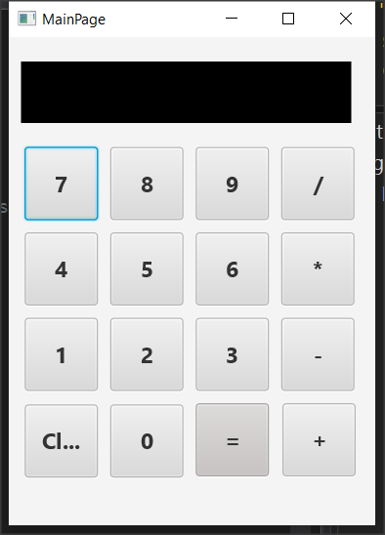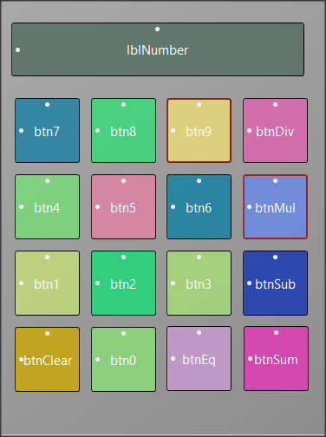

The application is a simple calculator that performs basic operations.

### Designer

The app consists of 16 different buttons and a label that displays the numbers.

The 10 buttons are the numbers from 0 to 9 and the rest are the basic operations, equality and clear.

In programs like the one that you need to manage multiple buttons, in order not to use separate events for each event _ click , it is possible to group the events _click.

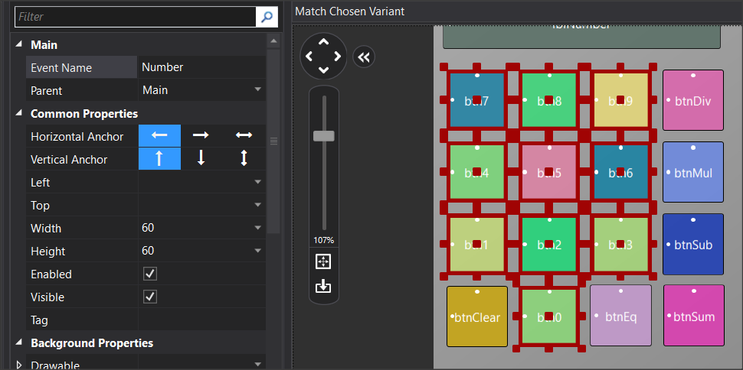

For example, after selecting all the buttons listed in the numbers from 0 to 9, then set the “Event Name” properties, for example Number. Now all buttons have a common click event named Number_Click.

**Private Sub** Number_Click

**Dim** b **As Button**

b = Sender

**Log**(b.Tag)

**If** done  **Then**

lblNumber.Text = 0

done = False

**End If**

lblNumber. **Text** = lblNumber. **Text** & b.Tag

**End Sub**

Also, for you to have a different value from each button you need to update the "tag"property. Assign a value to each different number. For example, in btnNumber1, set “tag” to 1, in btnNumber2 set “Tag” to 2 and so on.

Now in the event take advantage of the Tag value to enter a new number.

Sender assigns the clicked button to variable b.

The program code is as follows. Notice that no buttons have been declared as variables:

**Sub** Class_Globals

Private Root **As B4XView**

Private xui **As XUI**

Private lblNumber **As Label**

Private fltNumber1, fltNumber2 **As Float**

Private operation **As String**

Private done **As Boolean** ‘When true an operation just finished

**End Sub**

**Public Sub** Initialize

**End Sub**

**Private Sub** B4XPage_Created (Root1 As **B4XView**)

Root = Root1

Root.**LoadLayout**("MainPage")

lblNumber.**Text** = ""

done = False

**End Sub**

***‘When Number button clicked add to string lblNumber new Number***

***‘from tag***

**Private Sub** Number_Click

Dim b **As Button**

b = **Sender**

**If** done  **Then**

lblNumber.**Text** = 0

done = False

**End If**

lblNumber.**Text** = lblNumber.**Text** & b.Tag

**End Sub**

***‘When Clear Button clicked clear all numbers and operations***

**Private Sub** btnClear_Click

lblNumber.**Text** = 0

fltNumber1 = 0

fltNumber2 = 0

**End Sub**

***‘When an operation button clicked set operation string to tag***

***‘of clicked operation button***

**Private Sub** operation_Click

Dim b **As Button**

b = **Sender**

operation = b.**Tag**

fltNumber1 = lblNumber.**Text**

lblNumber.**Text** = 0

**End Sub**

***‘When button “=” clicked check operation string and do the operation***

**Private Sub** btnEq_Click

fltNumber2 = lblNumber.**Text**

**If** operation = "+" Then

lblNumber.**Text** = fltNumber1 + fltNumber2

**else If** operation = "-" Then

lblNumber.**Text** = fltNumber1 - fltNumber2

**else If** operation = "*" Then

lblNumber.**Text** = fltNumber1 * fltNumber2

**else If** operation = "/" Then

lblNumber.**Text** = fltNumber1 / fltNumber2

**End If**

fltNumber1 = lblNumber.**Text**

done = True

**End Sub**

## Transfer the app to B4A and Android

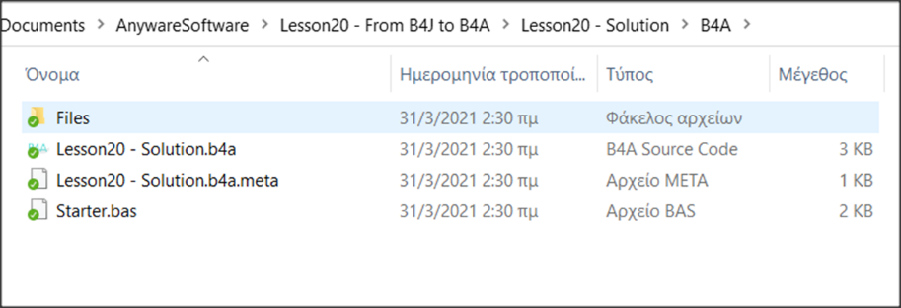Already when you start an application the appropriate folder for B4A and B4i has already been created even though you are not using it yet.

To start the transfer, you will need to install the B4A. For instructions on installation, see the link <https://www.b4x.com/b4a.html>.

After you complete the installation do not forget to install on your mobile the application **B4A-Bridge** which will help you transfer the calculator to the mobile. The app is free to install from Google Play.

## Transfer of design

Open the calculator with B4J. Similarly open the calculator with B4A. The file of interest is located within the B4A folder and has a b4a extension. Already all the code of the application exists within the B4A!

Open the Designer which visually makes no difference to that of b4j.

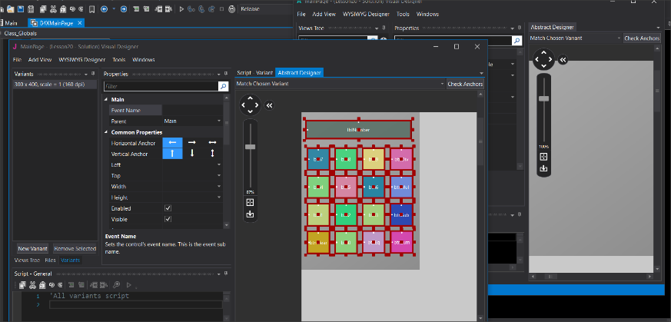The design has not been transferred to the B4A but you can easily select all objects from the designer of B4J by copying and pasting to the screen of the designer of B4A.

You can also make any changes you want to make your app look. Finally, save the changes and return to B4A.

## Install an app on your mobile phone.

Before installing the app on a mobile device, you must specify the name of your app and the name of the "package" to be sent to the mobile.

From the tab Main specify the name you want the application to have in the directive #ApplicationLabel:

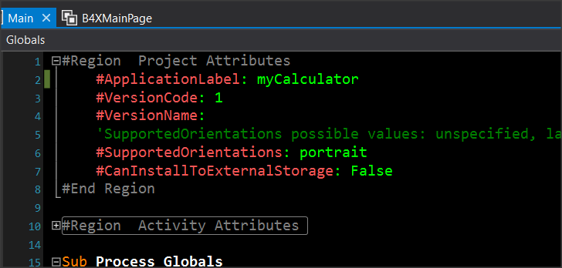

Picture Application Label

It's the name that will appear on the screen of your mobile phone or tablet.

Picture Build Configurations

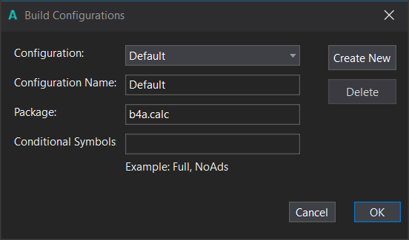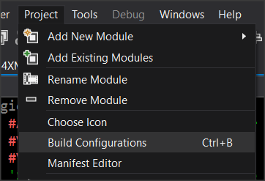

From the Build Configurations menu, specify the name of thePackage:This should be something unique for your device, which is why it is recommended to start with"b4a.". In the example, the package name is "b4a. calc».

Installation on the mobile phone requires that you have already installed the application B4A-Bridge.

1. Launch the B A-Bridge app on your Android device and make sure that it's connected to your local network.
2. From the Tools 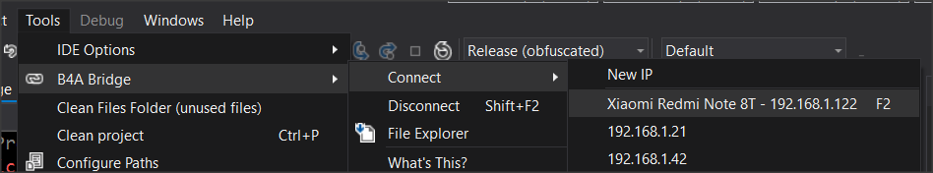 menu -> B4A Bridge -> Connect

Select your device that should appear in the menu. If you can't find it, check to see if it's connected to your local area network.

1. 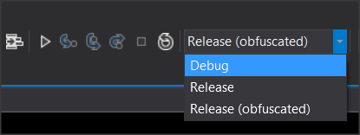Select the type of installation to perform. Debug if you are in the process of debuging the application and Release once you are finished with the deployment and want it to run independently of the development environment of B4A.
2. Tap the run icon and check your phone in B4A-Bridge.

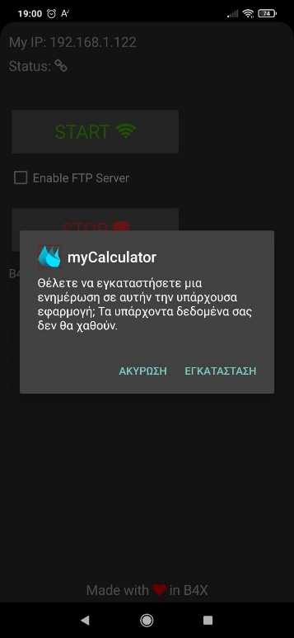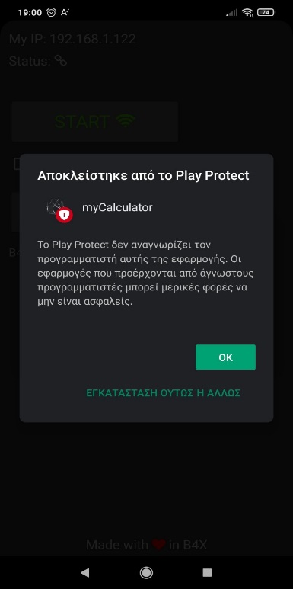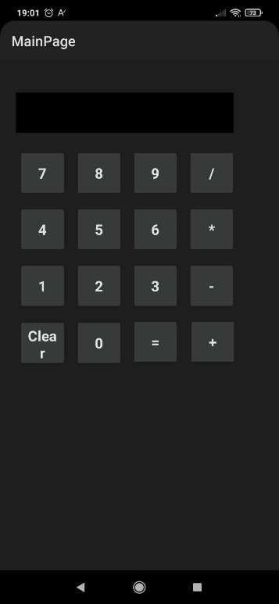

Do you want to install the application?

Cancel Install

Play Protect does not recognize the programmer of this application …

INSTALL ANYWAY

Blocked from Play Protect

During installation, you may receive a message from Play Protect that you can ignore and continue.